Organisation types

**Introduction**

organisations_sectors_01_a.jpg

Your organisation will form part of one of three sectors: the public sector, the private sector or the third sector. There are major differences between these three sectors, mainly in their purpose, the way they are run and financed as well as what they do with any profits.

To understand how your organisation's policies and procedures affect your customer service role, it is important to recognise how the customer service offered differs between the three sectors. Talk to your employer and colleagues about your organisation - they will have an insight into the way its aims relate to its sector.

You will now explore the three sectors in more detail:

* The Public Sector
* The Private Sector
* The Third Sector

**The public sector**

organisations_sectors_01_c.jpg

These are organisations funded by public money (i.e. taxes), e.g. NHS organisations such as doctors’ surgeries and hospitals; schools, councils, government departments and agencies.

They are usually organisations which provide preventative or supportive services to a wide-ranging client base, where profit is not the goal.

The main objectives of any organisation in the public sector is to provide efficient and effective public services, whilst carrying out government policy and complying with legislation.

Usually, an organisation's aim is stated in its mission statement: whilst private sector organisations usually focus on the customer, public sector organisations usually concentrate on the service they offer.

Broadly, public sector organisations fall into those reporting to government departments, which are headed up by ministers of the political party in power, and non-ministerial government departments that answer to Parliament rather than a cabinet minister, e.g. Ofsted, HMRC, Charity Commission.

Select the book below to learn more about this sector.

## The public sector

**Introduction**

public_sector_01.jpg

As you can see from the list below there are various types of organisations in this sector.

* NHS Health organisations – hospitals, doctors’ surgeries, clinics
* State education organisations – schools, colleges
* Local authorities (councils) e.g. London Borough of Ealing
* [Government departments](https://www.gov.uk/government/organisations) e.g. Department for Health
* Non-ministerial departments e.g. the Land registry
* Executive agencies that operate as separate organisations, e.g. The Met Office and Companies House are both executive agencies within the Department for Business, Energy & Industrial Strategy
* Executive non-departmental public bodies (NDPB) – Quangos – e.g. The Health and Safety Executive, Innovate UK
* Advisory non-departmental public body, e.g. the low pay commission, committee on fuel poverty
* Tribunal non-departmental public body, e.g. Copyright tribunal

[Select here](http://www.public-sector.co.uk/) to find out more information about public sector news.

**Local authorities**

public_sector_02.jpg

* Report to the Secretary of State for Communities and Local Government
* Responsible for the running of local areas

Explore the services offered by [Local government](https://www.gov.uk/browse/housing-local-services/local-councils) nationally.

In London local government takes place in two tiers; a city-wide, strategic tier and a local tier. City-wide administration is coordinated by the Greater London Authority (GLA), while local administration is carried out by 33 smaller authorities.

Upper tier - The [Greater London Authority](https://www.london.gov.uk/) (GLA) consists of two elected parts. They are the Mayor of London [Sadiq Khan](https://www.london.gov.uk/about-us/mayor-london)elected in 2016, who has executive powers, and the [London Assembly](https://www.london.gov.uk/about-us/london-assembly), who scrutinise the Mayor's decisions and can accept or reject his budget proposals each year.

The GLA is responsible for [strategic planning](https://www.london.gov.uk/).  Use the strategic planning link to find out about:

* Arts and culture
* Housing and land
* Policing and crime
* Environment
* Business and economy
* Planning
* Regeneration
* Transport
* Education and youth
* Volunteering
* Sports
* Health
* Research and analysis
* Communities
* Funding

Lower tier - 32 London borough councils (not including City of London) are responsible for local services not overseen by the GLA, such as local planning, schools, social services, local roads and refuse collection. [The London boroughs](https://www.london.gov.uk/in-my-area) each have a council made up from representatives elected every four years by local residents.

The [City of London](https://www.cityoflondon.gov.uk/Pages/default.aspx)does not have a conventional local authority, but is governed by the historic City of London Corporation which is elected by both residents and businesses, and has existed unchanged since the Middle Ages. The head of the Corporation is the [Lord Mayor of the City of London](https://www.cityoflondon.gov.uk/about-the-city/the-lord-mayor/Pages/default.aspx), which is a different position from that of Mayor of London. The City of London also has its own police force, The [City of London Police](https://www.cityoflondon.police.uk/about-us/Pages/default.aspx), which is independent of the Metropolitan Police Service which covers the rest of Greater London.

We have looked at London but there are several types of authorities - County and District Councils, Unitary authorities, Town and parish councils.

What do you know about your local authority?

**Government departments**

public_sector_03.jpg

Government departments are either ministerial departments or non-ministerial departments. Ministerial departments are led politically by a Government minister, normally a member of the [Cabinet](https://www.gov.uk/government/ministers) and cover matters that require direct political oversight. Non-ministerial departments generally cover matters for which direct political oversight is judged unnecessary or inappropriate and are led by Senior Civil Servants.

|  |  |
| --- | --- |
| **4 Examples of the 25 Ministerial Departments** | **4 Examples of the 21 Non Ministerial Departments** |
| Cabinet Office | Charity Commission |
| Department of Health | Food Standards Agency |
| HM Treasury | HM Revenue & Customs |
| Ministry of Defence | Governments Legal Department |

**Executive Agencies -**These are semi-independent organisations set up by the Government to carry out some of their responsibilities. There are 375 agencies including the Environment Agency, the Driver and Vehicle Licensing Agency, Border Force, HM prison service, HM Court and Tribunal Service. They have a degree of autonomy to perform an operational function and report to one or more specific Government departments, which will set the funding and strategic policy for the agency.

* Under control of government departments
* Have a defined business function
* Operate almost like a separate organisation from the main department

**Non-departmental public bodies**

about_teamwork_04.jpg

In the United Kingdom, non-departmental public body (NDPB) is a classification applied by the Cabinet Office, Treasury, the Scottish Government. NDPBs are not an integral part of any government department and carry out their work at arm's length from ministers, although ministers are ultimately responsible to Parliament for the activities of bodies sponsored by their department.

* NDPB Functions - Executive or Advisory.
* Executive typically established in statute and carry out executive, administrative, regulatory or commercial functions e.g. Environment Agency.
* Administrative provide independent expert advice to Ministers on a wide range of issues, e.g. Low Pay Commission.

|  |  |
| --- | --- |
| **Executive** | **Advisory** |
| Competition Commission | Advisory Council on the Misuse of Drugs |
| English Heritage | Committee on Standards in Public Life |
| Health and Safety Executive | Payment Systems Regulator |

**The private sector**

organisations_sectors_01_d.jpg

This sector which includes for example retail and financial services, is motivated to increase profit, attract new customers, and build on existing relationships. They are owned by shareholders, which may number from one to thousands. Public limited companies, whose shares may be bought by the public, are identified by the letters plc after the name; private limited companies, where there are a fixed number of shareholders, carry the abbreviation Ltd after the name

Select the book below to learn more about this sector.

## The private sector

**Private sector organisations**

private_sector_01.jpg

This is the part of the economy that is not state controlled, and is run by individuals and companies for profit. The private sector encompasses all for-profit businesses that are not owned or operated by the government. In most free-market economies, the private sector is the sector where most jobs are held. This differs from countries where the government exerts considerable power over the economy, like in the People's Republic of China. There are five different types of business in this sector.

* Sole trader
* Partnership
* Private limited company
* Public limited company
* Charity

You are now going to be looking at each type of business in detail.

**Sole trader**

private_sector_02.jpg

If you start working for yourself, you’re classed as a self-employed [sole trader](https://www.gov.uk/set-up-sole-trader) - even if you’ve not yet told HM Revenue and Customs (HMRC). As a sole trader, you run your own business as an individual. You can keep all your business’s profits after you’ve paid tax on them. You can employ staff. ‘Sole trader’ means you’re responsible for the business, not that you have to work alone. You are also personally responsible for any losses your business makes. For example if you are a window cleaner and set yourself up as a sole trader and you break something expensive in someone’s house they have the right to sue you for the cost of the item and if you do not have the cash they can seize your personal assets i.e. your car or house.

The legal requirements to set up as a sole trader are to:

* Register the business name with the National Business Register
* Register with the HM Revenue & Customs as self-employed

**Partnerships**

conflict_management_techniques_05.jpg

You would consider setting up a partnership if the number of people involved is small (up to about 20) and limited liability is not necessary. To set up a partnership there are various processes you must follow:

* Nominated person is chosen
* Be responsible for managing the partnership’s tax returns and keeping business records
* You and nominated partner must be registered for tax self-assessment with HMRC
* Other partners register separately
* All the partner’s names as well as the business name should be included on any official paperwork

**Limited company**

private_sector_04.jpg

A limited company has special status in the eyes of the law. These types of company are incorporated, which means they have their own legal identity and can sue or own assets in their own right. The ownership of a limited company is divided up into equal parts called shares. Whoever owns one or more of these is called a shareholder. Because limited companies have their own legal identity, their owners are not personally liable for the firm's debts. The shareholders have limited liability, which is the major advantage of this type of business legal structure.

Details that need to be registered at [Companies House](https://www.gov.uk/government/organisations/companies-house):

* Company name and address
* Details of the directors (at least one) and secretary (optional)
* Share capital and shareholder details

This information is usually contained in the following documents:

* Memorandum of Association
* Articles of Association
* Statement of capital and shareholdings

**Public limited company (PLC)**

private_sector_05.jpg

**The third sector**

organisations_sectors_01_e.jpg

This sector includes charities such as Oxfam, or organisations operating under a charitable status where money is not raised for a cause, but rather invested back into the operation, e.g. City and Guilds

Select the book below to learn more about the third sector.

## The third sector

**Introduction**

voluntary_01.jpg

How many voluntary organisations can you name?

The*voluntary sector* or community *sector*is when an organisation undertakes social activity as their aim and not for profit. This *sector* is also called the third *sector*, in contrast to the public *sector* and the private *sector*. Organisations who aim to raise aid for their stated cause:

* Voluntary organisations such as the Voluntary Services Organisation
* Organisations operating under a charitable status where money is not raised for a cause, but rather invested back into the operation, e.g. City & Guilds.

Charities - A charitable organisation is a type of non-profit organisation (NPO). It differs from other types of NPOs in that it centres on non-profit and philanthropic (love of humanity) goals as well as social well-being (e.g. charitable, educational, religious, or other activities serving the public interest or common good). Charities are registered at the Charities Commission.

The government offers advice including the 6 steps to set up a [charity](https://www.gov.uk/setting-up-charity) and how non-profit organisations can set up a [social enterprise](https://www.gov.uk/set-up-a-social-enterprise) business that has social, charitable or community-based objectives

There are four common charitable structures

* Unincorporated associations
* Charitable trusts
* Charitable incorporated organisation
* Charitable company

**Unincorporated associations**

voluntary_02.jpg

* The most common form within the voluntary sector
* Has a particular purpose
* Has a constitution
* Officers of the organisation can be personally liable if the charity is sued or has debts

**Charitable trusts**

voluntary_03.jpg

* A relationship between three parties - the contributor of some assets, the trustees who hold the assets and those people eligible to benefit from the charity
* A legal document needs to be completed named the Trust Deed or Declaration of Trust

**Charitable incorporated organisation (CIO)**

voluntary_04.jpg

* A CIO is an incorporated structure designed for charities. You create a CIO by registering with the Charity Commission. You don’t need to register with Companies House
* Trustees have limited or no liability for CIO debts or liabilities

**Charitable company**

voluntary_05.jpg

* You must register a charitable company with Companies House
* Trustees have limited or no liability for a charitable company’s debts or liabilities

**Private limited companies by guarantee (LBG)**

voluntary_06.jpg

This is an alternative type of corporation used primarily for non-profit organisations. A company limited by guarantee does not usually have a share capital or shareholders, but instead has members who act as guarantors.

* Has members who act as guarantors instead of shareholders
* The guarantors give an undertaking to contribute a nominal amount in the event of the winding up of the company
* Common uses of companies limited by guarantee include clubs and membership organisations, charities (e.g. Oxfam)

Select[here](http://www.companylawclub.co.uk/topics/companies_limited_by_guarantee.shtml) to find out more about LBG.

**Summary of differences between sectors**

There are major differences between these three groups or sectors, mainly in the areas of their purposes, the way they are run, how they are financed and what they do with their profits or surpluses of cash.

The very different purposes of the sectors and the ways they are financed determine how the organisations are structured and run.

|  |  |  |  |
| --- | --- | --- | --- |
|  | **Public** | **Private** | **Third** |
| **Purpose** | To provide a good service to the public | To make a profit for its shareholders | To provide free services for those in need |
| **Finance** | Public taxation | Make a profit from shares and shareholder investment | Donations |
| **Method** | Meeting targets within a budget | Increasing sales and lowering operating costs | Appeals, fundraising activities, charity shops |
| **Profit Surplus** | Goes back to Central Government | Pays shareholders dividend and then invested into the business with a view to making more money | Spent on supporting the organisations main aim |
| **Examples of Organisations** | NHS, Government departments, Schools | Marks and Spencer, Virgin | Greenpeace, Save the Children, RSPCA |

**Brand promise**

brand_promise_01_c.jpg

**Positioning** – when an organisation delivers the promise of its brand, it gains a reputation for it.  Customers buy the brand because of their expectations based on its reputation eg for quality, value, luxury, durability, etc.

**Identity** – the brand is about more than the logo or trademark; it should incorporate the character of the organisation and its approach to the customer.

**Recognition** – customers recognise and recall the organisation on hearing their jingle, seeing a set of distinctive colours/shapes, and feel secure.  Many unknown organisations try to emulate an element of a well-known brand to try to cash in on this recognition.

**Customer loyalty** – strong branding keeps customers coming back.  When an organisation consistently delivers its brand promise, customers will see no reason to go elsewhere.

Select the book below to learn more.

## Brand promise

**What is a brand?**

business_vision_book_03.jpg

relationships_01.jpg

* A brand name is the source of a product or service
* A brand distinguishes the products/services of an organisation from that of its competitors - an organisation uses a brand to differentiate themselves from others. It is what the customer thinks of when they see the brand
* In large, international organisations a successful brand is usually instantly recognisable
* In smaller organisations, the brand is built around the service and value provided
* A brand is also a specific combination of logo, words, type font, design, colours, personality, price, service, etc. A brand is also often known as a ‘trademark’ in some situations
* A brand is vital to successful customer service as competition in the market grows

A brand can become so famous it becomes a household name. For example, Hoover made vacuum cleaners that became so famous and popular that vacuum cleaners became known as hoovers even when made by other manufacturers.

**The definition of 'Logo'**

A graphical mark used to identify a company, organisation, product or brand. Logos can be displayed alongside - or in lieu of - a company's name in order to generate awareness of the company's association with a particular product or service.

Logos are an example of intangible assets because they hold value, but not in a physical form. Logos have become an integral part of a company's identity, and are used heavily in the marketing of products and services. A well-recognised logo can increase a company's goodwill, and is trademarked for intellectual property protection.

Historically, pictures were used to convey messages to individuals who were unable to read. A picture of a loaf of bread would be used on a sign to denote a baker. Even if the word "bread" was not displayed, consumers knew the type of product available at that store.

**Importance of a brand**

**organisation_types_book4_02.jpg**

A brand name is important to an organisation as it:

* allows customers to recognise it
* differentiates its products etc from competitors
* can mean quality or reliability, or some other feature or
* meaning that is important to the customer

A brand promotes the organisation, its products and/or services and its reputation. The brand always needs to promote a positive message. If it is in any way tainted, it can then mean the customer sees a negative message.

Organisations work hard at protecting their brand so that the customer always gets the correct message.

**Brand Awareness**

Brand awareness is the likelihood that consumers recognise the existence and availability of a company's product or service. Creating brand awareness is one of the key steps in promoting a product. Brand awareness is particularly important when launching new products and services; and for a company to differentiate similar products and services from its competitors.

Products and services that maintain a high level of brand awareness compared to competitors are likely to generate more sales. For example, in the soft drinks industry, very little separates a generic soft drink from a brand-name drink, in terms of taste. However, consumers are very aware of the brands Pepsi and Coca-Cola, in terms of their images and names. This higher rate of brand awareness typically equates to higher sales, and also serves as an economic moat that prevents competitors from gaining more market share.

**Creating Brand Awareness Using Social Media and Networking**

As of 2015, 28% of time online is spent on social networking platforms such as Facebook and Twitter. Social networking sites are effective tools for creating brand awareness. Consumers frequently discuss, share and like products and services that are of interest to them, or that they have purchased or intend to purchase. Brand awareness is created as other consumers view and interact with posts and updates. Effective brand awareness is supported by a seamless experience for consumers to connect to the company’s website via social media.

**Customer expectations**

A brand is a promise. With a brand, you set customer expectations. When someone buys the product or service, they count on those expectations to be fulfilled.

relationships_02.jpg

**Brand promise**

Branding is the way a product or service is recognised and is the promise made by the organisation to its customer. When a customer sees a particular brand they trust it helps them when making buying decisions as they know what to expect. If they do not recognise the brand they will have no clear expectations of the product or service and will almost be taking a risk on any purchase or usage.

It is therefore very important for the organisation to work on building the brand to make it recognisable and that with this recognition customers will know what to expect. Once built, which will take time and money, the organisation will work very hard to maintain the brand and ensure nothing undermines or weakens it.

**Reputational damage**

relationships_03.jpg

* Poor levels of service and value can negatively affect a brand
* A brand can also be negatively affected by word of mouth
* A successful brand can take years to build up and much less time to knock down in the event of a damaged reputation
* There are several examples of high profile organisations that have suffered financial losses due to negative brand association
* In these instances, the brand loses credibility which in turn, reduces customer trust

An organisation works hard to build a brand and then works hard to maintain it. It is expensive to build a brand and without a lot of work it can easily lose all it means. Organisations sometimes have to work hard to maintain a brand due to the affects of events. For example when a car manufacturer has to recall cars because of faults. The manufacturers work hard at reassuring the customers they will deal with the fault but that the cars are safe and there are no other problems. This can all be costly but it is in the manufacturer’s interest as very easily their brand can be known for the wrong reasons. If the organisation's brand becomes 'too damaged' or associated with the wrong image or values then it may need to re-brand.

**Brand value**

relationships_08.jpg

We frequently refer to 'brand values' as if everyone knows what we mean. It is assumed that there is a general understanding that a brand stands for something and what it stands for must have a value. These values can be critically important or small inconsequential things but above all they are the things which give the brand its worth and differentiate it from all others. Through these brand values a product or service is enhanced beyond its functional purpose. In this context, the brand provides the consumer with more value and this is why they are prepared to pay a premium to acquire it.

Read more about brand value [here.](https://www.b2binternational.com/publications/value-of-brands/)

**How a brand affects an organisation’s customer service offer**

**organisation_types_book4_06.jpg**

The brand reflects the organisation. If people see the brand they may feel they will get a certain level of service, be it positive or negative.

If the organisation’s brand is seen as promoting a good level of customer service then the organisation will work very hard at maintaining this. When the organisation thinks about its brand, it looks at the whole customer experience – the logo, the uniform, the website, the way staff answer the phone, the ‘house style’ in letters, the way it handles complaints and the level of customer service it offers. They all work together to back the brand.

The brand is not just the name or the logo - it is the full customer experience.  It is not just about the face-to-face customer service but about everything the organisation does.

**Preparatory activities**

**Question 1**

Explain **one key similarity** and **one key difference** between **public** and **private sector** businesses.

**Question 2**

Explain **one key similarity** and **one key difference** between **public** and **third sector** businesses.

**Question 3**

Explain **one key similarity** and**one key difference** between **private** and **third sector** businesses.

**Question 4**

Identify which one of the sectors listed your organisation exists in.

**Question 5**

Based on your answers to the above and by taking into account of current events, carry out a SWOT analysis on your organisation's sector. You may choose to use [this template](https://content.cgkpivot.com/documents/CSP/SWOT_Analysis_Template.pdf). Once downloaded, select 'save as' and rename the worksheet so that your changes are saved.

**Next steps**

Now you have completed this section select **SUBMIT TASK FOR REVIEW** and your Assessor will review and give you feedback. If you have any questions, please contact your Assessor via the messages function.

Task 1 Understanding organisation types

**Introduction**

your_organisation_01_a.jpg

To complete this task you need to learn about the organisation you work in. Your organisation will form part of one of three sectors: the public sector, the private sector or the third sector.

When completing this task, you will:

* research the purpose of your organisation
* find out what is meant by 'brand promise'

**Task 1**

In this task you will carry out research into the organisation you work for. As part of this task you will be demonstrating the following skills, knowledge or behaviours:

|  |
| --- |
| **Knowledge:** |
| By completing this task you should be able to:   * state the aims of your organisation in relation to its sector * state what is meant by your organisation's 'brand promise' |
| **Skills:** |
| By completing this task you should demonstrate personal organisation through your research by motivating yourself and managing your workload. |

### Distinction

As part of working towards **distinction** level, the Customer Service Practitioner standards require you to be able to:

* explain how your organisational policies and procedures impact on the delivery of customer service

**Knowledge application** As part of working towards **distinction** level, the

**Question 1**

Summarise your organisation's main aims in relation to its sector.

**Question 2**

Research and give **three** examples of other organisations' brand promises.

**Question 3**

Now research and explain your organisation's brand promise. If you work for a smaller organisation, you may need to speak to a senior colleague to find out what the brand promise is.

**Next steps**

Now you have completed this section select **SUBMIT TASK FOR REVIEW** and your Assessor will review and give you feedback. If you have any questions, please contact your Assessor via the messages function.

Task 2 Core values and service culture

**Introduction**

values_service_culture_01_a.jpg

In this section, you will learn about your organisation's core values and understand how those values link to the service culture.

Select the book below to learn more.

Core values and service culture

**Mission and vision**

business_vision_book_01.jpg

Organisations often use mission and vision statements to communicate their purpose, goals and values to their employees and customers.

**Mission** statements defines the organisation's overall business, its objectives and the approach it plans to use to reach those objectives.

**Vision** statements describe the where the organisation aims to be in the future.

Mission and vision statements can often be combined to provide an overview of the organisation's purposes, goals and values.

An organisation’s mission statement can reveal the differences in purpose between the sectors:

|  |  |  |
| --- | --- | --- |
| Effective Care, Well Delivered | NHS | Public sector |
| To bring inspiration and innovation to every athlete in the world | NIKE | Private sector |
| We defend the natural world and promote peace by investigating, exposing, and confronting environmental abuse, and championing environmentally responsible solutions | GREENPEACE | Third sector |

**Organisational objectives**

organisations_sectors_01_f.jpg

Usually, an organisation's aim is stated in its mission statement. An organisation’s objectives are determined by the type of organisation and its sector.

For example, the main objectives of any organisation in the public sector is to provide efficient and effective public services, whilst carrying out government policy and complying with legislation.  As they are funded with public taxes, they must provide the best value for money services.  Private sector organisations usually focus on growth and profit.

**Public sector**- focus on provision of efficient and effective services to the public

**Private sector**- focus on getting customers to buy their products/services

**Third sector**- focus on helping a cause or those that cannot help themselves

**Values**

business_vision_book_02.jpg

Values have primary importance in any organisation in translating the mission and vision into reality.

Everyone has their own values and beliefs, and our behaviour is driven by those values. Where organisations successfully generate a sense of shared values amongst their employees, this can drive high levels of customer service and experience, especially if they have been involved in developing the values. Values are often reinforced in organisations through recruitment, accountability and regular training and personal development sessions.

**Standards of customer service**

values_service_culture_book_01.jpg

There are recognised standards and behavioural expectations for people delivering effective customer service and customer care. Research by the Institute of Customer Service (ICS), identifies the most important elements of service as:

* Timeliness
* Appearance
* Courtesy
* Quality and efficiency
* Ease of doing business
* Problem-solving

and suggests that the competencies required for effective customer service are:

* Interpersonal skills
* Empathy
* Communication
* Handling stress
* Active listening
* Team-working
* Problem-solving
* Complaints-handling
* Product and organisation knowledge
* Commitment to aims and values of organisation

It is the values and purpose of any organisation which will determine the customer service culture within an organisation.

**What is the service offer?**

**task2_core_values_service_culture_book1_05.jpg**

A service offer is what an organisation says it will offer its customers and is therefore what the customer comes to expect. A service offer covers:

* the refund policy
* delivery times
* the level of service the organisation will provide

A service offer means the level of service will be consistent and both staff and customers know what to offer and what to expect.  Think about organisations that are known for the service level they offer, and how their customers would feel if they did not receive from them the level of service they expected. 

**Alternative service offers**

**task2_core_values_service_culture_book1_06.jpg**

When customer expectations cannot be met it is sometimes appropriate to make alternative service offers. These include offering:

* discounts
* replacement products
* reductions

It will depend on your position and role within your organisation as to whether you are authorised to make alternative service offers to customers. You should be aware of the limits of your own authority in line with your organisational policies.

**How brand and values impact the service offer**

**task2_core_values_service_culture_book1_07.jpg**

The brand and its values reflects the organisation. If people see the brand they may feel they will get a certain level of service, be it positive or negative, based on what they know about the values of the organisation.

If the organisation’s brand is seen as promoting a good level of customer service then the organisation will work very hard at maintaining this. When the organisation thinks about its brand, it looks at the whole customer experience – the logo, the uniform, the website, the way staff answer the phone, the ‘house style’ in letters, the way it handles complaints and the level of customer service it offers. They all work together to back the brand.

The brand and its values is not just the name or the logo - it is the full customer experience.  It is not just about the face-to-face customer service but about everything the organisation does.

**Organisational policies and procedures**

planning_monitoring_work_book_03.jpg

Policies and procedures are formally documented and they specify what must be done in certain situations. They are usually written to ensure that an organisation's values are carried out in specific ways and to meet the various regulations and legislation that govern customer service.

Select the book below to learn more.

Policies and procedures

**Introduction**

planning_monitoring_work_book_03.jpg

Policies are guidelines that regulate ‘the way things are done’ in an organisation. They set out expectations regarding how certain matters will be dealt with and set out the parameters of things, such as: expected standards, behaviours and the organisational stance on particular issues. Policies tend to reflect the bigger issues faced by organisations whilst procedures provide a framework for dealing with day-to-day matters in an organised and consistent way. Procedures set out the way that policies will be implemented. Policies guide decision-making and procedures drive action.

In combination, policies and procedures should:

* Make clear the organisation’s position on important issues
* Define what is expected from employees and the consequences of any breaches of the stated expectations, and
* Be consistent

**Organisational policies**

**task2_core_values_service_culture_book2_02.jpg**

The list below includes some examples of policies that you will probably have within your organisation:

* Disciplinary Policy
* Driving at Work Policy
* Customer Care Policy
* Display Screen Equipment Policy
* Fire Safety Policy
* First Aid Policy
* Manual Handling Policy
* Personal Protective Equipment Policy
* Portable Electrical Appliances Policy (testing and inspection)
* Stress Management Policy, and
* Training Policy

**Procedures**

**task2_core_values_service_culture_book2_03.jpg**

Policies often give rise to step-by-step procedures that must be followed in order to carry out certain tasks. Procedures ensure a specific job or task is completed in a set way, guaranteeing the same outcome. It is good practice to have formalised and documented organisational procedures because they:

* provide greater clarity of roles and requirements for staff
* provide quality assurance and improved organisation
* ensure consistency across the organisation including in standards of customer service
* ensure legislative requirements are met
* can be used in staff training

**Rules and regulations**

**task2_core_values_service_culture_book2_04.jpg**

Your immediate responsibilities at work will be contained within your contract of employment.  However, you will also be subject to the organisation’s rules, regulations and codes of behaviour to ensure you meet the standards that the organisation expects.

Rules and regulations may exist in an organisation regarding:

* holidays
* the sickness reporting and scheme
* maternity and paternity rights
* employee information and consultation, on health and safety for example
* relationships in the workplace
* the monitoring of internet use
* confidentiality and data protection
* use of telephone for personal calls
* use of company vehicles
* health and safety and general safe working practices
* what constitutes misconduct

**Complaints processes and procedures**

**task2_core_values_service_culture_book2_05.jpg**

The process or procedures to be followed when handling customer complaints may be included within your organisation's customer care policy or within a specific policy. All complaints policies should include:

* how customers can complain - contact details for the customer
* how customers should be treated throughout the process - listen to what they want and reassure customers that you understand their complaint
* state that complaints will treated fairly, politely and respectfully, without prejudice
* the time frames for dealing with complaints
* how customers should be communicated with during the process - keeping them updated as their complaint is being looked into
* detail the internal processes for investigating and resolving complaints
* state who has the authority to deal with specific types of complaints
* state how complaints should be recorded
* state how complaints can be escalated if the customer is not happy with the initial resolution

**Task 2**

In this task you will carry out research into the organisation you work for. As part of this task you will be demonstrating the following skills, knowledge or behaviours:

|  |
| --- |
| **Knowledge:** |
| By completing this task you should be able to:   * explain how your organisation's core values relate to its service culture * state the purpose of different policies and procedures that affect your customer service role |
| **Skills:** |
| By completing this task you should demonstrate personal organisation through your research by motivating yourself and managing your workload. |
| **Behaviours:** |
| By completing this task you should be working towards showing you can uphold the organisation's core values and service culture through your actions. |

### Distinction

As part of working towards **distinction** level, the Customer Service Practitioner standards require you to be able to:

* explain how your organisational policies and procedures impact on the delivery of customer service

**Knowledge application** As part of working towards **distinction** level, the

**Question 1**

Research and explain your organisation's core values. If you work for a smaller organisation, you may need to speak to a senior colleague to find out what the core values are. Think about recording your discussion for evidencing purposes and for referring to later.

**Question 2**

Explain how the brand promise and your core values relate to your organisation's service culture.

**Question 3**

Complete **one**of the following:

a) Explain why excellent customer service is important if you are working in the public sector, even though the customer may have little or no choice of service provider. What would be the consequences of not providing excellent customer service?

b) Explain the impact that excellent customer service has on the business if you are working in the private sector. What would be the consequences of not providing excellent customer service?

c) Explain the impact that excellent customer service has on the organisation if you are working in the third sector. What would be the consequences of not providing excellent customer service?

**Question 4**

How might your organisation's brand promise, core values and service culture be different if it was in one of the other sectors? Explain why this would be the case.

**Question 5**

List the organisational policies and procedures that affect your customer service role and explain their purposes. Make sure you include your complaints policy and procedures.

**Question 6**

Explain how the organisational policies and procedures you have listed above affect how you deliver your customer service.

**Next steps**

Now you have completed this section select **SUBMIT TASK FOR REVIEW** and your Assessor will review and give you feedback. If you have any questions, please contact your Assessor via the messages function.

Customer expectations

**Introduction**

meeting_customer_needs_expectations_01_a.jpg

Understanding the difference between an external and an internal customer can be challenging at first. Customers are more than just those that use your organisation – they are also your work colleagues, who deserve equal politeness and a high level of customer service.

Within this task you will look at:

* the relationship between customers’ needs and expectations and customer satisfaction
* how customer expectations are formed
* how they link to needs and customer satisfaction
* the importance of treating customers as individuals

**Types of customers**

**customer_expectations_book1_04.jpg**

Every organisation has customers for its services or products.  These customers fall into two categories:

* internal
* external

Whether internal or external, customers are all individual with very different needs and establishing what those needs are and fulfilling them is the basis of good customer service.

Select the book below to learn more.

Different types of customers

**External customers**

customer_service_06.jpg

External customers are the people that you usually think of when you use the expression 'customers'. They are someone **outside** the organisation who buys or receives products or services. They might be the visitors to an attraction, hotel guests, diners in a restaurant and or shoppers at a supermarket or online retailer.

External customers generate the revenue that keeps organisations afloat. People who work in industry spend most of their time trying to ensure that this type of customer has an enjoyable experience. The ultimate goal is to ensure that the external customer is so happy that they return to your business again, and tell others just how good it is.

The following video provides an overview of internal and external customers:

<https://www.youtube.com/embed/0OkLiBOPq48>

**Internal customers**

effective_feedback_05.jpg

As well as dealing with your external customers, you also need to recognise the importance of your internal customers. These are the people that work **inside** your organisation, maybe directly with you or in another department. They may also include people in other organisations that work with your organisation to provide your products or services. Internal customers are easy to overlook and take for granted, and are sometimes not treated as well as external customers – as they are not given as high a priority. However, the employees of any organisation are a key factor in facilitating its’ success and should be treated well and with respect.

Whoever the internal customer is you must remember that:

* You need to treat them with respect
* You must honour any commitments. In other words if you tell them you will do something then you must ensure you do it
* You are part of a team even if the person concerned is not part of your immediate team. The organisation is a team
* You deal with requests politely, professionally and willingly

By following these simple rules, you can help create a positive and productive working environment. Equally, you could be the internal customer asking colleagues for help, advice, information and it is important that you ask politely ensuring that the colleague understands what you want and the timescale you want it in. Should you have any difficulties in dealing with an internal customer it is important that you handle the difficulty in a professional manner and if you cannot resolve the problem yourself you follow the organisation’s procedures.

It is important to realise that the internal customer relies on your work and that what you do has an effect on others. If you provide good customer service then the next person can in turn provide good customer service to their internal or external customer. If you do not provide good internal customer service then it could ultimately affect the customer service offered externally. However if you and your colleagues all work together and ensure that you offer good internal customer service to each other, then it is likely to reflect on the level of service offered externally. In this way good internal customer service benefits the external customer.

Watch this video which looks at the importance of internal customers:

<https://www.youtube.com/embed/9qEgeS_v4ls>

**How does customer service affect operational areas of an organisation?**

Different organisations have many different operational areas depending on their size and structure.  See below for an example:

add PIVOT image

Customer service can affect all other areas of operation – for example if a customer service offer promises next day delivery, this can affect distribution. If a customer service transaction involves processing an order, this can affect the administration function.

Processes and operations are fundamentally linked and each operation can affect the other. This principle forms the basis of the customer service supply chain.

Look at the link between operational areas - different operational areas can include:

* Sales
* Human resources
* Distribution
* Product development
* Administration

Look at the examples below and think about which operational areas each one could affect:

* A customer service representative promises an urgent delivery
* A service requires the set-up of a new customer account
* A customer service deliverer identifies an incorrect product specification

Customer service also affects the continuous development of an organisation. Continuous development is an ongoing effort to improve products, services and service offer ad includes reviewing performance, target setting, implementing changes and analysing feedback.

Reviewing the customer service performance of teams and individuals can help to identify development activities and needs to ensure the organisation is consistently providing a high-quality service.

Target setting can be used to improve the performance of an organisation. Targets should be SMART and adaptable to individual needs and priorities. Targets can help with development by tracking performance.

Implementing a change can assist continuous development by ensuring an organisation updates and adapts its service offers in line with customer needs and expectations.

Feedback analysis is vital in continuous development to ensure an organisation listens to customer views and can consistently offer what customers require.

You need to think about how customer service and its delivery effects the others of an organisation such as sales, marketing, finance, distribution. Also, think about how customer service effects an organisations ability to improve.  

**Types of customers**

**customer_expectations_book1_04.jpg**

Organisations will group customers according to, for example, occupation, income group, age, sex etc, or a mix of these, and will then look at products/services within their range that should be aimed at each grouping. Even within these groupings you will need to consider customers who know what they want, others who have a vague idea of what they want, customers who are confused, customers who are angry or abusive.

Basically those who know what they want, need a fast and efficient service or sale that immediately meets their needs; those who have a vague idea of what they want will need more work with relevant questions being asked and the relevant products or services being suggested; those who are confused will need more time with more explanation being given on the services/products and more time spent to ensure that the products/services being offered are understood by the customer and meet their needs; those who are angry or abusive will require that you deal with them calmly – their needs will be that a situation or problem is resolved to their satisfaction and it is often in these cases that a balance needs to be met.

An organisation may group customers into different categories and organise itself around the different types of customers it has, others may allocate certain staff to deal with a certain group of customers. However an organisation deals with its customers, the needs of the customers are paramount.

**Treating customers as individuals**

customer_service_04.jpg

Customers expect to be treated as individuals, so it is important to treat them as such. Even if a customer wants quick service, they expect to be noticed and to be treated with respect. If not their expectations will be unlikely to have been met. Customers do not want to be ignored or treated as if they are invisible. If a customer is not treated as an individual they will not feel as if the organisation wants or needs their custom and are likely to go elsewhere.

Some customers may have special requirements. This doesn’t mean that the customers need to be treated differently but you may need to consider the following, and respond appropriately.

They have a **disability** of some kind:

* Mobility impaired
* Sight or hearing impaired
* Learning difficulties

They are **elderly**:

* They may not understand technological explanations
* They may not want to be rushed
* They may require an extra degree of formality

They do not speak English as a first **language**:

* They may not be confident on the telephone
* They may have a family member who acts as translator
* You may need to speak slower and use simpler phrases

Their **circumstances** demand it:

* In situations of stress such as bereavement or victim of a crime
* Trying to deal with small children at the same time

**Customer expectations**

**customer_expectations_01b.jpg**

Customers have many expectations and it is important that you identify these quickly and that you recognise the difference between customers’ needs, wants, expectations and satisfaction. To learn more, select the book below.

How customer expectations are formed

**The purpose and scope of customer service**

**customer_expectations_book2_01.jpg**

The **purpose** of customer service is to ensure the needs and wants of customers are met by the organisation. It is also about meeting customer expectations and ensuring satisfaction.

The **scope** of customer service is about an organisation deciding what it will offer in the way of customer service and what the limitations are.

**Customer expectations**

how_customer_expectations_formed_01.jpg

Different customers will have different needs and expectations from an organisation. For example: that timescales are met, promises are kept, they get value for money, quality, employees are knowledgeable and friendly, products are fit for use, are reliable and easy to use.

Other types of customer needs exist where customers’ health, language skills, age, cultural background or learning difficulties influence how a service provider may need to adapt their behaviour and their methods of communication to meet these individual needs. Customer expectations are what customers think should happen and how they believe they should be treated when asking for or receiving customer service. Customer expectations are formed by:

* What customers hear and see
* What they read and the messages the organisation sends via its reputation and brand
* What happens to them when dealing with the organisation
* Past experiences with the organisation

Customer expectations are heavily influenced by word of mouth and the media. Customers may have experiences with similar organisations that impact upon their overall impression and expectations of that specific service industry, for example hotels and restaurants, supermarkets, banking and insurance.

**Customers’ needs, expectations, satisfaction, and wants**

how_customer_expectations_formed_02.jpg

These different concepts are described below:

**Needs**- what the customer must have/requires

**Expectations**- what the customer thinks they should experience or get

**Satisfaction** - when an organisation meets, or surpasses a customer’s expectations

**Wants**- based on emotional factors

The customer may need something more than what they’re asking for. Try to get to the truth of the matter by asking questions.

* The customer may need something more…
* Something different to what they’re asking for
* Try to get to the truth with questions

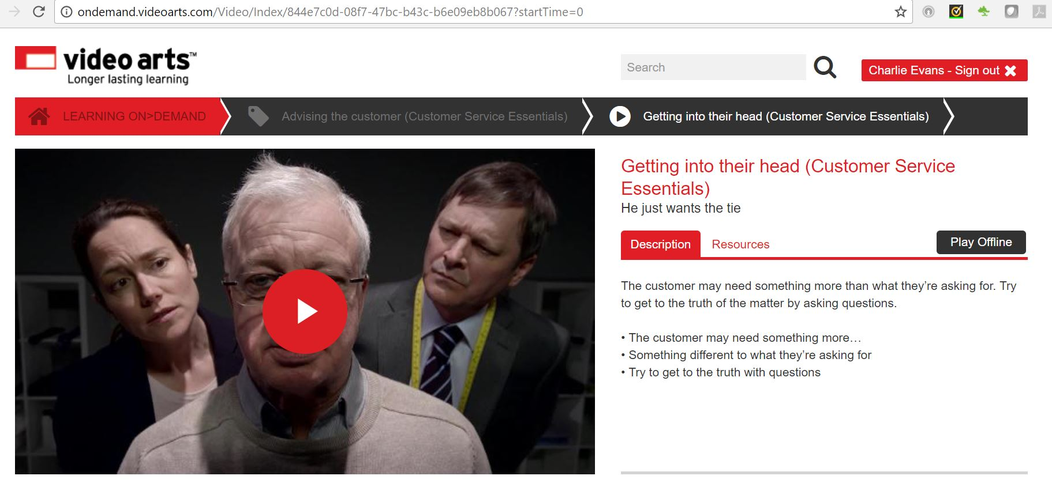

**What do customers expect?**

how_customer_expectations_formed_03.jpg

1. **More personalisation -**customers expect a company will put the information and products they want where they expect to find them. Nearly half of consumers will dump their online shopping if they can’t find a quick answer to their questions. Most customers still want a personal one-on-one experience.
2. **More options -**customers want self-service, voice, digital and social means to interact with a company and its people - and they still expect each to deliver a personalised experience.The phone is still the most preferred tool, which makes sense when you consider that talking to a knowledgeable, kind person who is helpful is about as personal as you can get.Still, in the past three years, the use of other channels has risen:
   * Web self-service - 18%
   * Online communities - 39%, and
   * Chat - 43%

While offering as many channels to communicate as customers demand is important, it’s probably more vital that communication is seamless and agile.For example: When customers contact you one way, then choose another to follow up, reps need to know what happened during the previous engagement, what’s pending as a result, and how satisfied the customer currently is. Then they can respond to the follow-up in the most appropriate way.

1. **Constant contact -**the majority of customers don’t find advertising, promotions and “just touching base” as a nuisance. They expect some follow-up efforts to fill in their customer experience. It’s a request that can benefit business as well. Keeping in touch can deflect incoming contacts, which can reduce costs and boost customer satisfaction and revenues. The key is to give them the right amount of information at the right time through the channel they prefer. So before businesses increase (or start) outbound communication, they want to involve customers. That boils down to finding out:
   * What customers want to hear from you
   * When they want to hear from you, and
   * The channel(s) they want you to use
2. **Listen closely,respond quickly -**most customers don’t find your surveys and other requests for feedback annoying (unless, of course, you bombard them constantly). Customers’ biggest expectation in the feedback loop is that companies do something with what they have to say. Companies need to respond to feedback, act on it and let customers know what’s been done to make their experience better based on the data. If not, customers will cease to give feedback.
3. **Front-line staff need more control -**customers’ tolerance for jumping through hoops has diminished dramatically over the years. Customers now believe they should have what they want the minute they request it.

That’s why customers expect front-line service and sales pros to be knowledgeable enough to handle anything - and have the authority to do what needs to be done to satisfy customers. Companies often fail to give reps this authority because all they think about is the small percentage of customers aiming to take advantage of them. But the reality is most customers have good intentions - they just want their issues resolved, problems fixed and questions answered. Those are things nearly any customer service rep or salesperson can handle - if trained properly and empowered.

**Discovering their needs**

**customer_expectations_book2_05.jpg**

Discover the customer’s need. Even they might not be sure what it is. Explore with open questions and discover more about them. Listen and check the facts, you may discover more… and watch out for clues – there might be more services or products you can offer them.

* Explore the request
* Listen and check
* Watch out for clues

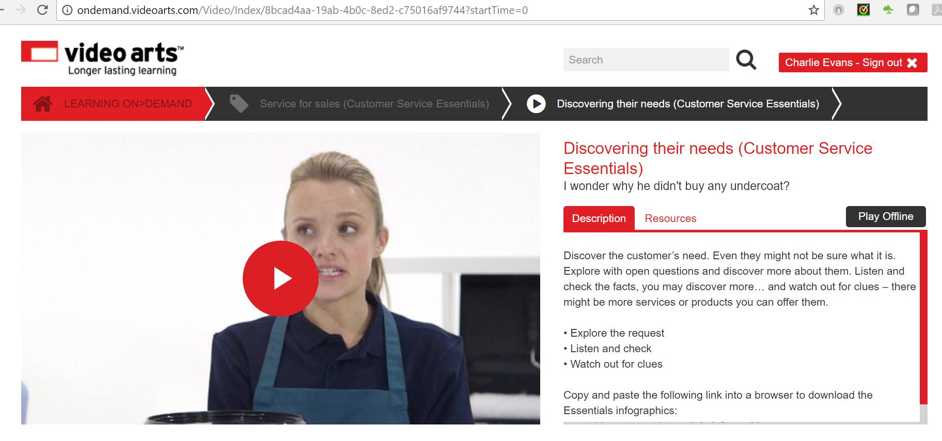

**Finding out what they want**

**customer_expectations_book2_06.jpg**

Customers don’t always know what they want. Whatever service you provide, encourage your customers to open up. Listen to their needs, desires and concerns. Watch this video to learn more.

* Customers don’t always know what they want
* Encourage them to open up
* Listen to them

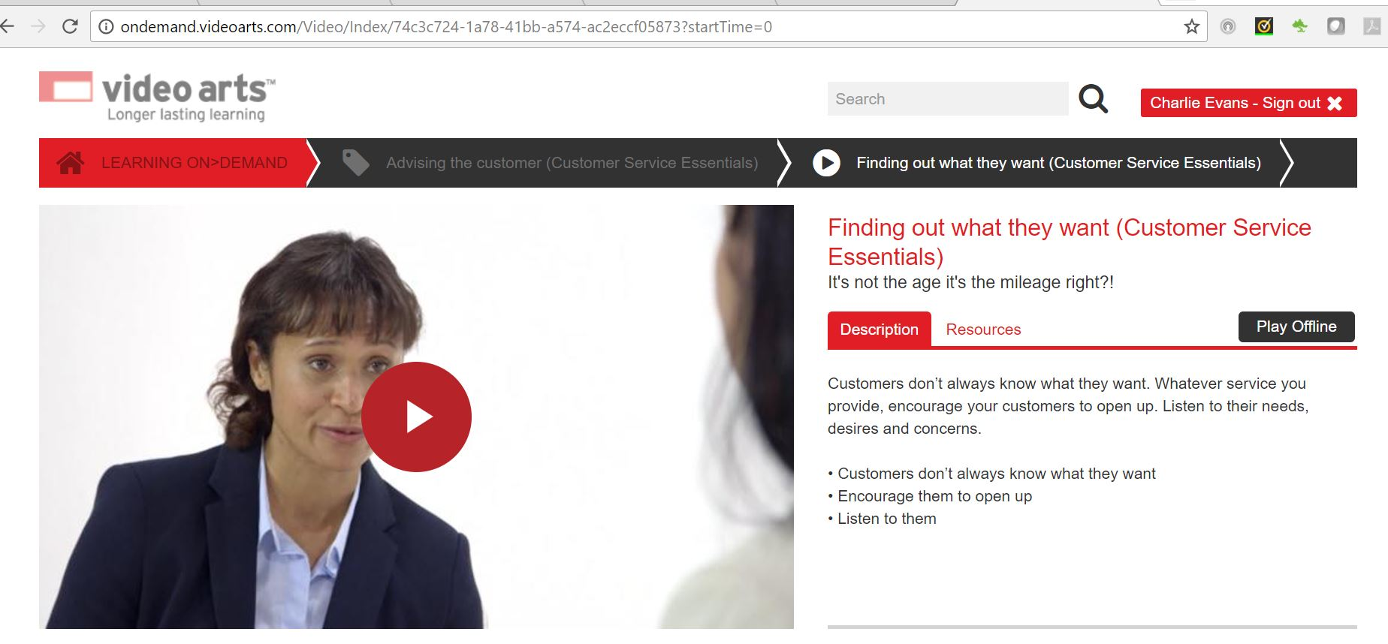

**Balancing the needs and expectations of the customer with those of the organisation**

effective_feedback_08.jpg

Customer service is not just about saying ‘yes’ to customers. It is necessary to balance the needs of the customer and the organisation. Balancing promises is deciding when the promises can be met by the organisation and when it is not viable for the organisation to do what the customer wants, either financially or practically. This may involve you influencing the customer and negotiating with the customer to reach an agreement.

There comes a time when dealing with customers that you may need to decide if you can do what the customer wants, or if it is just not possible – the time when you decide you can do no more and may have to risk losing the customer. Giving in to the customer all the time can ruin an organisation. Think of situations where the customer’s needs cannot be met and why. What might the customer's reaction be?

Customer service equals the entirety of what an organisation does to meet customer expectations and produce customer satisfaction. Customer expectations are what customers think should happen and how they believe they should be treated when asking for or receiving customer service. Customer satisfaction then occurs when a customer is happy with the service provided.

**Changing expectations and cultural factors**

**customer_expectations_book2_08.jpg**

Customers’ expectations may change based on:

* experience - their own or others’
* changing trends

**Cultural factors** can affect customers’ expectations. These include:

* **beliefs** - can be opinions, politics or principles. For example, it may be that customers expect to be addressed in a more formal way, rather than by their first name
* **moral values** - one example is where a customer believes a certain mode of dress should be worn by those who serve them and it should not be too revealing. Another is where a customer feels that goods should not be promoted in a certain way. Equally, customers may dress in a certain way and in turn will not expect to be stared at or treated differently because of it
* **laws and rules of behaviour** mean that in any country there is legislation that restricts the goods that can be sold and the way they can be sold, or that people are required to behave within the law. However, this can vary between countries and so customers may have little understanding of legislation within another country
* **use of language** will vary between countries and often between local areas. A word in one place may mean one thing and something else elsewhere. Also some language used can be seen as normal by some but offensive or ‘slang’ by others
* **traditions**can cover a wide range of things: for example, something as simple as habit, where a customer has used the organisation for years and so has been used to a certain level of service or a certain practice being carried out. Or it could be that they are used to certain customs or conventions being applied which can vary from country to country
* social standing
* **use of body language** can vary from country to country: for example in some countries people do not like you to stand too close

Cultural factors can also include religious beliefs and even family beliefs.

Customers are all different and this needs to be respected. They may act in a certain way, or have certain expectations and while your practice may not require change to suit them, you do have to understand everyone is different and take account of these differences.

**Preparatory activities**

**Question 1**

Using [this worksheet](https://content.cgkpivot.com/documents/Customer_Types_Needs_and_Expectations.pdf), identify the needs and expectations of customer types listed in the table, and explain how you would adapt your service to meet them. Download the worksheet, select 'save as' and rename the document to ensure that your work is saved. Once you have completed the worksheet please upload it below.

**Question 2**

Why is building good customer relations important to your organisation? What would be the consequences of getting this wrong?

**Question 3**

Why is it important to balance the needs of an organisation and its customers?

**Next steps**

Now you have completed this section select **SUBMIT TASK FOR REVIEW** and your Assessor will review and give you feedback. If you have any questions, please contact your Assessor via the messages function.

Task 3 Understanding customer expectations

**Introduction**

meeting_customer_needs_expectations_01_a.jpg

To complete this task you will be looking at your own expectations as a customer of other organisations. You will also consider your role in the meeting the expectations of customers within your own organisation.

When completing this task, you will:

* name an organisation you have high expectations of
* name an organisation you have low expectations of
* consider how these expectations might be changed

**Task 3**

In this task you will consider your role in meeting the expectations of your organisation's customers. As part of this task you will be demonstrating the following skills, knowledge or behaviours:

|  |
| --- |
| **Knowledge:** |
| By completing this task you should be able to:   * explain the difference between internal and external customers in the context of your organisation * describe the specific needs of different customers * explain when and how to adapt service approach to meet the needs and expectations of customers |
| **Skills:** |
| By completing this task you should demonstrate personal organisation skills in managing your workload and planning the completion of this task to meet your deadlines. |
| **Behaviours:** |
| By completing this task you should be working towards showing you can recognise customer needs and expectations, as well as knowing how to use this information to treat customers as individuals and provide a personalised experience. |

### Distinction

As part of working towards **distinction** level, the Customer Service Practitioner standards require you to be able to explain the:

* importance of building good customer relationships to the organisation
* difference in the way internal and external customer relationships are managed

i**Knowledge application**

**Question 1**

List **one**internal customer and **two**external customers of your organisation that you have experience of dealing with. Explain how their needs and expectations differed.

**Question 2**

How does your management of external customer relationships differ from your management of internal customer relationships?

**Question 3**

Identify the different types of customers you deal with in your customer service role and for each one you identify consider how their needs and priorities differ.

**Question 4**

Explain the expectations your customers have when they first come into contact with your organisation. What is your role in ensuring these expectations are met? Explain any company procedures you may have to follow. For example, observing data protection laws etc.

**Question 5**

Think about a time you had a really great experience as a customer. Describe all the factors that made it such a good experience. Think about the organisation's representative and discuss:

* the communication they used
* what knowledge they demonstrated
* which behaviours they demonstrated
* which skills they demonstrated

**Question 6**

What do you think it would take for you to **lower** your expectations of the organisation you discussed in the previous question? Consider whether one bad experience would be enough, or whether you would overlook their failures because of your previous experiences.

**Question 7**

Think about a time you had a really terrible experience as a customer. Describe all the factors that made it such a bad experience. Think about the organisation's representative and discuss:

* the communication they used
* what knowledge they failed to demonstrate
* which behaviours they failed to demonstrate
* which skills they failed to demonstrate

**Question 8**

What do you think it would take for you to **raise** your expectations of the organisation you discussed in the previous question? Consider whether one good experience would be enough, or whether it would take a lot more to change your mind because of your previous experiences.

**Question 9**

Using your examples of good and bad customer experiences, work out and write down a series of rules you could follow to ensure you meet customer expectations.

**Next steps**

Now you have completed this section select **SUBMIT TASK FOR REVIEW** and your Assessor will review and give you feedback. If you have any questions, please contact your Assessor via the messages function.

* tance of balancing the needs of both the organisation and its customers

Personal development planning

**Introduction**

creating_effective_personal_01_a.jpg

Personal development planning is a process you can use to develop yourself and your career.

Improving performance in a business environment can, for example:

* **increase your knowledge, skills and experience**
* **assist you with career development** – increasing the chances of promotion and other employment
* **help to motivate you** – aiming for career goals can make the job more interesting and challenging
* **develop a higher level of skills, knowledge and experience for the whole team** – improving the organisation’s chances to be competitive and preserve or improve jobs
* **lead to increased flexibility** – well-trained staff can be moved around to perform a wider variety of tasks; individuals benefit from greater choices of jobs and tasks

**Purpose of personal development planning**

personal_development_planning_01_b.jpg

At the heart of the process, there are three questions:

**1. Where am I now?**

To answer this question, you need to have a look at your current situation – e.g. your skills, knowledge and experience; qualifications; job description and tasks; salary package; grade or position at work.

**2. Where do I want or need to be?**

To answer this question, you need to decide where you would like to be in the future. This can be looking ahead six months, a year, five years or a period that is relevant to us. You need to think about your goals, and the things you want or need to achieve – e.g. a higher salary; promotion to the next level; having increased knowledge and skills in specific areas at work; more job satisfaction; better job security; a better range of employment options.

**3. How will I get there?**

This is where the practical details of your plan start to come together and you find learning activities and other ways to improve yourself and your performance at work – e.g. ask for a career appraisal with a manager; take various courses; do voluntary work to gain extra experience; offer to learn new tasks at work; shadow experienced colleagues to learn new skills; discuss the best training options with managers, colleges or other training providers.

During the process, you focus on your personal goals and set targets that are specific to you and your needs. You prepare a personal development plan (PDP) to bring all of this together and record progress. By following a structured process, chances of success are increased, and you can have a permanent record to show your progress, achievements, problems and ideas. These are useful for to review and show others who are involved in your career development, promotion plans or training programmes.

**Key stages in development planning**

personal_development_planning_01_c.jpg

There are several stages to go through to plan personal career development and focus on our three questions. We need to:

* analyse current skills, knowledge and experience – to identify skills gaps and where we are now
* identify development needs and set objectives – to focus on where we need to be
* identify learning styles
* arrange resources and support mechanisms to meet the objectives – the basis of how we are going to achieve our goals
* monitor and review progress and overcome barriers to learning – to make sure we are still going the right way

Select the book below to learn more.

Key stages in development planning

**Analyse current skills, knowledge and experience**

key_stages_01.jpg

When indviduals identify professional development needs for themselves, they need to carry out a learning needs analysis. This can be done by preparing, for example, a **skills audit**.

Performing a skills audit is a simple process to identify strengths and weaknesses. A list is made of the skills that are relevant to the role, and ability is assessed. Some organisations add an extra column to show the actions to be taken.

Customer service practitioners need a wide range of skills and knowledge that are needed to be able to perform functions effectively. Although performing a skills audit is a relatively simple process, it can cover many aspects of a role and needs to be organised in a logical manner, to make it accessible and useful.

As there can be so many skills and factors to evaluate, it can help to have a graded scale to rate current ability – e.g. 1 = excellent, 5 = poor. The rating can be from self-evaluation or be done with someone else, such as the line manager.

When deciding which skills to audit, the details can be taken from a variety of sources – e.g. the organisation’s own policies, procedures and standards; national occupational standards; essential standards; professional bodies’ standards; qualification specifications from awarding bodies; job descriptions.

Here are a couple of samples of skills audits:

|  |  |  |
| --- | --- | --- |
| **Skills required** | **Current ability rating (scale of 1–5)** | **Action to be taken** |
| Computing skills | 4 | To further learn and undertake short courses (if possible) to enhance computing skills |
| Leadership skills | 4 | To get more involved in communities/societies |
| Numeracy skills | 4 | To discuss with lecturers and fellow students on ways to improve |
| Revision and exam techniques | 3 | To learn from lecturers and fellow students on techniques to revise and answer exam questions as the method here is slightly different compared to Malaysia |
| Time management and organisation skills | 2 | To jot down all activities that needs to be done accordingly in a diary |
| Oral presentation skills | 4 | Learn to fully utilise and use other presentation aids that are available besides PowerPoint |
| Critical analysis and logical argument skills | 3 | To get more involved in group discussions |
| Selecting and prioritising information when reading | 3 | Listen to lectures and identify which are the important points |
| Referencing skills | 3 | To write more essays and get used to the Harvard referencing style |
| Summarising skills | 4 | Need to fully understand the topic |
| Developing appropriate written style | 3 | Read more articles and journals to get used to the writing style so that it can be implemented |
| Search skills (library and e-resources) | 3 | Fully utilise the libraries ‘resources and support’ section in SUSSED |
| Utilising and comprehension | 5 | Listen more to the way people converse with each other and try and pick up whatever necessary |
| Proofreading and editing | 3 | To take another look at the work |

|  |  |  |  |  |  |
| --- | --- | --- | --- | --- | --- |
| **Personal Audit Questionnaire** | **1** | **2** | **3** | **4** | **5** |
| 1) I lack confidence in expressing my needs |  |  | X | X |  |
| 2) I mange time effectively |  |  | X | X |  |
| 3) I am not confident to lead |  |  | X |  |  |
| 4) I cope with stress well |  |  |  | X |  |
| 5) I manage a number of tasks well |  |  | X | X |  |
| 6) I do not have confidence to give presentations |  |  |  | X |  |
| 7) I am patient when imparting skills and knowledge to others |  |  | X | X |  |
| 8) I do not have confidence to influence others |  | X | X |  |  |
| 9) I motivate people to perform |  |  | X | X |  |
| 10) I do not direct people to do tasks |  |  |  | X |  |

**Identify development needs and set objectives**

key_stages_02.jpg

The skills audit will help to analyse the current position – where I am now – and reveal areas that are strong and those that need attention. These can be entered on the PDP, so that you can see our strengths and skills gaps, then start to decide what you need or want to consolidate or improve.

Having analysed where we are now, we can work out where we want to be, then set personal objectives to plan how to improve our performance at work. When setting personal work objectives, it is important to have a realistic number of goals. If overloaded, you will feel overwhelmed and are more likely to fail, give up and lose confidence. Honesty about achievements and expectations is important.

It can be useful to support this process with personal reflection and discussions with senior colleagues, maybe during the appraisal process. Once you have established your needs, you can set objectives that support our strengths, address your weaknesses and help you improve your performance.

**SWOT analysis**

different_problem_01.jpg

As well as doing a skills audit and reflecting on our choices, you can also do a **SWOT**analysis to focus your attention:

**S**       Strengths

**W**      Weaknesses

**O**       Opportunities for improvement

**T**       Threats to such progress – things that may stop progress

A SWOT analysis examines the current situation, gives details about the goals, and highlights potential problems that may get in the way of progress.

|  |  |  |
| --- | --- | --- |
| S | Strengths | What are my strengths? What am I good at already? What qualifications do I have? What have I achieved already? What do people praise? When do I get positive feedback? |
| W | Weaknesses | What areas of weakness do I have? What mistakes did I make, or nearly make? What are the gaps in my skills, knowledge, understanding and experience? |
| O | Opportunities for improvement | How can I improve? What training can I do to improve? What support do I need? Which work opportunities can I find that will help me to develop? |
| T | Threats to such progress | What might stop me? Finance? Time? Support from others? Lack of information? What can I do to minimise these potential problems? |

A SWOT analysis examines the current situation, gives details about the goals, and highlights potential problems that may get in the way of progress.

SWOT.png

**SMART objectives**

performance_standards_03.jpg

Once areas for personal development have been identified, it is important to set targets. By having your goals and objectives clearly in mind, there is a much greater chance of success. One good way to set goals is to use **SMART objectives**:

**S       Specific** – details about what exactly needs to be achieved

**M      Measurable** – this could be the number of units to be covered, or the time limit

**A       Achievable** – the task needs to be possible for the individual

**R       Realistic** – the target and limits set need to be realistic

**T       Time-bound** – the deadline for achieving the target or completing the task

|  |  |  |
| --- | --- | --- |
| S | Specific | What are the details of the learning activity, task or training course that I want to do? What qualifications do I need for that promotion? Which job am I aiming for? |
| M | Measurable | Is there a certificate or report that can show my progress? Can I count the number of units I am covering so that I can see my progress? |
| A | Achievable | Can I do it? What support do I need to find to make sure that I can achieve these goals? |
| R | Realistic | Is it realistic to do the training or tasks in the time that is allowed? Is it realistic to work full time and do all of this study quickly, or do I need to study over a longer period of time? |
| T | Time- Bound | What are the deadlines? Do I need to have completed this task before my tutor comes next time, or in time for my annual review? |

**Identify learning styles**

key_stages_05.jpg

Once objectives have been set and agreed, it helps to be aware of different learning styles so that you can focus on the most suitable learning activities.

We all have our preferred learning styles that we use to develop our skills, experience and knowledge. Some people like to learn by reading about things, others need to see a demonstration to understand something, and others need to try the activity themselves before they remember everything.

There are many theories about learning styles, and here are some brief details about one of the most commonly used theories – **VARK – Visual,  Auditory, Reading/writing, Kinaesthetic**.

People have favourite ways of learning and training needs to be adapted to accommodate these preferences where possible. These four styles are:

* **Visual** – seeing and reading – e.g. watching a training video, reading instructions, using graphs and tables about giving a training presentation
* **Reading/writing** – e.g. reading instructions and writing personal notes
* **Auditory** – listening and speaking – e.g. being told how to give a training presentation
* **Kinaesthetic**– touching and doing – e.g. physically preparing and delivering a training presentation under supervision

According to this model, people have a dominant or preferred learning style. A visual learner will learn about a subject by watching and reading about it. Just being told about what to do will not register. Touching and doing the new activity will help to reinforce the learning at a basic level, but they will need to observe and read up on the details.

A visual learner will learn about a subject by looking at graphs, pictures and diagrams, or watching videos or demonstrations. Just being told about what to do will not register. Touching and doing the new activity will help to reinforce the learning at a basic level, but they will need to observe and read up on the details.

A reading/writing learner will learn best from reading instructions, research and information about the subject, and writing notes to help them remember important details.

An auditory learner will absorb the information by listening to their tutor or colleague, asking questions, then listening carefully to the answers.

A kinaesthetic learner needs to touch and do the activity. They may absorb a reasonable amount of information from listening to the tutor or watching a demonstration, but they will not truly understand the subject or activity until they do it for themselves.

**Arrange resources and support mechanisms to meet the objectives**

key_stages_06.jpg

Resources and support mechanisms that suit your needs, objectives, circumstances and organisation need to be arranged. These include, for example:

* development activities
* support mechanisms
* time and money

Personal **development activities** can be based on training or work-based experience. They can also be based on things that are done outside the workplace that develop skills that are used in the workplace. Generally speaking, development activities can include:

* completing training courses – e.g. in the workplace, via distance learning or from local training providers
* working in new areas within the organisation – e.g. in different departments or by doing simulation exercises
* taking on new challenges and responsibilities at work – preferably whilst being supported
* attending meetings, seminars, and conferences that are not within the normal remit of responsibility
* charity work – e.g. a finance department manager working in a charity shop to develop customer service skills
* working as a volunteer in a different work sector – e.g. a catering manager volunteering to work in a hospice to improve communication skills
* studying the organisation’s policies, procedures, operations and training materials to a deeper level
* doing independent research to develop knowledge

It is worth being imaginative and making good use of the resources and networks of support that are available. Taking part in development activities outside the normal routine of work can be very stimulating, satisfying, rewarding and revealing, taking you into sectors and environments that you would not normally consider. You can be challenged to develop skills that you would not need or use for your current ‘day job’ that may become useful in the future.

The **support mechanisms** that people need will vary, but it is important to plan them in advance wherever possible, Support can come from, for example:

* your line manager – e.g. to arrange access to new experiences; to give permission for study time in work hours; to act as a mentor or coach
* your organisation's HR and training departments – e.g. to help with access to courses; to access advice or counselling if there is a problem
* an outside training provider – e.g. allocating a course tutor or assessor to guide through a training programme
* colleagues – e.g. to help with developmental activities or provide cover during study periods
* family and friends – e.g. to give support at home during intense periods of study

It is also important to organise time and money before starting on a major programme of career development. Time management is critical and deadlines need to be managed, so that ordinary activities can continue and still be productive. Finances may also need attention and preparation – e.g. to pay for fees yourself; to apply for funding via an employer; to arrange for funding via a training provider such as a university or college; to replace income if you have to work part time for a while.

**Monitor progress and overcome barriers to learning**

key_stages_07.jpg

SMART targets help us to monitor progress against the objectives mapped out in the PDP.

Progress needs to be monitored so that you can, for example:

* assess progress against **specific** targets – to **measure** development – e.g. looking at dates for handing in assignments and seeing if they are on time
* adjust elements of objectives – to keep them **achievable** and **realistic** – e.g. changing timescales following illness
* allocate or seek additional resources – e.g. arranging for one-to-one tuition to learn a language needed for work on **time** for a newly signed project
* agree further development activities – e.g. work tasks have been done early and there is scope to help out in a different department for a few days

The PDP needs to be monitored regularly to keep things on track so that problems do not get out of hand. If everything is going well, the positive feedback will be a boost and help to motivate you to carry on. If there are problems, it is vital to catch them early so that they can be dealt with quickly and keep the rest of the PDP intact.

Monitoring can be quite informal because it is really keeping an eye on the smaller elements and details of the PDP.

There can be **barriers to learning** that can stop people engaging in learning and career development activities. You need to identify potential barriers, or threats to progress, and do what you can to mitigate these.

Potential barriers to learning, and some suggested ways to overcome these barriers, include, for example:

|  |  |
| --- | --- |
| **Potential barrier to learning:** | **Suggested ways to overcome the barrier:** |
| Lack of time | Work out exactly how much time will be needed and agree realistic goals  Discuss doing some study during working hours  Arrange cover when the individual is in college or doing internal courses  Create development activities that can be done on the job during normal hours  Arrange to do part-time courses over a longer period |
| Lack of confidence | Have one-to-one meetings with a mentor or coach (maybe the line manager) to identify the causes of lack of confidence  Seek positive feedback to reinforce the positive aspects of performance, skills etc.  Find small learning and development activities to build confidence – e.g. several short courses and seminars rather than a 9-month diploma course |
| Fear about standing out from colleagues | Use positive feedback to reinforce the positive aspects of performance, skills etc.  Check how well performance measures up against the organisation’s standards and expectations  Encourage team spirit and mutual support between individual team members  Watch for any bullying or harassment from other team members – act as required |
| Worrying about being overworked or overloaded | Develop time management skills  Examine the current and expected workload and check timescales that are realistic  Make sure that the workload is fair and arrange for extra assistance or cover from others if necessary  Do not worry if it is necessary to step back and take a break |
| Learning styles are incompatible | Consider changing the development activities – e.g. introduce new activities; appoint different tutors; use different formats to appeal to different learning styles  Make sure that the content is relevant to the individual and the organisation |
| Fear of change – e.g. in technology | Review the benefits of change, job security, the future of the company etc.  Find out about all aspects of the plans for change  Ask to be kept informed, and keep others informed  Have one-to-one discussions with the mentor/coach/line manager to identify causes of fear and ask for appropriate reassurance and support |

**Identifying personal and professional development requirements**

Watch this ILM video on Identifying Personal and Professional Development Requirements:

<https://www.youtube.com/embed/LO3tOY6xpso>

**Preparing a personal development plan (PDP)**

creating_effective_personal_01_b.jpg

A PDP is a document that is based on awareness, values, reflection, goal-setting and planning for personal development. This can be at work, in education or in the context of self-improvement. Employees who are taking part in business training are often asked to complete a PDP.

Select the book below to learn more.

Preparing a personal development plan (PDP)

**Personal development plans**

preparing_personal_01.jpg

In essence, a PDP tracks past performance, analyses the current situation and performance, and sets out learning objectives. The PDP can also contain SWOT analyses, SMART objectives and other action plans about how to develop skills, knowledge, understanding and experience in the future.

A PDP can also be called an Individual Development Plan, and some organisations will have their own versions.

When preparing a PDP, you need to remember to have:

* **clear SMART objectives** – Specific, Measureable, Achievable, Realistic and Time-bound
* **resource requirements** – e.g. learning activities, training materials or courses
* **timescales and finances** – e.g. work and study deadlines or course fees
* **support mechanisms** – e.g. line manager, course tutor, workplace mentor or coach

**Sample personal development plan**

Here is an example of a PDP for Alex Smith, a customer services senior supervisor:

|  |  |
| --- | --- |
| **Personal development plan** | |
| **Name:** Alex Smith | **Job title:** Customer service senior supervisor (1 of 3) |
| **Relevant professional and vocational qualifications:**  A level business studies, GCSE economics  Qualified first-aider  PTTLS (training qualification), qualified H&S induction trainer  Level 2 team leading  Level 2 customer service  Level 3 diploma in management (part of the way through) | |
| **Date:** 1 April 2017 | |

**Part 1 – personal analysis**

|  |  |
| --- | --- |
| **Strengths** | **Weaknesse** |
| Good listener, good communicator with team & customers  Organised & able to meet deadlines  Planning and allocation of tasks  Training – new and established team members  Coordinating & planning resources needed by team  Confident following recruitment process  Dealing with customer complaints (when team members need to escalate) | Can get distracted by interruptions – e.g. colleagues wanting something  Don’t enjoy repetitive routine  Get frustrated when people waste my time  Feel that team members take advantage of me sometimes  Spending too much of my free time doing work jobs to catch up – e.g. emails and reports for 1- 2 hours each evening at home |
| **Opportunities** | **Threats to progress** |
| This is a good role to show my ability to work under pressure, solve problems and make decisions  Can demonstrate a good range of management and leadership skills  Team has 30 members now (24 last year), further 10-15 to be recruited and trained at end of 2015 – good opportunity to develop my M&L skills further, especially strategy and planning  Can consolidate current role and skills, and start to think about going for promotion next year  I can ask for coaching and mentoring from line manager  My annual appraisal will give focus and be a source of guaranteed feedback | Time management skills  Work-life balance |

**Part 2 – setting objectives**

|  |  |  |  |  |
| --- | --- | --- | --- | --- |
| **Objective** | **Action** | **Resources and support mechanisms** | **How to measure success** | **Timescale and review dates** |
| Finish L2 apprenticeship in Customer Service Practitioner | 5 more units to go – complete one per week | Approx 70 hours of study needed to finish – plus review time  Computer and Internet access  Ask course tutor for extra feedback and support if necessary | Finish each assessment  Tutor feedback – work on weak areas & resubmit if necessary  L3 awarded | 10 study hours per possible – so end of May, mid-June at the latest  Course tutor review booked next week |
| Improve my time management | Arrange coaching and self-study | Next unit on L2 course covers this  Ask line manager for coaching afterwards if needed | Less chaotic diary  Reduction in stress  Less work at home in the evenings | Next L2 unit will be done by mid-April  Review & ask for coaching if needed end June |
| Maintain my motivation, enthusiasm and energy | Find ways to avoid too much repetitive work – e.g. delegate some tasks once they are established  Set new goals every so often  Discuss with line manager | Good team members  Time  Discussion time with line manager | Job satisfaction will be maintained  Feedback from manager will help me to focus | Ask for extra appraisal review end July (approx. a month after L2 study has finished) |

**Part 3 – personal objectives**

|  |
| --- |
| **Short-term goals (next 3 months)** |
| Finish L2 Customer Service Practitioner  Start to prepare for having larger team  Improve time management and stop working at home so much |
| **Medium-term goals (next 12 months)** |
| Consolidate current role this year and develop management skills with the larger team  Start to discuss and plan promotion opportunities for next year |
| **Long-term goals (beyond 12 months)** |
| Promotion to customer services leader  Do a level 3 course – check funding nearer the time |

Watch this ILM video “Fulfil a PDP”:

<https://www.youtube.com/embed/j1NCUp7-m1Y>

**Preparatory activities**

**Question 1**

What is meant by 'SMART' objectives? Explain each part of the acronym and what it means below:

**Question 2**

Research the types of headings that are often found on a Personal Development Plan. Make a list of the most frequently occurring headings and explain what they cover.

**Question 3**

List the training resources available to you in your organisation.

**Question 4**

Research the types of things that are normally included as part of a Learning Log. Make a list of the most frequently occurring areas and explain what they are.

**Question 5**

Consider who can help you to identify your learning and development goals. Give at **least two** examples and explain what they can do to help.

**Next steps**

Now you have completed this section select **SUBMIT TASK FOR REVIEW** and your Assessor will review and give you feedback. If you have any questions, please contact your Assessor via the messages function.

Task 4 Creating a personal development plan

**Introduction**

unit_2_provide_solutions_business_01_a.jpg

To complete this task you will need to create a Personal Development Plan that will cover the period of time you are completing your programme. As part of this you will need to describe your position within your team and what your individual targets and goals will be as part of your role.

When completing this task, you will need to:

* make a list of the responsibilities you have in your customer service role
* explain how your actions impact on others in your organisation
* complete a Personal Development Plan, including quarterly reviews on your progress against the objectives you identify
* complete a learning log covering the period of your programme, updating this as you progress

**Task 4**

In this task you will be looking at how you need to develop over the course of your programme to deliver the best customer service you can. As part of this task you will be demonstrating the following skills, knowledge or behaviours:

|  |
| --- |
| **Knowledge:** |
| By completing this task you should be able to:   * explain how the actions taken in the context of your job role and responsibilities impact on others in your organisation * describe how to achieve your agreed targets and goals |
| **Skills:** |
| By completing this task you should demonstrate personal organisation skills in organising your workload and prioritising tasks to meet deadlines. You should also be demonstrating that you can agree goals and deadlines, using tools and techniques to monitor your progress. |
| **Behaviours:** |
| By completing this task you should be able to show that you can:   * conduct a self-assessment to identify your strengths and weaknesses in relation to your job role * produce a Personal Development Plan to support the achievement of your agreed learning and development goals |

### Distinction

As part of working towards **distinction** level, the Customer Service Practitioner standards require you to be able to:

* review the effectiveness of your Personal Development Plan and update it over the course of your programme

**Knowledge application**

**Question 1**

List your job targets and goals:

**Question 2**

Discuss with your employer how your targets and goals can be achieved. Think about recording this conversation for evidencing and to refer to later. Summarise the key points of your discussion below.

**Question 3**

Explain how you will recognise when your goals have been met.

**Question 4**

Upload a copy of your role profile to help with your Personal Development Plan. Use the profile to list your responsibilities in relation to your customer service role:

**Question 5**

Explain how the actions you perform as part of your role impact on others, both in your organisation and outside it. Give examples where possible.

**Question 6**

Explain what the impact would be if you did not perform your work activities correctly.

**Question 7**

Use your job profile to work out the skills you need to perform your role correctly. Identify which skills you are already good at and which skills you need to improve on. Outline your strengths and weaknesses:

**Question 8**

Sit with your manager or mentor and create your own Personal Development Plan to cover the period of your programme. Your organisation may have a template for this, but if not, we have provided a [sample template](https://content.cgkpivot.com/documents/Personal_development_plan.pdf). You should list your agreed targets and goals and show how you plan to achieve them.

**Next steps**

Now you have completed this section select **SUBMIT TASK FOR REVIEW** and your Assessor will review and give you feedback. If you have any questions, please contact your Assessor via the messages function.

Professionalism

**Introduction**

personal_responsibility_intermediate_01_a.jpg

Personal and professional presentation is important in providing excellent customer service. Understanding how to make a good first impression and the expected standards of dress and behaviour in your organisation ensure that you are respected professionally. Demonstrating a positive and welcoming attitude to internal and external customers reflects well on you and your organisation.

**First impressions count**

It is important that you appreciate the affect your first impression makes on people who meet you in the workplace. This includes colleagues and customers.

Select the book below to learn more**.**

[Professionalism](https://skills.cgkpivot.com/mod/book/view.php?id=13288)

**1 First Impressions**

time_management_skills_11.jpg

It’s always important to represent your organisation in a positive manner.

What would your impression be of the individuals below?

first%20impressions.PNG

Some key things to remember:

* Appearance
* Tone of voice
* Choice of words
* Posture

**First impression – 7 SECONDS!**

You are evaluated by everyone every day - apparently your first impression is made in only 7 seconds.

* People look at your visual and behavioural appearance from head to toe
* They even listen to your tone of voice
* Demeanour, mannerisms, body language and even grooming are assessed
* You make a lasting impression instantly
* You may impress some and disenchant others

**2 Behaviour breeds behaviour**

**professionalism_book1_02.jpg**

People mirror the behaviour of others. Your behaviour will affect how others behave, for good or bad, so be aware of what you’re doing and how you’re doing it.

* People mirror the behaviour of others
* Positive behaviour elicits a positive response

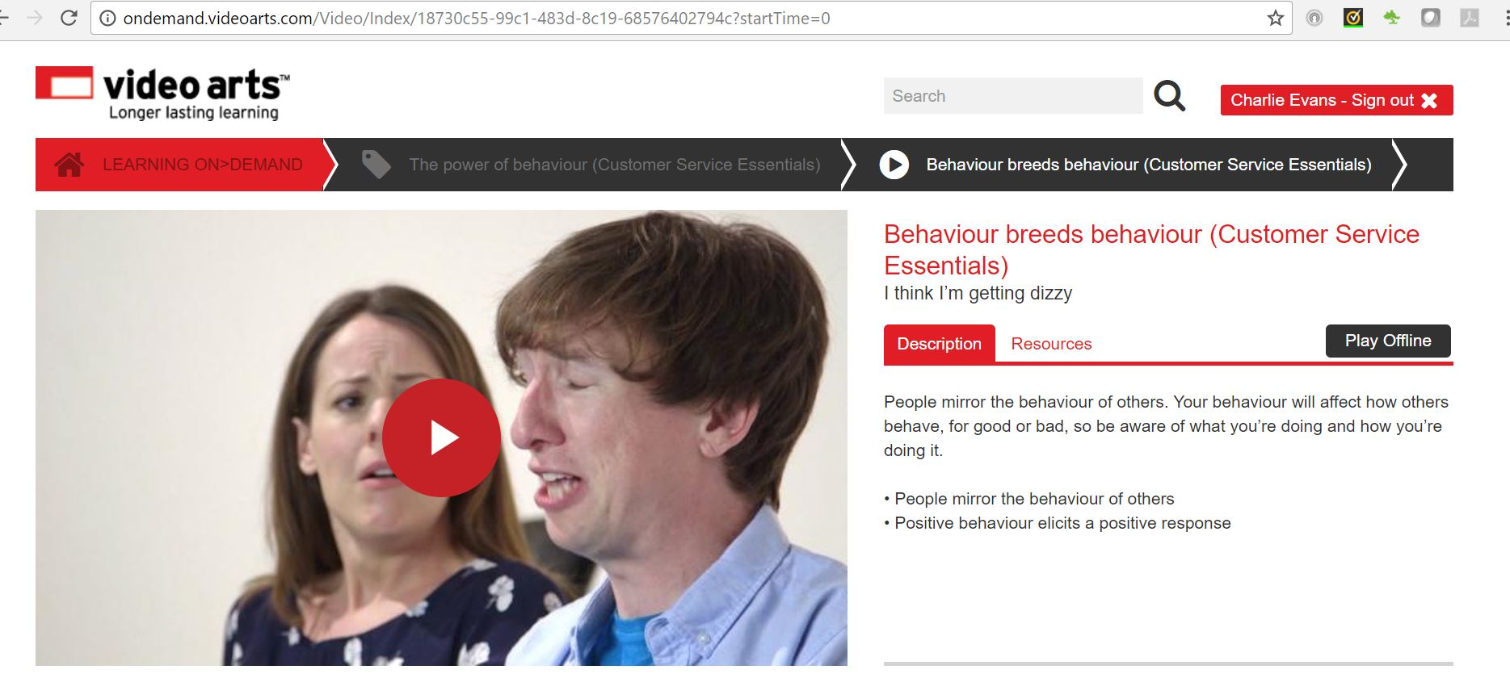

**3 Choosing your behaviour**

Behaviour is variable. Choosing the right kind at the moment of truth is critical. It isn’t difficult, it’s about awareness and discipline.

* Behaviour isn’t fixed, it’s a variable
* Choosing the right behaviour at the moment of truth is critical
* It isn’t particularly difficult to do
* It’s about awareness and discipline

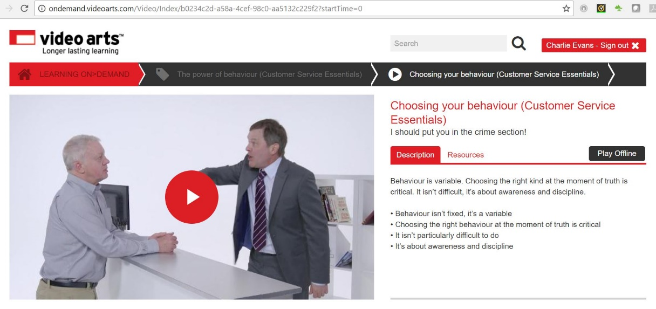

**4 Behaviour can help or hinder**

Your behaviour can help or hinder a transaction. Think about your verbal behaviour: don’t dominate conversation, or bully, and listen actively. Think about your visual behaviour: is your body language open and personable? Keep these two things in check for smoother, more pleasant transactions.

* Your behaviour can be a help or a hinderance
* Behaviour can be expressed visually or verbally

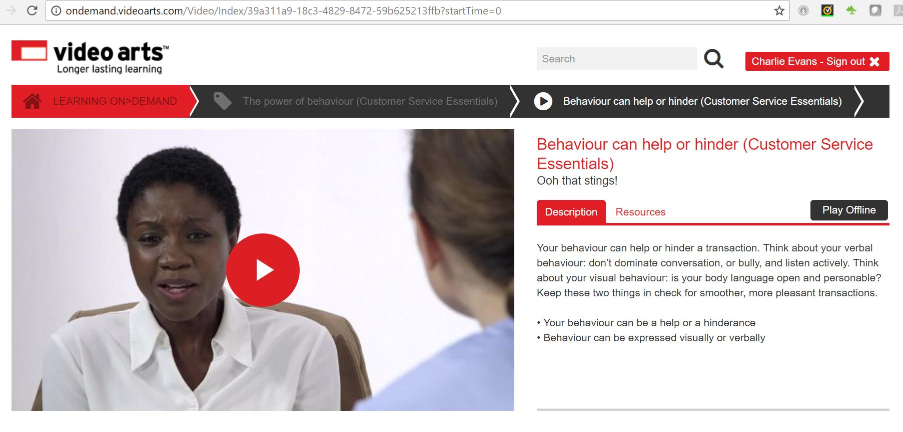

5 How behaviour can affect customer expectations

communicate_effectively_01_b.jpg

It is important to understand how behaviour, communication and interpersonal skills affect customer expectations and satisfaction.

When dealing with a range of customers, you will experience behaviours that require you to adapt your own behaviour. For instance, when confronted with:

* Aggressive behaviour
* Confused behaviour
* People who are upset
* Frustrated
* Worried
* People with special needs
* Cultural needs

Producing positive behaviours in turn will encourage a positive attitude and it is important that negative feelings are not displayed. Negative behaviour on your part will affect customer satisfaction and mean the customer's expectations will not be met.

Each customer transaction impacts upon longer term customer service relationships. Misunderstanding behaviour and making assumptions potentially leads to customer dissatisfaction and mixed communication.

Cultural factors can impact significantly on a customer’s expectation of the service you provide.

**6 Dealing with customers**

customer_service_10.jpg

A few points to consider when dealing with customers:

* Treat them with respect
* Honour any commitments
* Remember that you are part of a team even if the person concerned is not part of your immediate team – the organisation is a team
* Deal with requests politely, professionally and willingly
* Poor customer service can affect working relationships

First impressions count. If you get it wrong, you will have a disinterested customer.

Excellent customer service starts with the way you greet customers. It is important to create a good first impression in your approach, communication and professionalism as the customer will form an impression of your organisation based on your performance.

* Greet the customers in a warm and friendly manner but don’t be over-friendly as you need to maintain your professionalism
* Your body language is as important as what you say and do
* Try to look (and feel) approachable and welcoming and then go on to establish what the customers’ needs are

Having the right attitude to achieve customer satisfaction whilst meeting the needs of the organisation, always be professional:

* The way you look
* The way you communicate
* The way you act
* Your knowledge of your products and services

Body language can signal pleasure, anger, frustration or aggression without the service deliverer realising it and can affect the behaviour of the customer who reacts to what they perceive the message to be and vice versa.

This non-verbal communication should not be considered in isolation but should be considered along with the words being used.  Both a service deliverer and customer convey messages through their body language which can impact dramatically on the outcome of the interaction.

**7 Using positive and professional language**

**professionalism_book1_07.jpg**

If you are aiming to promote some of the products and services your organisation has to offer, it is vital that you make sure you keep your customers on side. If you can earn their trust in your skills and professional opinions, you can earn their loyalty and their money.

One of the quickest ways to lose a customer is to speak before thinking.  Saying something that can be construed as offensive by the customer will put barriers between you. Remember that different customers may find different things offensive, some of which may surprise you. We all recognise that bad language and lewd remarks are likely to offend customers, but can you think of other phrases or actions that could cause offence?

Promoting your products and services starts as soon as you meet your customer. The way you greet a customer when you first meet them, or open a call, will go a long way in helping them decide whether to trust you and your organisation. Keep all communication positive and use professional language at all times.

**8 Standards of presentation**

professionalism_02.jpg

In any organisation, there will be standards on how staff should dress. Organisations may issue uniforms that must be worn or expect staff to wear a certain standard of dress.

Uniforms are important and are provided for several reasons:

* to promote a professional image of both staff and the organisation
* to ensure consistency in staff dress
* to let the customer know who the employee is, who they are working for and so who to approach.

Even if a uniform is not offered, organisations will expect staff to wear a certain standard of dress, e.g. a style that reflects the image of the organisation. This often formalised as a **dress code** - a set of rules specifying the correct manner of dress for work, or specifying what is prohibited. In some cases this may be a uniform, but in others it may just be more general guidelines on what is appropriate.

Personal presentation is important as a tidy, well-presented employee is likely to be confident and proud of their work.

You will also be representing your employer and so will be presenting a professional image. You may also be one of the first people the customer sees and so offer the first impression of the organisation, which must of course be a positive one.

Presentation also covers a tidy work area.

|  |  |
| --- | --- |
| **Do** | **Don’t** |
| Neatly trimmed, clean nails  Dark socks  Limited aftershave  Little or no jewellery  Discreet belt  Conservative tie  Clean, smart, professional shoes  White or co-ordinating pale coloured long-sleeve shirt  Light natural-looking make-up  Matched light hosiery  Manicured nails  Solid colour, conservative skirt or trouser suit  Coordinating blouse or skirt  Neat professional hairstyle  Conservative low-heeled shoes  Portfolio or briefcase  Limited perfume  Simple jewellery | Novelty tie  Mobile phone on  Sportswear  Visible tattoos  Novelty socks  Chewing gum  Baseball cap  Personal stereo on  Dirty shoes  Visible body piercing  Jeans  Personal stereo on  Excessive jewellery  Excessive make-up  Visible underwear  Hipster trousers  Low-cut tops  Sandals or dirty shoes |

**9 Employers expectations for employees**

introduction_01_b.jpg

We have established from the previous page that there are always standards of personal presentation.

* Dress code
* Uniform and/or protective clothing
* Grooming
* Personal hygiene

**Here are some common standards of punctuality:**

* On time at the start of the working day
* On time coming back from lunch
* Leave on time
* On time for meetings

**Standards of behaviour in the work place include:**

* Reliable
* Professional
* Respectful of confidentiality
* Team player
* Confident
* Positive approach and body language
* Polite
* Helpful
* Considerate

**Your organisation and industry will have principles of conduct and codes of practice for employees to adhere to, for example**

* Confidentiality procedures – data protection
* Use of company equipment – computers, phones, office supplies
* Sickness reporting procedures – to whom, how often, medical certificates
* Smoking and drinking alcohol at work
* Acceptance of gifts/hospitality – from customers and suppliers

Information about your organisation might come from the company website, annual reports, or company newsletters.

Information about your industry might be available from industry associations, regulatory bodies, or industry publications.

You can obtain information about the role of your own occupation within an organisation and industry, training and career pathways from your job description, the Human Resources department and from training and development policy documents within your organisation.

**10 Organisational commitments to customers**

values_service_culture_book_05.jpg

It should be self-evident that having strong organisational commitment to providing high quality customer service is a key element of organisational success but organisations have to consider how they will demonstrate that commitment. Demonstration relies on everyone in the organisation understanding and living the values of the organisation. Also, it needs to be clear to customers what they can expect in terms of customer service. To achieve this, many organisations have a customer service charter, to promote the customer service standards it applies. The following is an example of a Customer Charter.

**ABC Customer Charter**

**Our Commitment**

We commit to embrace this Charter. However, if we should be deficient in any aspect, you are encouraged to contact us directly, so that the matter may be resolved.

**Relationship**

We will seek your input to the running, development and growth of ABC.

**Accessibility**

We guarantee to be available within normal business hours and respond to all e-mail enquiries within 2 working days.

**Privacy**

We guarantee confidentiality and privacy of any information we obtain from our customers and will not disclose that information to any third party for any purpose without prior consent.

**Service Guarantee**

Our goal is to provide a consistently superior customer experience. We provide a no quibble, money-back guarantee on all our services if we fall short of your expectations and are unable to resolve the matter to your satisfaction.

**Responsiveness**

We will respond to all enquiries in plain English.

**Complaints**

We see complaints as an opportunity improve the service we offer. Consequently, all of our staff are empowered to resolve customer complaints.

**How to contact ABC**

E-mail us at: customer [services@ABC.co.uk](mailto:services@ABC.co.uk)

Make a great first impression, remember your STANCE. Smile, have a friendly Tone, your Appearance is important, as is using the customer’s Name. Always be Customer Focussed and maintain Eye-Contact so they are engaged and feel valued.  
  
STANCE

* Smile
* Tone
* Appearance
* Name
* Customer focussed
* Eye contact

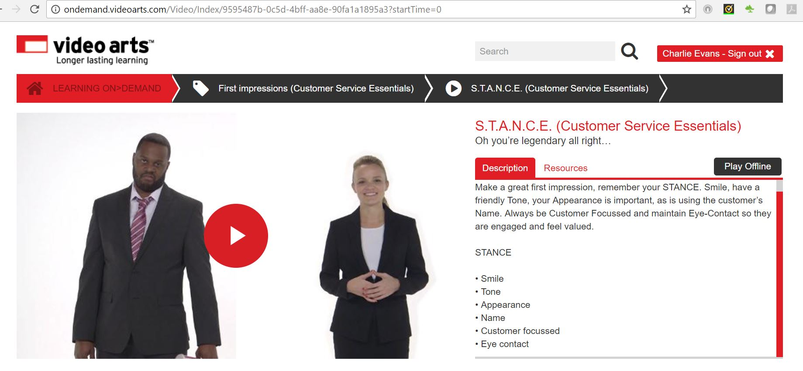

**Dropping your emotional baggage**

You can choose who you want to be at work. Leave your baggage at the door and give yourself a fresh start every day. Don’t let your problems become your customer’s problems or you’ll end up in a negative spiral. Think about enjoying the positivity of helping people.

* You can decide who you want to be at work
* Leave your baggage at the door
* Don’t let your problems become your customer’s problems

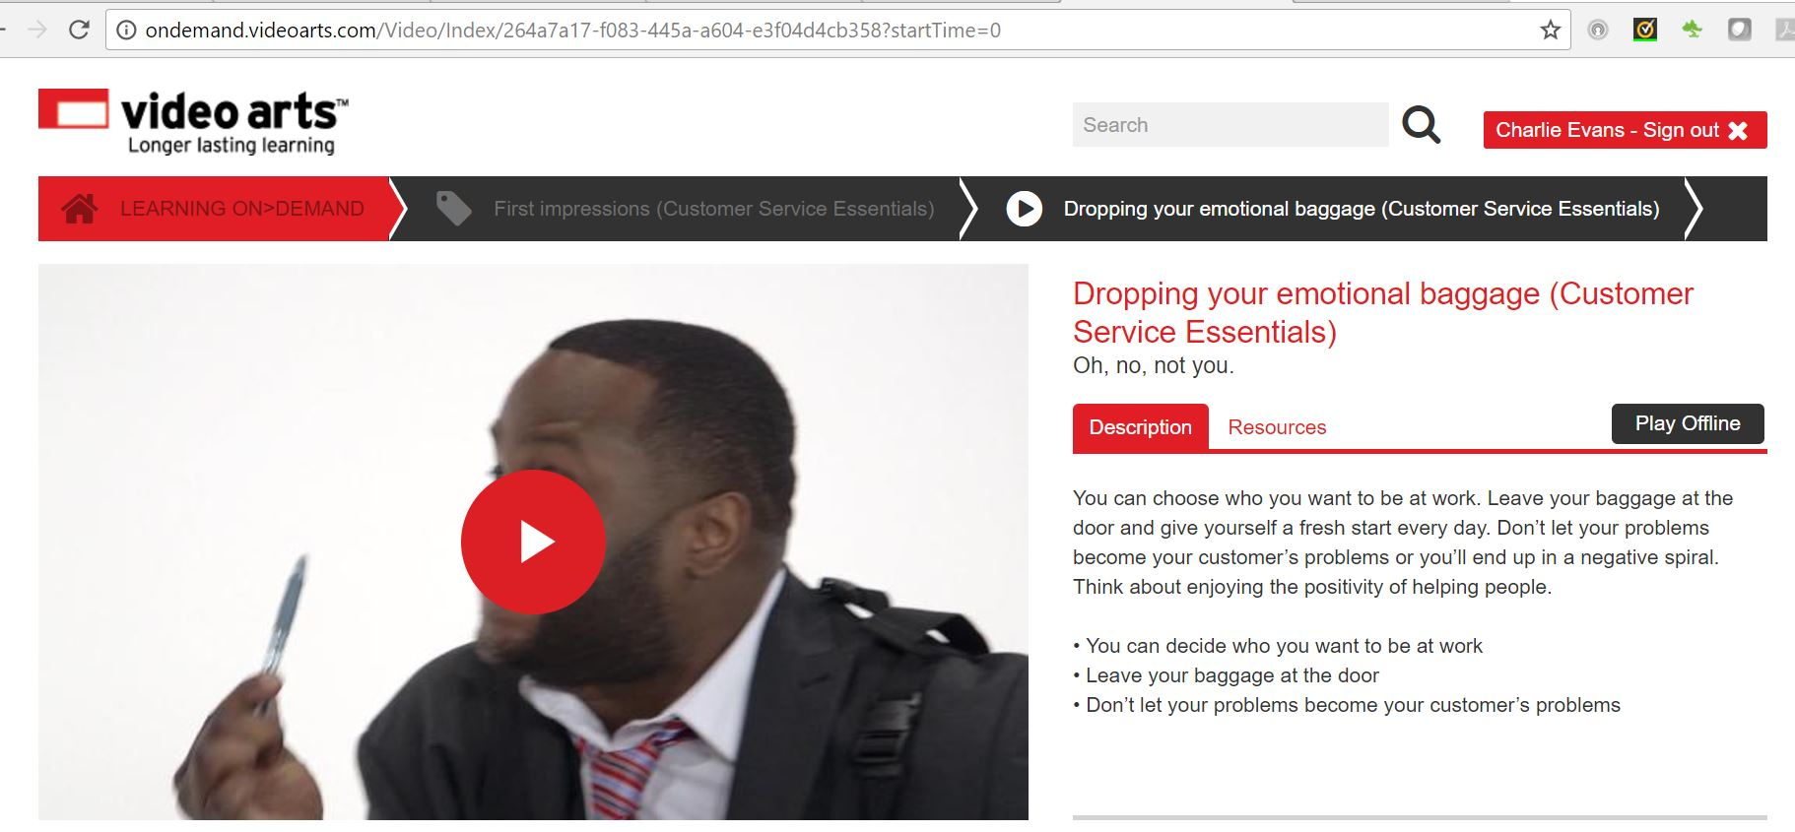

**Preparatory activities**

**Question 1**

What is meant by a dress code and why is it important?

Type your answers in the box below

**Question 2**

When working in customer service, it is important your wear the right clothes for the job. Download and complete [this worksheet](https://content.cgkpivot.com/documents/Presenting_a_professional_image.pdf). Once downloaded select 'save as' and rename the document to ensure your work is saved.

Once you have completed the worksheet please upload it below.

**Question 3**

Explain what is meant by 'codes of conduct', they types of thing they normally cover and why they are important.

Type your answers in the box below

**Question 4**

Come up with a list of the types of behaviour you think would help you model good behaviour and lead by example. For example, being punctual.

Type your answers in the box below

**Question 5**

Download and complete[this table](https://content.cgkpivot.com/documents/Professional_and_positive_language.pdf), ticking to indicate whether the words used are examples of professional and positive language or not. Once downloaded, select 'save as' and rename the document to ensure that your work is saved.

**Question 6**

Give **three** new examples of **unprofessional**and **negative**language:

Type your answers in the box below

1.

2.

3.

**Question 7**

Give **three**new examples of **professional** and **positive** language:

Type your answers in the box below

**Next steps**

Now that you have completed this section, select **SUBMIT TASK FOR REVIEW** below and your Assessor will review and give you feedback. If you have any questions, please contact your Assessor via the messages function.

Task 5 Presenting a professional image

**Introduction**

personal_responsibility_intermediate_01_a

To complete this task you need to consider why your organisation has a certain dress code and the effects of codes of conduct on your organisation's customer service. You will also consider what is meant by professional language, as well as how to demonstrate a positive and welcoming attitude towards customers.

When completing this task, you will:

* describe and explain the importance of your organisation's dress code
* identify how different dress codes are appropriate for different businesses
* list and explain the effects of your organisation's code of conduct
* identify examples of professional and positive language
* complete case studies on how to respond positively to customers
* explain the importance of having a positive and welcoming attitude

**Task 5**

In this task you will be thinking about how what you wear, what you do and what you say affects your ability to deliver good customer service. As part of this task you will be demonstrating the following skills, knowledge or behaviours:

|  |
| --- |
| **Knowledge:** |
| By completing this task you should be working towards a better understanding of how to act, behave and speak at work to remain professional at all times. |
| **Skills:** |
| By completing this task you should be working towards demonstrating you can be professional and use an appropriate 'tone of voice' that reflects the organisation's brand. |
| **Behaviours:** |
| By completing this task you should be working towards showing that you can:   * present a professional image in line with the organisational dress code and code of conduct * demonstrate a positive attitude and welcoming approach consistently when dealing with customers * maintain professional and positive language consistently in customer interactions |

**Knowledge application**

**Question 1**

Outline your organisation's dress code and describe an outfit you might regularly wear to work that would fulfil its requirements. Remember that a dress code does not always mean a uniform.

Type your answers in the box below

Dress code:

Example of suitable outfit:

**Question 2**

Explain how and why your organisation's dress code is important to its public image.

Type your answers in the box below

**Question 3**

Research the codes of conduct that your organisation follows and list them here.

Type your answers in the box below

**Question 4**

Explain the effect of these codes of conduct on your organisation's customer service.

Type your answers in the box below

**Case study 1**

Read this case study and then describe how you would demonstrate a positive and welcoming approach to each of the customers by answering the questions that follow.

You work in a retail store where one of the products is sold with a lifetime guarantee, displayinh a sticker saying '100 per cent Satisfaction Guaranteed.' A customer attempts to return a product for a refund saying he is dissatisfied with it. The product is showing a lot of wear, and you have no doubt the customer has received a lot of good use from it.

**Question 1**

What would be your organisation's procedure for dealing with this situation?

Type your answers in the box below

**Question 2**

Assuming you were able to deal with the situation without having to refer the complaint to someone else, how could you demonstrate a positive attitude and welcoming approach to this customer whilst following your organisation's procedures?

Type your answers in the box below

**Case study 2**

You receive a telephone call from a customer complaining that a product which they purchased from your organisation didn't perform according to expectations. When you investigate further, you find that there have been a series of similar complaints where the instructions in this product's box have been for an earlier model, which operates differently. This problem was obviously caused by the manufacturer.

**Question 1**

What would be your organisation's procedure for dealing with this situation?

Type your answers in the box below

**Question 2**

What could you tell the customer over the telephone to demonstrate a positive attitude and welcoming approach?

Type your answers in the box below

**Question 3**

Assuming you were able to deal with the situation without having to refer the complaint to someone else, what would you do to satisfy this customer whilst following your organisation's procedures?

Type your answers in the box below

**Case study 3**

You work for an insurance company in the customer service department. You receive a customer email saying they are unhappy with the coverage provided by a policy that they have taken out online. The language and vague statements in the email lead you to suspect that the customer just wants a refund so that they can take advantage of a competitor's special offer on a similar policy.

**Question 1**

What would be your organisation's procedure for dealing with this situation?

Type your answers in the box below

**Question 2**

Assuming you were able to deal with the situation without having to refer the complaint, how would you word your reply whilst following your organisation's procedures and using correct email etiquette? How would you establish the facts while maintaining a positive and welcoming attitude?

Type your answers in the box below

**Question 3**

Give an example from your own experience where you have used a **positive** and **welcoming attitude**towards a challenging customer. Explain how this benefited both the customer and the organisation.

Type your answers in the box below

**Question 4**

Give an example from your own experience where you have used a **professional** and **positive language**with a challenging customer. Explain how this benefited both the customer and the organisation.

Type your answers in the box below

**Next steps**

Now that you have completed this section, select **SUBMIT TASK FOR REVIEW** below and your Assessor will review and give you feedback. If you have any questions, please contact your Assessor via the messages function.

Feedback

**Introduction**

effective_feedback_01_a.jpg

We all need feedback to find out how well we are doing, which is a very important element when developing yourself. When feedback is good, it gives us positive reinforcement and gives us the confidence to carry on and develop our strengths further. The negative aspects of feedback are useful too, because they show us where we need to make changes.

When working to improve performance, feedback needs to be collected over time to allow time for objectives to be achieved or to take effect. If the time period is too short, there may not be enough data available to be able to measure progress. If too long, energy and motivation to achieve objectives may decrease, and opportunities to improve may be missed.

Select the book below to learn more.

[Different feedback mechanisms](https://skills.cgkpivot.com/mod/book/view.php?id=13316)

**1 Introduction**

effective_feedback_06.jpg

We all like to feel valued and that our opinions matter. You cannot force people to give you feedback, although you can make sure that you pursue your organisation’s policies and procedures for giving and receiving feedback. When going through a process of developing self-awareness, you can actively seek out feedback from useful sources that will help you review your progress.

Understanding different feedback mechanisms helps to give insight into:

* how to maximise the effectiveness of feedback you receive
* how to give effective feedback to others – particularly other team members

When giving feedback it is important to consider the person receiving the feedback. If the feedback is positive, it is a good opportunity to give praise and encouragement. This empowers and motivates someone to continue doing well and not lose focus. They feel valued and respected and will benefit from feeling appreciated and recognised.

When you are asked to give feedback about someone else, it can be a good idea to only say things that you would say to that person’s face. This helps to keep your comments objective, fair, valid and useful. When delivered tactfully, constructive criticism and genuine praise are both valuable and welcome.

There are many different mechanisms for giving feedback which are covered on the next pages.

**2 Feedback mechanisms**

effective_feedback_04.jpg

**Formal reviews**

These provide valuable, organised and focused opportunities for you to have detailed conversations with your line manager. Formal reviews usually start with a performance appraisal form that shows objectives, comments and maybe a rating system. The form is then discussed during a meeting when you and your line manager can:

* give and receive feedback
* review progress so far
* discuss current strengths and issues
* set goals and targets for the next stage

**Informal feedback during work activities**

Informal feedback can be given at any time – e.g. on completion of a project, at the end of a shift, or when something good or bad happens at work. Opportunities to give informal feedback are usually unplanned and can just be a quick chat, a passing comment, or a spontaneous note or email.

**Feedback from peers**

Individuals can ask their peers to give them feedback. It can be useful to have feedback from people you work with who can, for example:

* understand the work environment and requirements
* understand how to do the tasks being discussed
* give valuable and appropriate information that can be used to make future improvements

The feedback needs to be given carefully and tactfully, and can be formal or informal.

**Formal feedback from customers, suppliers or other stakeholders**

This can occur when an organisation asks customers, suppliers or other people outside the organisation to give feedback. The information is usually collected on questionnaires, forms or in surveys.

**Informal feedback from customers, suppliers or other stakeholders**

Customers, suppliers and other people outside the organisation can decide to give spontaneous, informal feedback, verbally or in writing. This could be praise from a customer after a meal, or complaints from a supplier about late payments.

**3 Sandwich technique for negative points**

effective_feedback_02.jpg

If some of the feedback is negative, this needs to be delivered carefully and objectively. The best way can be to use a sandwich technique, where negative news is put between two bits of positive news, for example:

* praise the individual for a good aspect of their performance
* mention and explain areas that need to be improved, and give guidance and support about how to improve
* finish on a high note about positive aspects, plans and hopes for future developments and improvements

**4 360-degree appraisal**

Some organisations use a 360-degree model for formal appraisal, where performance feedback is given from a full circle of people at work – senior managers, line managers, colleagues, team members, customers and the person being appraised.

360_Feedback.jpg

The idea is to give a rounded view of performance from many angles that gives more valuable and detailed feedback than might be gained from just one line manager. It takes into account the importance of a wider circle of work relationships.

**5 Self-appraisal**

different_feedback_mechanisms_05.jpg

Self-appraisal can be part of the 360-degree appraisal process and it can be a surprisingly useful way of evaluating strengths and weaknesses. Self-appraisal can feel awkward or uncomfortable, and people usually prefer their line manager to take responsibility for scoring their performance.

Keeping a reflective diary to monitor activities is useful, however, and can be brought into appraisal and reviews with your line manager.

This mechanism is particularly useful when evaluating skills, experience and knowledge that are connected with self-awareness. To maximise its effectiveness, it can be beneficial to compare self-appraisal with comments from other people to gain a more objective view.

**Gathering feedback from different sources**

effective_feedback_07.jpg

There are many sources of feedback and it can be collected from, for example:

* **line managers** – e.g. in formal appraisals or informal chats
* **customers** – e.g. in surveys, comments or complaints
* **team members and other colleagues** – e.g. during appraisals or informal discussions
* **training providers** – e.g. in reports and debriefing sessions after completing a unit of a training course or following an observation session
* **coaches and mentors** – e.g. as part of a question and answer session after a learning activity or discussion

It is important to look at the feedback in detail and be objective about the comments. Some feedback will be reliable, useful and easily interpreted. For example, structured and informed feedback from a line manager, coach or training provider will be valuable as they have the skills to give useful and constructive criticism.

Good-quality feedback is likely to be based on good knowledge about, for example:

* about you
* your workplace environment
* observations of the situation and task being reviewed
* your organisation’s standards and requirements

This means that the results can be interpreted as being valid and truthful. This gives you an honest view of yourself and you can:

* be positive about the feedback – positive feedback is great for confidence and morale, and negative feedback is useful
* learn from the issues that need to be improved – and appreciate the opportunity to learn something about your performance you might not have seen before
* enjoy and accept praise
* take confidence from positive comments – they are a guide that things are going well and need to continue to the same high standard

Some feedback is not reliable, however, due to the inexperience of some of those taking part. There may be emotional and over-critical comments from some people due to personal reasons, which may not be honest, valid or useful. For example, customers sometimes leave feedback that is biased, emotional and subjective. When this happens, it is important to interpret the feedback in context, check facts very carefully and look for useful and valid information that can be used as a guide for improving performance.

By gathering feedback from different sources, as happens in the 360-degree appraisal, you can:

* have access to a three-dimensional picture of ourselves from other people’s perspectives
* have access to reliable feedback from certain sources – so that we can gain useful and valid insight and information
* see how some feedback is unreliable – and should not be taken too seriously or personally

**Preparatory activities**

**Question 1**

Download and complete [this worksheet](https://content.cgkpivot.com/documents/Using_feedback_from_colleagues.pdf) on using feedback from colleagues. Once you have downloaded the worksheet, select 'save as' and rename your worksheet to ensure that your work is saved.

Once you have completed the worksheet please upload it below.

**Question 2**

Describe 360-degree feedback.

Type your answers in the box below

**Question 3**

Research organisation charts, and upload one below for your organisation. Look at how you fit into the organisation. Use the chart to make a list of all the people in your organisation that you could seek feedback from. Explain each person's role, and why seeking feedback from them will help you develop your skills.

Type your answers in the box below

**Question 4**

Describe why feedback is so important. How can you use feedback from others to develop your customer service skills and knowledge?

Type your answers in the box below

**Next steps**

Now you have completed this section select **SUBMIT TASK FOR REVIEW** and your Assessor will review and give you feedback. If you have any questions, please contact your Assessor via the messages function.

Task 6 Using feedback from colleagues

**Introduction**

**task6_using_feedback_colleagues_01_a.jpg**

To complete this task you will seek constructive feedback from relevant people within your organisation and reflect on how you can use this feedback to develop your customer service knowledge and skills.

When completing this task you will:

* collect and record constructive (or useful) feedback and reflect on it

**Task 6**

In this task, you will be obtaining feedback from your colleagues to add to or use in the Personal Development Plan you created in Task 4. At the end of this task you should revisit and update your plan. As part of this task you will be demonstrating the following skills, knowledge or behaviours:

|  |
| --- |
| **Knowledge:** |
| By completing this task you should be working towards showing you understand your role and responsibilities, as well as the impact of your actions on others. |
| **Skills:** |
| By completing this task you should be able to demonstrate your communication skills, including verbal and non-verbal. You should demonstrate that you can use a range of questioning skills to get feedback, listening, clarifying understanding and responding to it appropriately. |
| **Behaviours:** |
| By completing this task you should be able to show that you can:   * seek constructive feedback about your customer service skills and knowledge from others * use feedback from others to develop your customer service skills and knowledge |

**Knowledge application**

* **Question 1**

Complete the following:

Seek and record constructive feedback on your customer service performance from two relevant people within your organisation. One should be a line manager, and one should be a colleague who you work closely with on a daily basis. Explain why these individuals are suitable sources to help you develop your customer service skills.

Type your answers in the box below

My line manager is:

They are a suitable source for feedback because:

The colleague I work closely with is:

They are a suitable source for feedback because:

**Question 2**

Reflect on how you will use the feedback you received to understand what you do well, as well as how you can improve your customer service knowledge and skills to do even better.

Type your answers in the box below

**Question 3**

Sit with your manager and agree on an objective to include in your Personal Development Plan to help you improve as a result of the feedback you have received, and your reflections on it. Write it below, and remember to add this to the plan you created in Task 4.

Type your answers in the box below

**Question 4**

Following your next one-to-one performance review, write a summary of the feedback you received and how you can use it to improve. If your organisation uses a 360-degree feedback system you should also note any constructive feedback from this exercise.

Remember to use any constructive feedback you receive to regularly update your Personal Development Plan.

Type your answers in the box below

**Next steps**

Now you have completed this section select **SUBMIT TASK FOR REVIEW** and your Assessor will review and give you feedback. If you have any questions, please contact your Assessor via the messages function.

Personal organisation

**Introduction**

planning_monitoring_work_01_a.jpg

Successful organisations and companies achieve their goals through the efforts of teams. One of the most important responsibilities an employee can have, therefore, is that of team member.

Effective team members are those that are constantly striving to improve their own performance and those of their team. Your personal organisation skills will ensure that you are able to contribute effectively to the achievement of team goals and targets.

Select the book below to learn more.

[Objectives, Goals and Targets](https://skills.cgkpivot.com/mod/book/view.php?id=13326)

**1 Planning**

planning_monitoring_work_book_01.jpg

The planning that team leaders will be involved in requires the identification of goals and objectives that the team will work towards. Your team leader will allocate work, determine how the achievement of goals and targets will be implemented and monitor progress in terms of quality, cost and time.

A goal is a general statement of achievement and an objective is a specific and measurable action taken to reach the goal by a certain time. The word ‘objectives’ is often used interchangeably with the word ‘targets’.

Examples of goals and objectives might be:

**A personal goal:**

‘To achieve outstanding feedback from customers.’

**A personal objective:**

‘To complete my product training by the end of next month.’

**A business goal:**

‘To increase customer survey satisfaction to 95%.’

A business objective arising from the above business goal:

‘By the end of July 2017, all employees will complete online product training'.

To plan your work effectively you will need to agree personal objectives with your team leader. The SMART acronym has become pretty universal as a framework for setting effective goals.

**2 Objective Setting**

business_needs_objectives_book_02.jpg

The middle management function would usually be expected to ensure the delivery and implementation of strategic goals and objectives, as set out by senior managers, through development and management of action plans, and ensuring their implementation. Objectives should be SMART: Specific, Measurable, Achievable, Realistic, and Timed (or time-bounded). Well-constructed objectives should incorporate their own key performance indicators (of which more shortly). The significance of the measures chosen cannot be overstated: without appropriate measures, it is very difficult if not impossible to manage the implementation of objectives.

While SMART may be very familiar to us, it is worth reminding ourselves of what each component of the acronym actually means.

**Specific**

Is the objective clear and precise?

What exactly has to be achieved?

**Measurable**

Do you know how to measure it (think: quality, cost, time, and quantity)?

Is it possible to easily ascertain whether the objective has been achieved?

**Agreed/Achievable**

Agreement with the person undertaking the work leads to greater commitment. Is it achievable? Does the person undertaking the tasks involved see it as achievable too?

**Realistic**

Do you (and the person undertaking the task) think that the target is sufficiently challenging but also deliverable?

**Timed**

Have clear timescales for the achievement of the objective been set?

**3 Objective Chains**

process_improvement_04.jpg

Creating coherence from top to bottom is critical to the implementation of organisational goals and objectives. Top level objectives are linked directly to the overall mission of the organisation and strategic objectives flow out of either the Vision or the Mission statements, providing the framework for the next level of objectives and priorities and so on.

Vision and Mission statements are the inspiring words chosen by successful leaders to clearly and concisely convey the strategic direction of the organisation, communicating the intentions of the organisation to a wide audience. Both types of statement are slightly different in their intent, although both convey the direction of travel of the organisation. Vision Statements define the organisation’s purpose, reflecting the values of the organisation rather than bottom line measures of success. Thus, the Vision Statement communicates both the purpose and the values of the organisation.

For employees and the general public alike, the Vision Statement gives clear direction about what the organisation aspires to be.

For example, look at the Vision Statement of the largest fast-food company in the World, McDonald’s:

‘McDonald's vision is to be the world's best quick service restaurant experience. Being the best means providing outstanding quality, service, cleanliness, and value, so that we make every customer in every restaurant smile.’

A Mission Statement typically defines the organisation's purpose and primary objectives. Its prime function is to define the key measure or measures of organisational success and its audience is internal: the leadership team, staff and stockholders.

Consider the Mission Statement below which focuses on what constitutes success for The Walt Disney Company:

‘The Walt Disney Company's objective is to be one of the world's leading producers and providers of entertainment and information, using its portfolio of brands to differentiate its content, services and consumer products. The company's primary financial goals are to maximise earnings and cash flow, and to allocate capital profitability toward growth initiatives that will drive long-term shareholder value.’

The organisational objectives chain approach relies on one level of objectives being linked to the next level of objectives. Everyone in an organisation should understand what the organisation's high-level objectives are and what their part is in achieving these objectives. Shown diagrammatically an organisational objectives chain might look like:

business_needs_objectives_book_03.jpg

**4 Conflicting Targets**

planning_monitoring_work_book_02.jpg

Conflict may arise when set targets ‘clash’ such that one target causes the other to be missed or at least become more difficult to achieve. Examples might be:

* A target to reduce defects in production by 25% might clash with a target to increase production by 35%, in that striving to be faster in production could lead people to cut corners and actually increase defects
* A target to reduce absence through sickness by 20% might encourage ill people to come to work and spread infection, leading to greater levels of sickness in the long term
* You will no doubt have noticed that there is considerable scope for conflict between individuals at work arising from targets, including, for example, having targets that are:
  + Too demanding
  + Given insufficient time
  + Have too little resources to complete
  + Lack clarity and specificity
  + Are unrealistic
  + Conflict with other requirements
  + Do not match the skills of the individual
  + Stress from overloading
  + Include risk for the individual
  + Provide team members with unequal workloads
  + Poorly communicated and misunderstood, and/or
  + Un-prioritised

If you find that you have been given conflicting targets, it is your responsibility to discuss this with your team leader. Don't leave it until the last minute - try and stay on top of your targets, goals and objectives and discuss any issues with your team leader as soon as possible.

**5 Working to Organisational and Team Priorities**

planning_monitoring_work_book_04.jpg

As a team member, you will be responsible for meeting team priorities and for working in accordance with the priorities defined by the organisation. Prioritising is a skill that helps define what you should or need to be focusing on. Moreover, concentrating on the priorities will help ensure that you are working as effectively as possible. Senior managers who will expect your team’s activities to accord with their priorities, set the organisational level priorities.

Day-to-day priorities are often set by team leaders and usually relate directly to decisions around: what needs to be done (objectives or targets), by whom and with what resources, when the work is to be completed by, in what order it is to be completed and any cost or time implications.

As new deadlines, goals and tasks come up, team leaders need to re-assess the team’s priorities. Setting goals is not enough as there will regularly be tasks that require immediate attention. Results will be hard to achieve if the team lacks direction on what they should focus on. In deciding what your individual priorities should be, your strengths and interests should also be taken into account.

Whilst it is not always easy or possible to task employees with work that really interests them, it is certainly likely that you will do your best work if you are working on tasks that stimulate and interest you. Take the time to talk to your team leader and discuss with them what you enjoy or what you feel you would like more training and/or support with.

**Time Management**

In a professional environment timescales are particularly important to ensure that all work is completed on time, this is especially true in the customer service industry as customers expect a fast, reliable and efficient service. If customers do not receive a fast and efficient service, they may look to take their custom elsewhere.

Select the book below to learn more.

[Time Management](https://skills.cgkpivot.com/mod/book/view.php?id=13327)

**1 What is “Time Management?”**

time_management_skills_01.jpg

“Time management” refers to the way that you organise and plan how long you spend on specific activities.

It may seem counter-intuitive to dedicate precious time to learning about time management, instead of using it to get on with your work, but the benefits are enormous:

* Greater productivity and efficiency.
* A better professional reputation.
* Less stress
* Increased opportunities for advancement
* Greater opportunities to achieve important life and career goals

Failing to manage your time effectively can have some very undesirable consequences:

* Missed deadlines
* Inefficient work flow
* Poor work quality
* A poor professional reputation and a stalled career
* Higher stress levels

Spending a little time learning about time-management techniques will have huge benefits now – and throughout your career.

**2 Goal setting**

**personal_organisation_book2_02.jpg**

To start managing time effectively, you need to set goals. When you know where you're going, you can then figure out what exactly needs to be done, in what order. Without proper goal setting, you'll fritter your time away on a confusion of conflicting priorities.

People tend to neglect goal setting because it requires time and effort. What they fail to consider is that a little time and effort put in now saves an enormous amount of time, effort and frustration in the future. Watch the Mind Tools video below on personal goal setting.

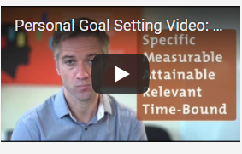

https://youtu.be/yux_m8AdzwY

**3 Prioritisation**

time_management_skills_03.jpg

Prioritising what needs to be done is especially important. Without it, you may work very hard, but you won't be achieving the results you desire because what you are working on is not of strategic importance.

Most people have a "to-do" list of some sort. The problem with many of these lists is they are just a collection of things that need to get done. There is no rhyme or reason to the list and, because of this, the work they do is just as unstructured. So how do you work on To Do List tasks – top down, bottom up, easiest to hardest?

To work efficiently you need to work on the most important, highest value tasks. This way you won't get caught scrambling to get something critical done as the deadline approaches.

Watch this Mind Tools video on how to prioritise your time.

https://youtu.be/TRkSLJLh2NM

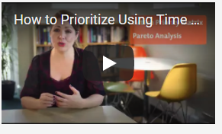

**4 Managing interruptions**

time_management_skills_04.jpg

Having a plan and knowing how to prioritise it is one thing. The next issue is knowing what to do to minimise the interruptions you face during your day. It is widely recognised that managers get very little uninterrupted time to work on their priority tasks. There are phone calls, information requests, questions from employees, and a whole host of events that crop up unexpectedly. Some do need to be dealt with immediately, but others need to be managed.

Watch this video on managing interruptions.

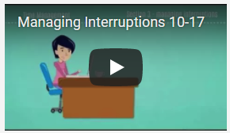

https://youtu.be/8_y2cwxjAao

Remember that some jobs need you to be available for people when they need help – interruption is a natural and necessary part of life. Here, do what you sensibly can to minimize it, but make sure you don't scare people away from interrupting you when they should.

**5 Procrastination**

time_management_skills_05.jpg

"I'll get to it later" has led to the downfall of many a good employee. After too many "laters" the work piles up so high that any task seems insurmountable. Procrastination is as tempting as it is deadly. The best way to beat it is to recognise that you do indeed procrastinate. Then you need to figure out why. Perhaps you are afraid of failing? (And some people are afraid of success!)

Once you know why you procrastinate then you can plan to get out of the habit. Reward yourself for getting jobs done, and remind yourself regularly of the horrible consequences of not doing those boring tasks! For more help on recognising and overcoming procrastination watch the Mind Tools video below on Beating Procrastination.

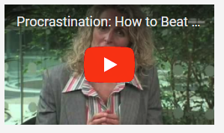

https://youtu.be/Yx-NMkFYiog

**6 Scheduling**

time_management_skills_06.jpg

Much of time management comes down to effective scheduling of your time. When you know what your goals and priorities are, you then need to know how to go about creating a schedule that keeps you on track, and protects you from stress.

This means understanding the factors that affect the time you have available for work. You not only have to schedule priority tasks, you must leave room for interruptions, and contingency time for those unexpected events that otherwise wreak chaos with your schedule. By creating a robust schedule that reflects your priorities and well as supports your personal goals, you have a winning combination: One that will allow you to control your time and keep your life in balance.

**7 Time management tools**

time_management_skills_07.jpg

There are many different time management tools which are used to aid the effective management of tasks.

|  |  |
| --- | --- |
| **Diaries** | * Noting down all events in a diary allows you to plan your work in order to complete it to a deadline * A diary is also useful for recording reminders and follow-up tasks that have to be completed – you can tick off tasks that have been done and carry forward any that remain * Check the diary as the first job of the day so that you can see the tasks and events scheduled and begin to plan your day |
| **To Do lists** | * List all the jobs you have to do and tick them off as you go * Use prioritising to number jobs in the order in which they must be completed * Try to get into the habit of making a to do list for the following day before you leave work so that it is easy to pick up where you left off |
| **Schedules and organisers** | * These include calendars, paper-based organisers, PDAs and software such as MS Outlook * Scheduling should be done regularly, e.g. at the start of every week or month * Identify the time you have available for the work and then schedule in the actions that must be taken in order to carry it out * Use your To Do list to schedule in the high-priority urgent activities, as well as routine tasks that must be completed * You should also allow for extra time that will inevitably be taken up by interruptions and unexpected tasks |
| **Planners** | * Often wall-mounted and therefore visible to all * They are good for planning staff absences and long projects as they usually cover a whole year at a view * Different colours (stickers or pens) can be used to denote different staff or project tasks * It is usually advisable that one person has responsibility for updating the chart and this can be time-consuming * Too many entries can also result in a colourful and confusing chart – consider grouping and splitting tasks onto a second planner |
| **Others** | * Bespoke time management documents and software systems per specific to organisations * Matrix documents |

**8 Be organised**

time_management_skills_08.jpg

Work tasks need to be organised and you need to take into consideration:

* Deadlines for completion of tasks
* Routine and regularly occurring tasks
* Promises and commitments
* Regular meetings
* One-off meetings
* Appointments – personal or otherwise
* Training courses to be attended
* Special events in the office
* Appraisal interview
* Days off/leave

You may be the person within the team that is responsible for these tasks, or this may be the role of team leaders, or a scheduling department that supports the planning of workloads.

**Time management techniques**

* Prioritising - Prioritise your work in the order it is to be carried out. Break each task down into manageable chunks

**Categorising tasks focus on the important jobs manage deadlines**

|  |  |
| --- | --- |
| **Urgent and important** | This is usually a crisis job – it needs to be done and takes precedence over all other tasks. Often it is urgent and important because it is an urgent task that hasn’t been done and then becomes important and therefore priority because the deadline is fast approaching |
| **Urgent but not important** | Controlling the urgent tasks when they are at the not yet important stage is vital so that they don’t become a crisis You must also ensure that this type of work is done accurately as you do not want it to come back to you When a job becomes urgent and important you will often feel under pressure and that is when mistakes are made |
| **Important but not urgent** | These tasks need to be broken into manageable amounts and are often the tasks that are your core job. They need to be done and need time allocated to them. You will often find the urgent tasks that crop up can squeeze them out which is why you need in your daily plans to allow time for the unexpected urgent tasks. |
| **Not urgent or important** | Can someone help you with it or does it really need to be done? Ask for advice and make your decision with your supervisor |

**9 Anticipating and dealing with problems**

time_management_skills_09.jpg

Despite planning, sometimes problems occur. The main issue when a problem arises is how it is dealt with.

Problems can be:

* Equipment break downs
* Who don't meet their deadlines
* The task has to be changed at the last moment
* Unforeseen problems such as bad weather or transport strikes preventing people arriving at work.

Ways of resolving minor problems include replanning/reprioritising your work, gaining the support of others, identifying a solution and seeking permission to implement it, referring the problem on.

* You should refer problems on if
* The solution will cost money or affect many others
* It will impact seriously on the overall target
* There is no apparent solution
* There is a security, health or safety risk
* The solution is outside the your scope of authority

There are many things to distract you from your current task, Whatever the distractions, try to think of a way of controlling or minimising them.  
  
Finding out what these distractions are and controlling them can help you in managing your time.

|  |  |
| --- | --- |
| **Incoming phone calls** | * Could it be that you could put the phone on answering machine mode and at regular intervals listen to the calls; dealing with those that are important? * Could someone else answer and screen your calls? * Is there somewhere else you could work quietly to finish the task? |
| **Interruptions from colleagues with queries or wanting to chat** | * Take you away from the job you are doing and disturb your train of thought * Make sure colleagues are aware that you have a task to complete * Suggest a convenient time when you could answer their query or catch up for a chat |
| **Constant checking of emails** | * Whilst these must be checked regularly, set yourself times when you will check them and log out of the program in between |

**10 Planning**

time_management_skills_10.jpg

It is important that you plan your day effectively to achieve your set objectives.

You need to:

* Set yourself realistic targets and objectives
* Be prepared for the unexpected
* Know how you spend your time
* Set priorities in terms of urgency and importance
* Do one major thing at a time
* Schedule your work

Benefits of good time management:

* It prevents work mounting up and helps you to feel in control
* Makes best use of your work time so that you are more likely to be able to leave on time
* You will be less likely to spend your time outside work worrying about 'the job'
* No one works well if they are tired or hungry – it is better to have a break and come back to the task refreshed

Good time management will help you to achieve a balance between your work and personal life. Sometimes it may mean saying 'no' to requests:

* It is better to be honest about what you are capable of achieving than taking on too much, knowing that it is not achievable
* Being assertive means saying directly and honestly what you want and holding out for it, without being aggressive

**11 Service level agreements**

**contract_management_procurement_book_06.jpg**

Service level agreements (SLA) are contracts between a service provider and its internal or external customers that documents what services the provider will supply and the performance standards they are required to meet.

For example, a sales department might have a service level agreement with the finance department that they will provide up-to-date figures by a certain date each month.

You need to be aware of any SLAs that impact on your customer service role, to ensure that you take these into account when managing your time and priorities.

**12 Reputation**

time_management_skills_11.jpg

The way you behave at work and how you carry out all aspects of your job role will gain you a reputation. Once gained, reputations are hard to change so be aware of the importance of creating a good first impression.  
When carrying out your job role, always complete tasks to a high standard and pay attention to detail: it may not seem too important to always punch papers squarely, but a messy file with papers sticking out top and bottom sends out a message about its owner.  
  
Setting and maintaining high standards, for both your work and your behaviour, will lead to a higher level of job satisfaction for you, and a higher level of trust in you from your organisation, which could in turn lead you to promotion.  
You should always work professionally:

* Having the right attitude to doing your job role to the best of your ability
* Ensuring the needs of the organisation are met despite difficult circumstances, e.g. being under pressure through lack of time or during busy periods
* Being aware of what your organisation expects of you and acting accordingly
* Having the appropriate knowledge and accepting what you can do within the limits of your authority

Being accountable to others is important within any business to maintain the work flow. The table below outlines how you can be accountable in your role:

|  |  |
| --- | --- |
| **Finishing on time** | * If you have agreed to a deadline, it is up to you to ensure you meet that date whatever happens |
| **Dealing with problems that may arise** | * You should try to resolve minor problems that may delay your work yourself * This may mean rescheduling tasks or working extra hours or gaining the help of colleagues |
| **Reporting progress** | * It is essential that any problems in meeting deadlines are communicated to your supervisor as soon as possible to lessen the impact on others’ work and targets, and so that contingency plans can be put in place * It is better to limit the damage by ‘owning up’ if you are behind rather than trying to cover up and allowing the situation to get increasingly worse * You will be afforded far more respect if you have the confidence to admit your failings than if you allow them to be found out later or blamed on others |

**13 Work life balance**

time_management_skills_12.jpg

This is a comfortable state of equilibrium achieved between an employee's primary priorities of their employment position and their private lifestyle. Most psychologists would agree that the demands of an employee's career should not overwhelm the individual's ability to enjoy a satisfying personal life outside of the business environment. Employees in companies already implementing work-life balance practices enjoy significant benefits, such as:

* Being able to effectively manage multiple responsibilities at home, work and in the community without guilt or regret
* Being able to work in flexible ways so that earning an income and managing family/other commitments becomes easier
* Being part of a supportive workplace that values and trusts staff

Good work-life balance policies and practices are great for organisations. Some of the benefits for you and your staff are:

* Getting and keeping the right staff
* Getting the best from staff
* Being an 'employer of choice' and future proofing
* Improving productivity

[Select here](http://www.superfriend.com.au/employers/a-healthier-workplace/work-life-balance) to find out more about work-life balance.

**Problem Solving**

The aim of this section is to provide you with the knowledge and skills to enable you to solve problems in the workplace. This section will provide you with the understanding of how to analyse complex problems, apply decision making techniques when assessing possible solutions and plan how you will implement solutions.

Complete this e-learning module:



https://skills.cgkpivot.com/mod/scorm/player.php?a=13&currentorg=&scoid=0&sesskey=%20NoLTKnsvkO&display=popup

**Decision Making**

This section will teach you the skills needed to reach the best possible decisions, improving your knowledge of the decision-making process to enable effective decision making in the workplace.

Complete this e-learning module:



https://skills.cgkpivot.com/mod/scorm/player.php?a=14&currentorg=&scoid=0&sesskey=cyGIEqmHuI&display=popup

**Preparatory activities**

* **Question 1**

Consider the use of **electronic methods**of keeping 'to-do' lists, workplace diaries or calendars, as opposed to traditional paper-based methods.

a) Give two **advantages** of electronic methods

b) Give two **disadvantages** of electronic methods

Type your answers in the box below

a)

b)

**Question 2**

Research some of the tools and techniques that are available to help you monitor progress and completion of tasks - for example Gantt charts, logic network diagrams or Kanban boards. Briefly describe **two** of them.

Type your answers in the box below

**Question 3**

Explain which of these tools and techniques would be **most useful** for use in your own work situation, and why.

Type your answers in the box below

**Question 4**

Ask your line manager or mentor whether there are any service level agreements that your team are subject to. If there are, describe how they might affect how you plan tasks. If not, skip this question.

Type your answers in the box below

**Next steps**

Now you have completed this section select **SUBMIT TASK FOR REVIEW** and your Assessor will give you feedback. If you have any questions, please contact your Assessor via the messages function.

Task 7 Organising, prioritising and monitoring your workload

**Introduction**

**task_7_organising_prioritising_01_a.jpg**

To complete this task you will look at the way you plan and prioritise your workload. You will see if you can change how you carry out your daily tasks to improve your own efficiency, and the efficiency of your team and your organisation.

**Task 7**

In this task, you will be reflecting on the objectives you defined in the Personal Development Plan you created in Task 4. You will be looking at your workload, priorities and objectives as well as how to monitor your progress. At the end of this task you may wish to revisit and update your plan. As part of this task you will be demonstrating the following skills, knowledge or behaviours:

|  |
| --- |
| **Knowledge:** |
| By completing this task you will be working towards better understanding your role and responsibilities, and knowing which targets and goals you need to deliver against. |
| **Skills:** |
| By completing this task you will demonstrate personal organisational skills by showing that you can:   * prioritise and plan the completion of tasks according to agreed deadlines * use appropriate tools and techniques to monitor the progress of tasks |
| **Behaviours:** |
| By completing this task you will work towards showing that you can consider personal goals and propose development that would help achieve them. |

**Distinction**

As part of working towards **distinction** level, the Customer Service Practitioner standards require you to be able to:

* respond in a professional manner to challenges and changes, and adjust your priorities accordingly

**Knowledge application**

* **Question 1**

Download and complete [this worksheet](https://content.cgkpivot.com/documents/Organising_prioritising_and_monitoring_your_workload_1.pdf) on organising, prioritising and monitoring your workload. Once you have downloaded it, select 'save as' and rename it to ensure that your work is saved.

Once you have completed it, upload it below and then reflect on how your day went:

* + did everything go to plan?
  + did you get as much done as you wanted?
  + did the order or priority of your tasks change?
  + how did you monitor your progress?
  + were there any periods where you could have been more productive?
  + could you have combined all the activities in order to save time (eg made all outgoing calls in one block, or dealt with messages more promptly)?

Type your answers in the box below

**Question 2**

What activities did you complete within their deadline?

Type your answers in the box below

**Question 3**

What activities didn't you complete? Why not?

Type your answers in the box below

**Question 4**

What tools and techniques did you use to monitor your progress? Were they effective?

Type your answers in the box below

**Question 5**

What priorities did you have to adjust, and why?

Type your answers in the box below

**Question 6**

What could you do differently to manage your time better?

Type your answers in the box below

**Question 7**

Download and complete [this worksheet](https://content.cgkpivot.com/documents/Organising_prioritising_and_monitoring_your_workload_2.pdf) on problems in completing tasks within deadlines. Once you have downloaded it, select 'save as' and rename it to ensure that your work is saved.

Once you have completed it, upload it below.

**Attach additional evidence (5 files total, 100 MB max file size)**

**Question 8**

Download and complete [this worksheet](https://content.cgkpivot.com/documents/Organising_prioritising_and_monitoring_your_workload_3.pdf) on a technique for problem solving. Once you have downloaded it, select 'save as' and rename it to ensure that your work is saved.

Once you have completed it, upload it below

**Attach additional evidence (5 files total, 100 MB max file size)**

**Question 9**

What will be the results of your suggested change for the organisation?

Type your answers in the box below

**Question 10**

What will be the results of your suggested change for your customers?

Type your answers in the box below

**Question 11**

How will you monitor whether the change has been a success or not?

Type your answers in the box below

**Next steps**

Now you have completed this section select **SUBMIT TASK FOR REVIEW** and your Assessor will review and give you feedback. If you have any questions, please contact your Assessor via the messages function.

Organisational systems and resources

**Introduction**

**organisational_systems_resources_01_a.jpg**

Organisations use a wide range of different systems, equipment and technologies to meet customer needs and in this section you will explore some of them. Within your organisation you may have bespoke systems and technology to support your specific customer needs and you will have received training and guidance on how they should be used.

Depending on the size of your organisation, there will also be tools used to monitor customer service levels. The tools used vary depending on the type of customer service you are offering - face to face or non-facing. If your organisation does not have a formal method of evaluating customer service, you will be asked to research the methods used in other organisations.

**Telephone skills**

communicate_effectively_02.jpg

Great telephone skills are the building blocks of every business and it is easy to see why. Many of the important experiences that your existing, new and potential customers are having are based upon the level of customer service they are receiving from you and your colleagues whilst on the phone. Employees that can use their telephone skills to effectively deliver excellent service will grow and maintain a thriving business.

Control your call by sticking to a structure, asking open questions when you need to and show that you are listening. Record and repeat information so the caller feels connected.

* Use open questions
* Show that you’re listening
* Record and repeat information

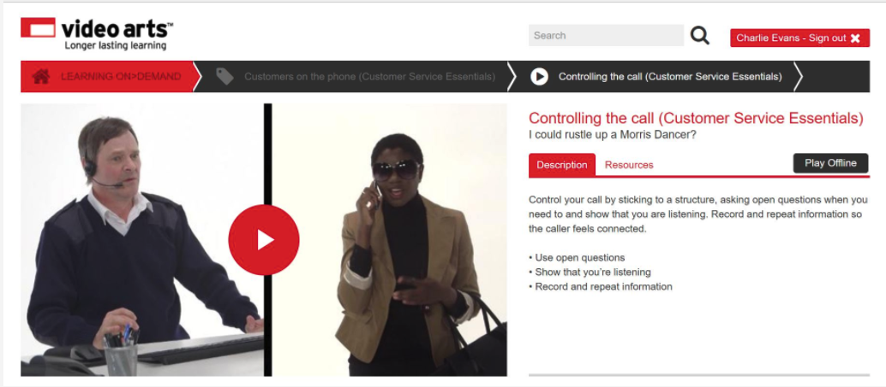

Select the book below to learn more.

[Using the telephone](https://skills.cgkpivot.com/mod/book/view.php?id=13395)

**1 Introduction**

telephone_skills_book_01.jpg

Most organisations make and receive telephone calls from external and internal sources. This is the normal method of customer contact so getting this right is important as it can have an impact on the business.

**Consider this...**  
A message is communicated by the tone of voice and words, of which 82% is tone of voice and 18% are words.

All organisations have their company procedures to follow, below is some helpful advice.

**Dealing with inbound and outbound telephone calls**  
  
The table below outlines some main points on how to deal with the different stages of telephone calls.

|  |  |
| --- | --- |
| **Preparing to make outbound calls** | Have all the information on why you are making the call ready before you dial.   * Identify yourself, your company and the reason for your call * Ask if it’s a good time for the customer to speak with you * Tell the customer what to expect next |

**2 Beginning of the call**

When you’re on the phone, answer right away and use a verbal handshake. Smile as you talk, and introduce yourself.

* Answer straight away
* Use a verbal handshake
* Smile as you talk and introduce yoursel

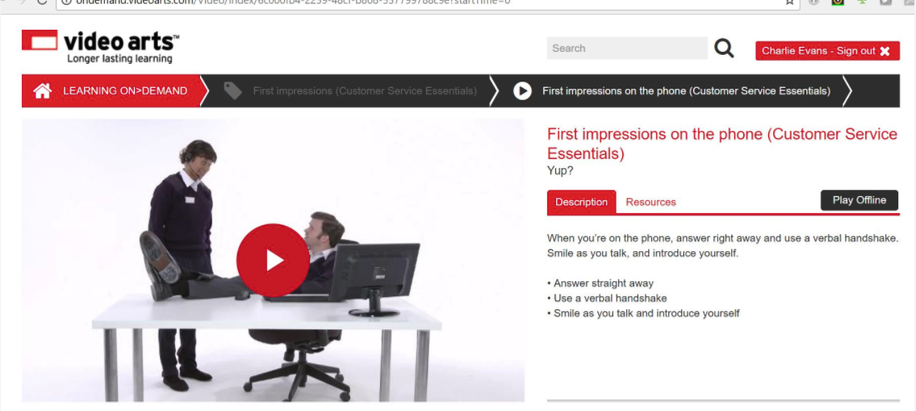

|  |  |
| --- | --- |
| **Greeting** | First impression counts!  All companies will have a standard greeting, which is often scripted.  This will ensure that the caller knows they are through to the correct department, and that they have the name of the person they are speaking to. |
| **Identification/verification of caller** | There are different ways to identify/verify the caller.    Some methods are:   * Confirming personal/account details you have on record * Passwords * Memorable words * Security key   This is to adhere to data protection legislation and security. |

**3 During the call**

telephone_skills_book_03.jpg

**Body of call**

Tone of voice should express feeling or emotion:

* Flat and indifferent - bored, lack of interest in job, not interested in caller or conversation
* Enthusiastic - interested in the conversation, likes job, wants to help caller
* Caring - interested in caller, wants to help
* Cold - hostile, hates job, wants to be anywhere but here

Word content:

* Keep jargon to a minimum in order to avoid confusing customers
* Use language they understand!
* You need to speak at a rate that can be understood, and how the customer responds will affect this

Effective listening skills:

* Pay attention
* Assess the customer’s level of expertise
* It’s valuable to know if they are novices or experts
* Knowing their level can save a lot of time
* Echo important points
* Take notes

Using questioning to control the call:

* Open questions - they require a fuller answer. As a result of asking open questions you should be able to gain enough information to give the caller a solution to a particular problem or be in a better position to help
* Closed questions - usually produce a ‘Yes’ or ‘No’ answer. This can be useful in the closing minutes of the conversation, or to confirm details to make sure you have covered all you need to
* Probing or specific questions - help to clarify points and request specific information

**4 During call tasks**

|  |  |
| --- | --- |
| **Transferring to another department** | When you can’t deal with the request you may need to transfer to others:   * Ask permission * Tell the caller to whom he or she will be transferred * Explain why * Give phone number * Transfer the call |
| **Taking a message** | Get the correct and complete information:   * Use a pad * Record date and time * Spell names accurately * Don’t be afraid to ask how names are spelt - people will be impressed you want to get the details correct * What does the caller want? A return call? The caller will call back? * When is a good time to call? * Ask, can you help?   This does two things: it provides you with information about the purpose of the call that you can pass on in the message, or it may eliminate the necessity for a return call if you can help by providing the caller with the information required.   * Take responsibility - follow through |
| **Putting customer on hold** | Keep the caller up to date   * Explain why * Ask permission * Put caller on hold * Thank the caller for holding |

5 **Closing the call**

When closing the call, don’t leave your customer ‘lost at sea’. Agree actions and how they’ll be followed up. Volunteer useful information and agree the next steps.

* Agree actions and how they’ll be followed up
* Volunteer useful information
* Agree next steps

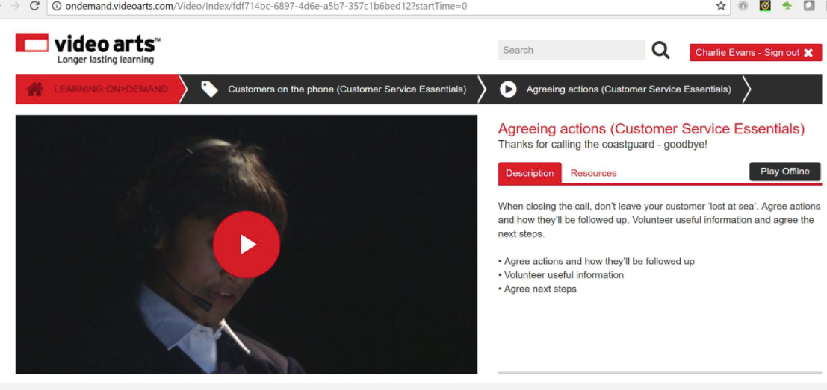

|  |  |
| --- | --- |
| **Ending/closing the call** | Lasting impressions count!   * Summarise the call to the caller * Confirm the caller has completed all enquiries * Confirm any actions to be taken   System notes should reflect the call:   * Clear and concise * Correct spelling and grammar * Full words * Avoid slang * Limit jargon * Dated |

**6 Voicemail**

telephone_skills_book_06 .jpg

Voicemail has become a standard part of every business-class telephone system and knowing how to leave a professional voicemail phone message will reflect positively upon your company. Every employee using the phone as part of their job should know how to leave a professional phone message.

The table below outlines some main points on how to deal with the different areas of voicemail.

|  |  |
| --- | --- |
| **Leaving a voice mail** | You need to:   * Introduce yourself * Leave contact details * Speak slowly and clearly * Keep it short * End professionally |
| **Checking system / collecting messages left** | If this is your own voicemail or shared voicemail this should be checked regularly:   * At the start of the working day * When there is a message indicated * After long periods away from your desk * Before you leave   You must remember to collect the following details from the messages:   * Name of person * Contact details * Brief account of message * Action to be taken   If you are unable to deal with the message you need to pass to the correct person. |

**7 After you have the message**

|  |  |
| --- | --- |
| **Passing on voicemail** | It is important that you take ownership of delivering the message to the correct person within an agreed timeframe. Companies use different ways to pass on messages. These can be:   * Email * Face-to-face * Record within a book * Notelets   It is vital that you get the message to the person who needs to deal with it. |
| **Deleting messages** | You will need to delete messages or a message mailbox will become full. A few things to think about before deleting:   * Do you have all the details * Will this be followed up? * Do you need to keep the message? |

**8 The customer**

**organisational_systems_resources_book1_08.jpg**

Good telephone skills mean more satisfied customers. They are just as important as face-to-face communication skills. Effective telephone skills mean problems are solved more quickly and efficiently. Good speaking and listening skills give customers a more positive image of the company.

**Consider this...**  
The points below should be considered when you are using the telephone and voicemail system to make sure that the communication is being understood:

* Speak clearly
* Support your points with examples and detail
* Use words and phrases that your listener will understand
* Use positive body language and show you are listening
* Use positive feedback with words and phrases like "yes", "I see", "right", "okay", etc.
* Do not interrupt - let the caller finish what they are saying before you respond
* Ask the speaker to clarify if there's something that confuses you or especially interests you
* Body language has an impact on the call: the person on the other end can tell if you are smiling, how you are sitting in your chair, and if you are engaging with them

**9 Customer experience**

**organisational_systems_resources_book1_09.jpg**

Customer service is fundamental to all organisations. What experience the customer receives will influence the organisation? It is important to keep customers happy and maintain a high customer service.

Good customer service has the potential to alter consumer viewpoints and provide businesses with important feedback related to the products and services they offer.

The effects can be:

* Increase in profits
* Customer loyalty
* Internal benefits

Poor customer service can negatively impact a business in a variety of ways. This is especially true for small organisations that rely on repeat business and positive word-of-mouth advertising for its success. In addition to running the risk of alienating current customers with sub-standard service levels, chronically poor service can impact the business potential for attracting new customers as well.

The effects can be:

* Loss of potential customers
* Loss of future customers
* Loss of employees
* Loss of reputation
* Loss of profit

You must keep the customer’s experience in mind always.

**Consider this…**

How you would want the request dealt with, how you would be feeling – Treat people as you would want to be treated.

**10 The phonetic alphabet**

**organisational_systems_resources_book1_10.jpg**

What is the phonetic alphabet and why do we use it?

The phonetic alphabet is a list of words used to identify letters in a message transmitted by radio or telephone. Spoken words from an approved list are substituted for letters. For example, the word "Navy" would be "November Alpha Victor Yankee" when spelt with the phonetic alphabet.

Using this system you will be able to clarify information being given or received - information like car registration number, letters to passwords, etc.

All companies use the same phonetic alphabet within the UK.

|  |  |  |  |
| --- | --- | --- | --- |
| A | Alpha | B | Bravo |
| C | Charlie | D | Delta |
| E | Echo | F | Foxtrot |
| G | Golf | H | Hotel |
| I | India | J | Juliet |
| K | Kilo | L | Lima |
| M | Mike | N | November |
| O | Oscar | P | Papa |
| Q | Quebec | R | Romeo |
| S | Sierra | T | Tango |
| U | Uniform | V | Victor |
| W | Whiskey | X | X-ray |
| Y | Yankee | Z | Zulu |

For your own printable copy of the phonetic alphabet [select the link.](http://www.phonetic-alphabet.org.uk/)

**11 Telephone features**

Most telephone systems are different. However, all telephone systems have many similar features and functions that can be used.

Below are a few that you may have used:

|  |  |
| --- | --- |
| **Hold** | Allows you to place a current call on hold. You can then answer another ringing telephone, make an outgoing call, or retrieve a waiting call. |
|  |  |
| **Call transfer** | Allows you to transfer a call to another telephone at no charge |
| **Conference call** | You can create conference calls with this feature. |
| **Mute** | Allows you to hear what's being said on the phone, but they cannot hear you. |
| **Speaker** | You can put the caller on loud speaker so others can hear. |
| **Company directory** | You can have access to all company staff members via their number using the directory. |
| **Call Waiting** | Allows a user to hear a tone when they are on the line to notify them that another caller is trying to reach them. Users have the option of answering the second call or allowing it to go unanswered. |
| **Voicemail** | You can set-up a personal message instructing callers on how to leave you a message. |

**12 Data protection and security**

**organisational_systems_resources_book1_12.jpg**

Why do you have to follow data protection and security procedures when dealing with a telephone call?

When dealing with customers on the telephone it is important that you follow the Data Protection policy. This is used to confirm, through a verification process, who you are talking with. This in turn can detect and prevent fraud from taking place. You should also keep your passwords or log-in details secure and do not share them with others. Passwords should be changed regularly, and you should not use ones that are easy to guess.

The Data Protection Act controls how your personal information is used by organisations, businesses or the government.

Everyone responsible for using data has to follow strict rules called 'data protection principles'. They must make sure the information is:

* Used fairly and lawfully
* Used for limited, specifically stated purposes
* Used in a way that is adequate, relevant and not excessive
* Accurate
* Kept for no longer than is absolutely necessary
* Handled according to the person's data protection rights
* Kept safe and secure
* Not transferred outside the UK without adequate protection

[Select here](https://www.gov.uk/data-protection/the-data-protection-act)to see full details of Data Protection Act

**13 How this affects you**

**organisational_systems_resources_book1_13.jpg**

Most organisations will record all telephone calls. This is for monitoring and training purposes. The caller must be made aware that this is happening.

However, the term 'call recording' is not specifically mentioned anywhere in the Data Protection Act, which may suggest that the law is open to interpretation.

The Act refers to the processing of information or data as obtaining, recording, or holding the information or data or carrying out any operation or set of operations on the information or data:

* Organisation, adaptation or alteration of the information or data
* Retrieval, consultation or use of the information or data
* Disclosure of the information or data by transmission, dissemination or otherwise making available
* Alignment, combination, blocking, erasure or destruction of the information or data

Therefore, any call recording undertaken and retained by a contact centre, be it only for training purposes, could be construed as processing of data. It is therefore advisable for contact centres to protect call recording in the same way they would protect any digital or written data where that information can identify the customer, and where they would be susceptible to a data breach.

**Evaluating customer service**

evaluate_customer_service_advanced_01_a.jpg

It is vital for all organisations to measure how effective they are to meet customer needs, increase business, retain customers and to maintain market share.

An organisation that does not measure its effectiveness cannot develop, grow, or maintain standards in any delivery area.

Select the book below to learn more.

[Measuring organisational effectiveness](https://skills.cgkpivot.com/mod/book/view.php?id=13376)

**1 Organisational effectiveness**

measuring_organisational_effectiveness_01.jpg

There are many methods that can be used to measure the effectiveness of an organisation. The methods may change because:

* the size of organisation
* the sector of organisation
* organisational priorities

Watch the video to learn more about organisational effectiveness:

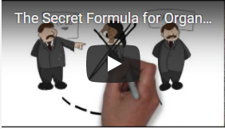

In any role it is important to be able to assess if you are effective.

Organisations can measure the effectiveness of individuals through a number of methods for example:

* customer feedback
* appraisal
* observation of performance
* achievement of targets
* completion of work to timescales

Individuals can also self-assess.

No matter what the method, any feedback showing necessary improvement should be acted on and the relevant improvement method decided on.

**2 Obtaining feedback**

Organisations obtain feedback or information through a variety of methods. For example:

* questionnaires
* focus groups
* comment cards
* complaints
* sales figures
* competitors activities

**3 Performance review**

effective_feedback_08.jpg

You will have performance reviews or appraisals with your line manager during your career, these are usually at regular times, for example every 6 months.

During an appraisal you can expect your manager to look back on your achievements and agree training to improve your overall performance moving forward.

You can also expect targets to be set and a future appraisal date will be agreed.

**4 Sales/performance targets**

measuring_organisational_effectiveness_04.jpg

* Performance targets are a simple way to monitor the performance of an individual or team.
* Targets are set based on an individuals and or teams past performance. Your targets may also be set to meet the companies targets set by management.
* Your manager will always monitor team and individual targets and he/she may adjust them. If a target is changed you can expect to be given reasons for the change.

**5 SMART Targets**

Principles of target setting are outlined in the SMART method

measuring_organisational_effectiveness_05.jpg

**6 Competitor benchmarking**

measuring_organisational_effectiveness_06.jpg

Companies will always keep a close eye on their competitors. They will try to gather as much information about each other as possible for example:

* A mystery shopper - may test the customer service
* Pricing -  ensuring the prices of similar products and services are similar
* Sales/ special offers
* Monitor advertising campaigns
* Published records – all companies have to publish their accounts and profits.

**7 Methods of identifying service failures**

measuring_organisational_effectiveness_08.jpg

**Complaints**

Complaints must be recorded and followed up properly following your company policy.

**Customer feedback**

This feedback can be in any form – formal or informal. Customer comments or suggestions do not have be complaints.

**Market research**

This is a useful indication of customer wants, needs and expectations and can be matched to the current service offer.

**Sales figures**

Can highlight failures because the actual sales are less than the forecast or required sales.

**Product returns**

Can be used to identify if the same products are being returned consistently and for the same reasons.

**Staff monitoring**

As previously identified within performance reviews and sales/performance targets

**Mystery shoppers**

These undercover quality assurance officers can check service from a customer’s point of view, giving valuable insight into how the organisation delivers its offer.

**Customer focus groups**

This is a way of gaining feedback into what customers think about an organisation and how they could improve.  New ideas can be generated and highlighted.

**Customer feedback**

Customer feedback is an important tool in evaluating and improving customer service. Watch this video to learn more about the importance of customer feedback and then select the book below to learn more.

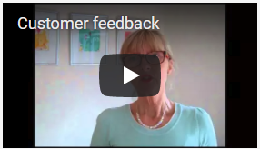

https://youtu.be/RMqt5iE6xzk

[Gathering customer feedback](https://skills.cgkpivot.com/mod/book/view.php?id=13377)

**1 Purpose of feedback**

The purpose of encouraging customers to provide feedback is to:

* continuously improve
* be responsive to the changing needs of customers in order to maintain their loyalty
* identify if customer service standards are slipping
* prevent a situation becoming a problem that has to be solved
* identify potential problems, particularly with processes
* rectify repeated problems
* show the customer they are valued

**The importance of feedback**

Organisations have many methods of monitoring customer service, but the most important is customer feedback. If the customers are not happy, the organisation will find itself in trouble.

**2 Uses of feedback**

**3 Methods of collecting feedback**

effective_feedback_12.jpg

To enable you to effectively evaluate customer service you also need to specifically understand the measurement tools relevant for gathering, analysing and interpreting customer feedback. These include:

* Online
* Written - emails and letters of complaint
* Verbal - face to face and by phone
* Text
* Social media - comments on Twitter and Facebook
* Surveys - online and paperbased
* Questionnaires - Comments and Suggestion Boxes

Feedback can be gathered formally or informally. Formal feedback gives useful information on an organisation’s performance:

* Formal feedback is structured, written feedback, actively sought by the organisation
* Formal feedback techniques include:
  + questionnaires
  + interviews/surveys
  + loyalty cards

Informal feedback is often the source of information on individuals’ performance, and is obtained where a customer offers feedback without being asked, e.g. through:

* online reviews/forums
* social media sites
* comment cards
* spontaneous comments
* complaints

Informal feedback should be reported and shared.

**4 Sampling**

communicate_effectively_04.jpg

**Random sampling**

Random sampling is where we select a group of people, the sample, from a larger group of people, everyone has an equal chance of being selected for the sample.

**Non-Random Sampling**

Non-random sampling does not provide for all to be selected for the sample, there are several reasons to choose non-random sampling:

* Quota sampling:
  + Proportional - In this technique the researcher would sample from a known proportion of the population, eg you know that the population of a college is 65% female and 35% male, you want a sample of 100 for your research, then you would collect a sample from 65 females and 35 males.
  + Non-proportional - This method is far less restrictive, you would decide how many samples you would require from each category, 50 female and 50 male, you are not concerned with the proportion against the population of the college.
* Convenience – This is a very common technique for collecting data. The sample is chosen because they are easy to recruit and are available to the researcher.
* Judgment – The sample is chosen because the researcher believes that the sample is more pertinent to the research, e.g. if you were sampling the effect of long term exposure to the sun on skin, then you make a judgment and sample older people rather than children.
* Volunteer – This method is cheap in time and costs, but is highly likely to introduce a bias to the sample, e.g. a phone in conducted by a news programme on a current affairs issue is a volunteer sample. Due to its nature of this sample it will not be representative of the population as the volunteers can phone in as many times as they want. Interested volunteers will only vote on the subject.

**5 Creating a questionnaire**

gathering_customer_feedback_03.jpg

When developing any questionnaire, there are certain principles, best practice, to follow. The following principles should be considered:

* What needs to be found out
* Who is the target audience
* The length of the questionnaire
* The type of questions
* Using the right vocabulary
* Avoiding bias
* Placing the questions with care

**Questionnaires:**

* must be carefully designed
* questionnaires may be sent out to customers
* who have recently made a purchase or used a service
* who have not used the organisation for some time
* handing questionnaires to customers at the time of purchase allows any issues to be dealt with promptly
* an incentive is often used to encourage customers to complete them

**6 Interviews/surveys**

* Face to face
* Over the telephone
* Set questions should be drawn up

**Disadvantages:**

* + expensive
  + time consuming

**Advantages:**

* + more information can be gathered
  + information is often more detailed

**7 Loyalty cards**

Loyalty cards are used by organisations to collate information and feedback from customers. They:

* Create a database on the organisation's customers
* Record details of customer purchases
* Identify customer purchasing trends
* Allow the organisation to target promotional offers to specific customers
* Encourage loyalty

**8 Data collection and analysis plan**

gathering_customer_feedback_04.jpg

A customer service plan will also include a data collection and analysis plan, this plan will include:

* Sampling frame - the sample from where the data is being collected. The sample must be considered from the start, what are you trying to find out and from **whom?**
* Method of collection - There are many ways to conduct customer feedback, all will have advantages and disadvantages. For example: Email survey: Advantage – cheap and efficient; Disadvantage – the “delete” button
* Recording method - The **recording methods** to be used – online, data entry (e.g. Excel®), hand written. Different recording methods will be used dependent on the survey type. You should also consider the requirements for quality and data protection at this point.
* Timescale - during the planning stage the timeframe should include the following: Prepare survey; Conducting the survey; Analysing the survey

**9 Recording methods**

introduction_01_d.jpg

It is imperative that an efficient and accurate recording method is chosen. There are various methods available:

* **Paper** - While paper-based recording is a cost-effective method for recording data, it is prone to poor data input and therefore errors.
* **Online** - The online gathering of feedback is both cost effective and efficient, there is a small margin for error, but this is on the part of the customer. Overall this method is a good method for the gathering information which is resource efficient.
* **Software**- There are many software packages available for recording customer feedback which are efficient and cost effective. The most common package available is Excel® which allows the user to perform calculations and present the information in many formats, including lists, charts, and tables.

**10 Other considerations**

gathering_customer_feedback_06.jpg

**Policies and procedures**

When gathering any feedback, all organisations will have policies and procedures which must be adhered to. These policies and procedures are in place to explain:

* the roles and responsibilities
* the limits of authority
* how to handle of customer information.

These policies will also explain the service offer that the organisation will provide.

**Legal requirements**

When gathering any customer feedback organisations must consider the legal requirements of gathering, storing, and using information from their customers.

In the United Kingdom, this legal requirement is written in to the Data Protection Act. Compliance is not a choice but a requirement.

**Ethical requirements**

Customer feedback must be gathered according to the organisations policies and procedures. Included in this is the organisations ethics, the way the business is going to ‘do the right thing’.

Compliance with the organisational principles will guide those involved in the gathering of customer feedback.

The ethics of a company will produce a set of values that the organisational will abide by, included in this will be the need to treat all, including customers and staff, honestly and fairly.

**11 Improving service based on feedback**

* actively seek customers’ opinion as to how service could be improved
* share feedback
* act on customer feedback

**Improving customer service**

Organisations need to continually improve and change for a variety of reasons:

* Changes in customer needs
* New trends
* Environmental issues
* Economic reasons

Select the book below to learn more.

[Improving customer service](https://skills.cgkpivot.com/mod/book/view.php?id=13379)

**1 Introduction**

Any organisation has many reasons for needing to make improvements to the standard of customer service it offers. Change needs to be considered and no organisation will make change just for the sake of doing so.  Any change will be consider the advantages and disadvantages and taking into account customer feedback, sales, levels of complaints etc.

Changes in customer needs can include:

* **customers demand new ways of purchasing products or services**: e.g. with new technology customers want the ability to make purchases on a 24/7 basis
* **customers demand higher levels of service**: e.g. through social media customers are now more aware of what the standard of service is from competitors and have higher expectations of what the level of service is they should be offered by an organisation

Through television, social media and the Internet, customers are more aware than ever of the level of customer service that is acceptable and what their rights are. This means any organisation will need to ensure that their customer service meets the expectations of their customers, and if not, to make improvements. Technology has changed all our lives, and all organisations now need to be aware of its influence.

**2 Trends**

Customer service may need to change because of trends. Trends can include:

* new technology which can affect purchasing, ordering or appointment making - this can benefit customers who want to be able to do this at times that suit them, anywhere
* use of new approaches to greet customers or to finish a sale
* changes to reception areas e.g. making them more open, accessible and people-friendly
* changes in seating, e.g. in coffee shops where there are sofas etc

Customer service is not just about how you deal with people face to face but how you work to meet customer expectations.

**3 Environment and economy**

Additionally customer service may need to change because of environmental issues. For example,  people are keen to save the environment and make use of less paper so items like tickets, vouchers can now be accessed and accepted on mobile phones or laptops.

Economic issues can also affect customer service. For example when there is a recession organisations need to be leaner but still offer a level of customer service that meets or exceeds that of the competition. In an economic boom people except a higher quality of service which they may be willing to pay for.

**4 Methods of change**

The standard of customer service being delivered by staff will always be checked. Customer service can be improved by:

* staff training
* observation of staff
* improved procedures
* use of new methods

Change can only be successful if it is introduced with care. Change requires the support of others who are involved. Support can be obtained by informing others through:

* team meetings
* memos
* emails
* training sessions
* management updates
* colleagues

Successful introduction of change or improvement requires those involved to be:

* informed about the change and why
* trained in its introduction
* involved in its implementation
* involved in its evaluation

Those involved need to be behind change as they will have to implement it. They need to be positive as customers will soon pick up if they are resentful or negative. If staff are not involved in change, it can be difficult to implement easily and its success can be compromised. Staff or other service providers need to have change or improvement discussed with them and they need to be involved as it may be there practices that need to be changed.

**5 Sources of information and constraints**

There are many sources of information that may help identify ways in which customer service can be improved:

* customer feedback
* sales
* complaints
* returns
* staff feedback

There are a number of constraints on staff and their ability to suggest improvements to customer service:

* level of authority - they may not been seen as senior enough to comment
* level of experience - they may not been seen as experienced enough to comment
* cost - the suggested improvements may be too expensive
* lack of resources - there may not be sufficient resources in place to carry out the improvements

In terms of actually implementing customer service improvements, organisational policies and procedures need to be followed. It is important that staff with the relevant level of authority implement any agreed customer service improvements. Always act within the limits of your own authority.

**Preparatory activities**

* **Question 1**

List the systems used in your organisation to meet customer service levels. For example, if you were working in a hotel, one of the systems you might use would be for room bookings.

Type your answers in the box below

**Question 2**

List the equipment and technologies used in your organisation to meet customer service levels. For example, the telephone.

Type your answers in the box below

**Question 3**

List the measures and evaluation tool used in your organisation to monitor customer service levels. For example, mystery shopper reports.

If your organisation does not use a formal measure to evaluate customer service, you should research the types of measures and evaluation tools used in another organisation of your choice, and list them here.

Type your answers in the box below

**Next steps**

Now that you have completed this section, select **SUBMIT TASK FOR REVIEW** below and your Assessor will review and give you feedback. If you have any questions, please contact your Assessor via the messages function.

Task 8 Using organisational systems and resources

**Introduction**

evaluate_customer_service_advanced_01_a.jpg

To complete this task you will need to consider the different systems, equipment and technologies used in your organisation to meet customer needs.

You will also need to look at the evaluation tools used to monitor customer service levels. Examples of tools you might use for this include the analysis of customer feedback, use of mystery shoppers, or supervisors listening in on calls to/from customers. If your organisation does not have a formal method of evaluating customer service, you will be asked to research the methods used in other organisations.

When completing this task, you will need to:

* explain how the systems, equipment, technologies and tools used in your organisation help you to meet and monitor customer service levels
* describe your organisation's service level agreement, and explain how it affects your role
* choose and test an appropriate method of collecting customer feedback, and evaluate how effective it was

**Task 8**

In this task, you will consider how your organisation uses systems, equipment and technology to meet the needs of your customer and monitor service levels. As part of this task you will be demonstrating the following skills, knowledge or behaviours:

|  |
| --- |
| **Knowledge:** |
| By completing this task you should be able to:   * explain the use of different systems, equipment and/or technology available in the organisation to meet customer service levels * describe the measures and evaluation tools used in the organisation to monitor customer service levels |
| **Skills:** |
| By completing this task you will demonstrate personal organisation in your research by motivating yourself and managing your workload. |
| **Behaviours:** |
| By completing this task you should work towards showing that you can take responsibility for keeping your service knowledge up-to-date. |

**Knowledge application**

* **Question 1**

Download and complete [this worksheet](https://content.cgkpivot.com/documents/Using_organisational_systems_and_resources_1.pdf) which allows you to explain how the systems, equipment and technologies you listed in the preparatory activities are used in your organisation to meet customer service levels. Once you have downloaded the document, select 'save as' and rename the document to ensure that your work is saved.

Please upload your completed worksheet below.

**Attach additional evidence (5 files total, 100 MB max file size)**

**Question 2**

Download and complete [this worksheet](https://content.cgkpivot.com/documents/Using_organisational_systems_and_resources_2.pdf) which allows you to explain how the measures and evaluation tools you listed in the preparatory activities are used to monitor customer service levels in either your organisation or the organisation that you researched. Once you have downloaded the document, select 'save as' and rename the document to ensure that your work is saved.

Please upload your completed worksheet below.

**Attach additional evidence (5 files total, 100 MB max file size)**

**Question 3**

Research your organisation's service level agreement, and describe its impact on your role.

Type your answers in the box below

**Question 4**

Collect feedback from your customers on their customer service experience. Customers can be internal or external, and feedback can be formal or informal. You will need to get feedback from a reasonable number of customers to make the feedback worthwhile. Be aware that you may need to obtain permission from your manager or the organisation to collect feedback.

Explain which approach you used to gather feedback, how you put it into action and why you chose this method.

Type your answers in the box below

**Attach additional evidence (10 files total, 100 MB max file size)**

**Question 5**

Analyse the feedback you collected in the last exercise. Evaluate how successful your chosen approach was in measuring and monitoring customer service levels. What could you have done differently? Would you choose a different approach next time?

Keep the results of the customer feedback safe, as you might find it useful as part of completing Task 17 in making suggestions for improvements to your customer service offer.

Type your answers in the box below

**Next steps**

Now that you have completed this section, select **SUBMIT TASK FOR REVIEW** below and your Assessor will review and give you feedback. If you have any questions, please contact your Assessor via the messages function.

Legislation and regulations

Introduction

customer_service_legislation_agreements_L3_01_a.jpg

This section covers the legislation and regulations that affect how you deliver customer service in your organisation. There are serious consequences for failing to comply with legislation and regulations - not just legal penalties, but also the potential impact on your organisation's reputation.

Customer service legislation

customer_service_legislation_agreements_L3_01_b.jpg

Organisations have a range of contractual and statutory duties which affect the way products or services can be delivered.

**Legislation which affects the customer service process is:**

[Sale of Goods Act](http://www.legislation.gov.uk/ukpga/1979/54/contents) - This act relates to the pricing and quality of products and/or service supplied to a consumer.  Goods and services should be fit for purpose, of good quality and as described. Services must be provided to an acceptable standard and at a reasonable price (if the price was not agreed in advance).

[Supply of Goods and Services Act](http://www.legislation.gov.uk/ukpga/1982/29) - This deals with the supply of goods or services to customers, such as work done and products supplied by tradesmen and professionals like dentists, builders, plumbers, gardeners.

[Unsolicited Goods and Services Act](http://www.legislation.gov.uk/ukpga/1971/30/contents) - This covers goods or services that have not been ordered by customers. It ensures traders cannot charge for goods or services they have sent to customers which have not been ordered.

[Trade Descriptions Act](http://www.legislation.gov.uk/ukpga/1968/29/contents) - This act prohibits organisations from applying a false trade description to any goods. It also covers the supply or offer to supply any goods to which a false trade description has been applied. Organisations are not allowed to make certain kinds of false statement about the provision of any services, facilities or accommodation. This law is enforced by trading standards officers.

[Consumer Protection Act](http://www.legislation.gov.uk/ukpga/1987/43) - This act protects the public by prohibiting the manufacture and supply of unsafe goods; making the manufacturer or seller of a defective product responsible for damage it causes; allowing local councils to seize unsafe goods and suspend the sale of suspected unsafe goods; prohibiting misleading price indications. Customers can claim compensation for death, injury, or damage to property of over a certain amount, if a product they use turns out to be faulty. Producers and distributors of goods are required to ensure that their products are safe and it is an offence to display or to give a customer misleading information.

[Consumer Credit Act](http://www.legislation.gov.uk/ukpga/1974/39/contents) - This act regulates consumer credit and covers areas such as: eligibility for credit schemes, cooling off periods, content of credit agreements and calculation of APR.

[The Consumer Protection Regulations/Distance Selling Regulations](https://www.which.co.uk/consumer-rights/regulation/distance-selling-regulations) -This offers protection to customers who shop by telephone, mail order, the Internet or digital TV.

[Misrepresentation Act 1967](http://www.legislation.gov.uk/ukpga/1967/7) - This act exists to protect consumers from false or fraudulent claims that induce you into buying something, or entering a contract and allows you to claim damages in the case of fraudulent misrepresentation.

[Data Protection Act](http://www.legislation.gov.uk/ukpga/1998/29/contents) - This act relates to the confidentiality of information and who has access to it. It has eight principles.

**Watch this video to see more about the Consumer Rights Act 2015:**

<https://www.youtube.com/embed/781v8vfGvTQ>

**Consumer protection**

**Which?** is a brand name used by the Consumers' Association, a registered charity and company limited by guarantee. It exists to promote informed consumer choice in the purchase of goods and services by testing products, highlighting inferior products or services, raising awareness of consumer rights, and offering independent advice.

The **BSI Kitemark** is a UK product and service quality certification mark which is owned and operated by The British Standards Institution (BSI Group). The Kitemark is most frequently used to identify products where safety is paramount, such as crash helmets, smoke alarms and flood defenses.

Watch this video to learn more:

<https://www.youtube.com/embed/vOeU4MIjJOo>

Preparatory activities

**Question 1**

Using [this worksheet](https://content.cgkpivot.com/documents/CSP/Customer_service_regulations.pdf), research the regulations, which may apply to your organisation. Once downloaded, select 'save as' and rename the worksheet so that your changes are saved.

Write a couple of sentences to explain your rights and responsibilities for each Act.

**Question 2**

Using [this worksheet](https://content.cgkpivot.com/documents/CSP/Customer_service_legislation.pdf), visit some local organisations that are open to the public and make a note of the signs displayed there, such as 'No refunds on sale items', 'No responsibility accepted for damage however caused' or health and safety notices. Once downloaded, select 'save as' and rename the worksheet so that your changes are saved.

Consider which piece of legislation relates to each sign, and make notes below. Work out whether the signs are correctly worded and displayed in accordance with these laws. You might be surprised by how many illegal signs are used openly in major organisations.

Case study 1

Read this case study and then answer the questions below.

Mrs Morrison bought a watch for her husband's birthday from her local branch of Dobben's, using her store card as payment. After wearing the watch for a few days, her husband complained that the back regularly fell off, and he was concerned that it would be lost.

Mrs Morrison took the watch back to Dobben's and spoke to the assistant on the watch counter, asking for a replacement watch. The assistant asked whether Mrs Morrison had the receipt for the watch, but unfortunately it had been misplaced, so Mrs Morrison replied that she hadn't.

The assistant said that as the receipt was not available, Dobben's company policy was that a refund could not be given, and Mrs Morrison was advised to return the watch to the manufacturer under its guarantee and ask for the watch to be repaired or replaced.

**Question 1**

What legislation covers this situation?

**Question 2**

Is the assistant correct in applying company policy in this situation? Explain why/why not.

**Question 3**

What are Mrs Morrison's rights in this situation?

Case study 2

Read this case study and then answer the questions below.

Asif Patel, a lorry driver, was hit by a grain bucket attached to a telescopic loader when he was collecting a load at a local farm. The incident happened as Mr Patel was walking through a passageway towards the farmer. As we was walking, a telescopic loader driven by a farm employee struck him from behind, bruising his neck, back and shoulders.

The farmer, Christian France, told Mr Patel that is was his own fault and he should have looked where he was going - the loader was noisy, and he should have heard it coming. The farmer's policy on health and safety was that visitors to the farm were responsible for their own actions, and he had posted a notice at the entrance saying so.

**Question 1**

What legislation covers this situation?

**Question 2**

Is the farmer correct in applying company policy in this situation? Explain why/why not.

**Question 3**

What are Mr Patel's rights in this situation?

Next steps

Now you have completed this section select **SUBMIT TASK FOR REVIEW** and your Assessor will review and give you feedback. If you have any questions, please contact your Assessor via the messages function.

Task 9 Meeting legislation and regulations

Introduction

risk_governance_01_a.jpg

To complete this task you will need to carry out research into the legislation and regulations that affect how you deliver customer service in your organisation. There are serious consequences for failing to comply with legislation and regulations - not just legal penalties, but also the potential impact on your organisation's reputation.

This task will cover consumer protection legislation as data protection legislation, health and safety legislation and equality and diversity legislation are covered in other tasks.

When completing this task you will:

* research relevant legislation and regulations to summarise what they cover
* consider when different legislation is applicable and how to use it
* consider the impact of consumer protection on your organisation, and specifically on your own role and responsibilities
* complete a case study on what happens when legislation is not followed correctly

Task 9

In this task you will be considering which legislation and regulations have an impact on your customer service.  As part of this task you will be working towards demonstrating that you have the following skills, knowledge or behaviours:

|  |
| --- |
| Knowledge: |
| By completing this task you should be able to:  explain how the relevant legislation and regulations affect your organisation's customer service provision |
| Skills: |
| By completing this task you should demonstrate personal organisation in your research by motivating yourself and managing your workload. |
| Behaviours: |
| By completing this task you should work towards demonstrating that you can take responsibility for keeping your knowledge up to date, as well as knowing how to treat customers correctly while complying with legal requirements.  You should also be working towards demonstrating that you can uphold your organisation's values, ethical standards and service culture through understanding and complying with legislation, regulations and codes or practice. |

### Distinction

As part of working towards **distinction** level, the Customer Service Practitioner standards require you to be able to:

* explain the potential impact on your organisation if it fails to adhere to each of the relevant pieces of legislation and regulations

Knowledge application

**Question 1**

Not all of the consumer legislation and regulations you have researched will apply to your job directly, but many will. Make a list below of the legislation and regulations that do apply to you, and how each has an impact on your role. Include any additional pieces of consumer legislation that also affect your particular role.

**Question 2**

Explain the possible consequences of **failing** to adhere to **consumer protection legislation**. Consider how it would affect you personally as well as your organisation.

Next steps

Now you have completed this section select **SUBMIT TASK FOR REVIEW** and your Assessor will review and give you feedback. If you have any questions, please contact your Assessor via the messages function.

Task 10 Health and safety

Introduction

health_safety_01_a.jpg

The aim of this section is to provide you with the knowledge and skills to ensure you understand your health and safety responsibilities in the workplace.

You will learn how to identify hazards and evaluate risks and reduce the risks to health and safety in the workplace and consider the impact of health and safety legislation on your organisation and your own role and responsibilities.

E-learning

Complete the 3 e-learning modules below and then answer the questions that follow. The 3 modules include:

Health and Safety at Work

Health and Safety - Preventing Accidents

Health and Safety - Wellbeing.

Essentials Plus SCORM - <https://skills.cgkpivot.com/mod/scorm/player.php?a=10&currentorg=&scoid=0&sesskey=9eKbbRiLvY&display=popup&mode=normal>

<https://skills.cgkpivot.com/mod/scorm/player.php?a=11&currentorg=&scoid=0&sesskey=9eKbbRiLvY&display=popup&mode=normal>

https://skills.cgkpivot.com/mod/scorm/player.php?a=12&currentorg=&scoid=0&sesskey=9eKbbRiLvY&display=popup&mode=normal

Task 10

In this task you will be considering which legislation and regulations have an impact on your customer service.  As part of this task you will be working towards demonstrating that you have the following skills, knowledge or behaviours:

|  |
| --- |
| Knowledge: |
| By completing this task you should be able to:  explain how the relevant legislation and regulations affect your organisation's customer service provision  state the responsibilities of employees and employers under the Health and Safety at Work Act |
| Skills: |
| By completing this task you should demonstrate personal organisation in your research by motivating yourself and managing your workload. |
| Behaviours: |
| By completing this task you should work towards demonstrating that you can take responsibility for keeping your knowledge up to date, as well as knowing how to treat customers correctly while complying with legal requirements.  You should also be working towards demonstrating that you can uphold your organisation's values, ethical standards and service culture through understanding and complying with legislation, regulations and codes or practice. |

### Distinction

As part of working towards **distinction** level, the Customer Service Practitioner standards require you to be able to:

* explain the potential impact on your organisation if it fails to adhere to each of the relevant pieces of legislation and regulations

Knowledge application

**Question 1**

List the current **health, safety and welfare legislation** and **industry regulations** that apply to your organisation.

For each piece of legislation state how it relates to your organisation.

**Question 2**

List your own areas of responsibility for **health and safety**.

**Question 3**

Explain how your organisation makes you aware of the **health and safety** requirements in your workplace.

**Question 4**

Explain how **health and safety** is monitored in your organisation.

**Question 5**

Explain the possible consequences of **failing** to adhere to **health and safety regulations**. Consider how it would affect you personally as well as your organisation.

**Question 6**

Describe the emergency evacuation procedure in your workplace.

Next steps

Now you have completed this section select **SUBMIT TASK FOR REVIEW** and your Assessor will review and give you feedback. If you have any questions, please contact your Assessor via the messages function.

Task 11 Keeping information confidential

Introduction

managing_data_workplace_01_a.jpg

Organisations collect a wide range of information in the workplace – about customers, employees, suppliers and competitors to name but a few. In this section you will consider the impact of data protection on your organisation, and specifically on your own role and responsibilities.

The importance of data protection

managing_data_workplace_01_e.jpg

Access to data needs to be strictly controlled so that unauthorised people and organisations cannot get hold of information that needs to be kept private. It is extremely important to **protect data** in the workplace so that organisations can, for example:

* **keep and use customer data safely and correctly** – e.g. to maintain a good reputation; to build trust and develop customer relationships
* **protect sensitive data** – e.g. about the organisation’s plans, strategies, customers, suppliers or internal reports
* **comply with legislation**

If access is not controlled, there can be serious breaches of trust between customers, staff, teams, organisations and so on. This can affect working relationships at all levels and an organisation can lose its customers if its reputation is tarnished, especially in financial services or healthcare.

Uncontrolled access can also lead to breaches in security. Unauthorised people can gain access to sensitive data about the organisation itself – such as financial affairs or plans – or its stakeholders – such as names, addresses, medical conditions or financial details.

There can be very serious consequences if confidential information goes to the wrong people, and it can, for example:

* **result in the organisation losing customers and income** – e.g. from having a bad and unprofessional reputation
* **cause financial problems for customers** – e.g. if their bank accounts are hacked as a result
* **cause financial problems for the organisation** – e.g. from paying compensation and having to repay money that has been taken; if competitors get hold of key information
* **lead to a breach of contract** – e.g. being sued for releasing information
* **cause a security problem** – e.g. a personal attack or terrorist threat if security arrangements are leaked; passwords and access codes being used by unauthorised people
* **lead to prosecution under the Data Protection Act** – for the employee and employer
* **cause embarrassment** – e.g. if personal details or medical records are made public

Operational data needs to be kept confidential as well, to stop information being passed to competitors or used for criminal purposes.

In the workplace, managers and their staff need to keep private details about customers, customers’ businesses, colleagues and the organisation absolutely confidential. They should **not**:

* **discuss private customer details outside work or with inappropriate people** – e.g. reception staff should not gossip about celebrities staying in the hotel where they work; counsellors should not discuss their customer’s divorce or drug problem; bank staff should not disclose details about a customer’s overdraft to their family
* **release details on the Internet, to the media or anyone who is not authorised** – e.g. people should not post photos of their customers (or colleagues) on social media sites without their permission
* **use their powers to access information inappropriately** – e.g. tax office staff cannot use their systems to trace people for personal reasons

Select the book below to learn more about the Data Protection Act. Once you have completed the book you can then complete the e-learning module which will reinforce your learning.

[The Data Protection Act 1998 (DPA)](https://skills.cgkpivot.com/mod/book/view.php?id=13126)

**1 Introduction**

the_data_protection_act_01.jpg

The **Data Protection Act 1998** deals with the security of confidential information that is held by an organisation. This can include, for example:

* bank account details
* credit card details
* full names, addresses and dates of birth
* CCTV footage
* medical records
* pay and tax records

There are very strict guidelines about how confidential information can be accessed, used and stored. This information cannot be given to anyone who just asks for it, which is why we go through a series of security questions when we need to discuss or access our own personal data.

Individuals and organisations can be prosecuted under the DPA for misusing confidential data.

Organisations usually have policies and procedures about archiving, retrieving and deleting information. These will make sure that the procedures comply with the DPA, so it is important to follow them, especially when handling personal or private information.

**2 Archiving information**

the_data_protection_act_02.jpg

When information is no longer needed on a day-to-day basis, it is usually archived. Some records are kept permanently and some are kept for a set amount of time. For example: sales teams might keep information about potential customers just for a couple of years; small businesses will keep their tax papers, accounts and receipts information for around six years; solicitors will keep certain document, such as wills, indefinitely.

However the data is stored, confidential information must be stored securely so that only authorised people can access the details.

**3 Retrieving information**

the_data_protection_act_03.jpg

When information is needed again, it is important to have a logical system so that it can be found. Someone in the future may need to know exactly where the information is stored, so we need to be careful about leaving sufficient details about the location – e.g. a log of the hard disk that was used; the reference number in the depository warehouse for the year in question; a well-organised filing system that uses date and/or alphabetical order.

To comply with the DPA, retrieval systems need to be regulated, controlled and monitored – e.g. using traceable log-in systems and passwords to access data.

**4 Deleting information**

the_data_protection_act_04.jpg

When the times comes for information to be destroyed, it is still important to remember to maintain confidentiality. This is to stop confidential details being accessed by unauthorised people who might use it for criminal, undesirable or antisocial reasons. For example, records that show someone’s bank details, date of birth and national insurance number can be used for identity theft.

Safe ways of deleting information include:

* **shredding**– preferably cross-shredding that chops up the paper into small pieces so that strips of paper cannot be put back in order
* **using a secure disposal agency** – the confidential waste can be taken to or collected by a regulated, reputable company that will destroy it under strictly controlled conditions
* **destroying backed-up information on hard drives, flash drives or rewritable disks** – advice from IT experts might be needed to destroy information properly as physical destruction may be required

Data Protection Act E-learning

You should handle information belonging to others in the same way you would expect your information to be treated. There are some basic principles of data protection that we need to know when we are asked for information and when handling information belonging to others. This module will provide you with the knowledge required to adequately protect customer data. The approximate course duration is 70 minutes.

Upon completion of this course you will be able to:

* recognise what the Data Protection Act 1998 does
* identify the eight principles of data protection
* state the consequences of breaching the Data Protection Act
* recognise how the Data Protection Act can be breached
* identify the data protection rights of individuals.

<https://skills.cgkpivot.com/mod/scorm/player.php?a=230&currentorg=&scoid=0&sesskey=TxTfxf7rT0&display=popup>

Ethical standards

Ethical standards are moral principles that guide the way an organisation behaves. The same principles that determine an individual’s actions also apply to business. This involves distinguishing between “right” and “wrong” and then making the “right” choice. It is relatively easy to identify unethical organisational practices. For example, organisations should not use child labour. They should not unlawfully use copyrighted materials and processes. They should not engage in bribery.

However, it is not always easy to create similar hard-and-fast definitions of good ethical practice. An private sector organisation must make a competitive return for its shareholders and treat its employees fairly.  Organisations also have wider responsibilities. They should minimise any harm to the environment and work in ways that do not damage the communities in which they operate.

Select the book below to learn more.

[Ethical standards](https://skills.cgkpivot.com/mod/book/view.php?id=13135)

**1 What is ethical behaviour?**

ethics_01_b.jpg

A large organisation has a lot of power, which it can either use responsibly or selfishly. Ethical organisations carefully consider the implications of what they are doing and the effect they might have on the community and the environment.

Ethics is about doing the right thing. Ethical behaviour requires organisations to act in ways that stakeholders consider to be both fair and honest. Managers making ethical decisions take into account:

* Impact: who does my decision affect or harm?
* Fairness: will my decision be considered fair by those affected?

**2 Ethical brands**

Many organisations believe that acting ethically increases costs and so reduces profits. For example, an organisation can cut costs by hiring child labour at very low wages in developing countries. Paying below average wages lowers the firm's total costs.

Other organisations such as the [Fairtrade Foundation](http://www.fairtrade.org.uk/) have built an **ethical brand image**, believing that customers are prepared to pay more for products that consider the environment and pay a reasonable wage. Higher sales compensate for higher costs.

Organisation's activities that meet the requirements of the law, but are considered unfair by stakeholders can result in **bad publicity**. For example, a restaurant that pays minimum wage but keeps staff tips to boost profits is not breaking the law. It does, however, run the risk of losing the goodwill of customers.

Watch this video on ethics and decision making:

<https://www.youtube.com/embed/7chfmZ469lE>

**3 The importance of ethical behaviour**

|  |  |
| --- | --- |
| **Principle** | **Reasoning** |
| Public opinion | There is a strong body of opinion that some organisations are unethical, and that the effect of this behaviour on the wider society can be unacceptable. For example, the reputation of the UK Banking industry has been severely affected by the public perception of the outcomes of recent business decisions |
| Effect of organisational malpractice | Ethical standards act as a brake on the worst examples of malpractice, hence control their effects |
| Demands of stakeholders | The role of stakeholders as guardians of ethical standards is increasing in many areas |
| Education and knowledge | Ethical standards as a discipline can help to inform organisation's decision-making, and underpin the decision-making process |
| Publicity on ethical violations | Provides the opportunity for organisations to reflect on their own business practices and decision-making processes |
| Management of organisations | Management styles and approaches can be influenced by the application of ethical processes |

**4 Risks of non-compliance with ethical obligations**

business_ethics_03.jpg

* Reputational risks via the media
* New legal provisions
* Lack of motivation for employees
* Poor reputation with customers affecting market share

**5 Ethical trading**

business_ethics_06.jpg

Whilst fair trade is concerned with the relationship between the buyer and the grower or producer, ethical trade is concerned with the rights of workers within the supply chain.

Ethical trading – or ethical sourcing – means that an organisation takes responsibility for the labour and human rights practices within its supply chain.

**Principles of Ethical Trade**

The [Ethical Trading Initiative (ETI)](http://www.ethicaltrade.org/about-eti) is a leading alliance of organisations, trade unions and NGOs that promotes respect for workers' rights around the globe. Their vision is for a world where all workers are free from exploitation and discrimination, and enjoy conditions of freedom, security and equity. This organisation promotes the principles of ethical trade.

**Child labour**

One of the ethical trade initiative principles is that there shall be no new recruitment of child labour.

Organisations shall develop or participate in and contribute to policies and programmes which provide for the transition of any child found to be performing child labour to enable her or him to attend and remain in quality education until no longer a child.

Children and young persons under 18 shall not be employed at night or in hazardous conditions.

These policies and procedures shall conform to the provisions of the relevant International Labour Organisation (ILO) standards.

**What is corruption?**

Wrongdoing by or on behalf of an organisation through means that are illegitimate, immoral, or incompatible with ethical standards. The Bribery Act 2010 created a new offence which can be committed by commercial organisations which fail to prevent persons associated with them from **bribing** another person on their behalf.

**Principles of the Bribery Act 2010**

business_ethics_06_b.jpg

**6 Codes of practice**

A **Code of Practice** is generally produced by Trade Associations and Professional Bodies and guide member organisations on how they should conduct their business.  Most include guidance on how to deal with customers and usually cover how members should deal with complaints and customer problems; guidance to customers on how to make a complaint/follow grievance procedure.

Codes of practice do not have the same kind of authority as regulation and legislation. However, if a member of a trade association or professional body ignores a code of practice, the association or professional body may make it very difficult for that member to continue in business and any publicity may adversely affect their brand and reputation.

**7 Corporate social responsibility**

business_ethics_09.jpg

Corporate social responsibility (CSR) is the process of assessing an organisation’s impact on society and evaluating its responsibilities. CSR begins with an assessment of an organisation and its:

* customers
* suppliers
* environment
* communities
* employees

**Categories of CSR**

|  |  |
| --- | --- |
| **Responsibility** | **Detail** |
| Economic | For example, responsibility to shareholders to maximise returns; responsibility to employees to produce well-paid jobs; responsibility to consumers to produce cost-effective goods. |
| Legal | To operate within the letter of the law. |
| Ethical | To operate in a way that is seen to be right, just and fair, above and beyond legal requirements. |
| Philanthropic | Improve the quality of life for employees, neighbourhoods, etc. |

Task 11

In this task you will be considering which legislation and regulations have an impact on your customer service.  As part of this task you will be working towards demonstrating that you have the following skills, knowledge or behaviours:

|  |
| --- |
| **Knowledge:** |
| By completing this task you should be able to:   * explain how the relevant legislation and regulations affect your organisation's customer service provision * state your responsibilities for keeping information confidential and in the organisation |
| **Skills:** |
| By completing this task you should demonstrate personal organisation in your research by motivating yourself and managing your workload. |
| **Behaviours:** |
| By completing this task you should work towards demonstrating that you can take responsibility for keeping your knowledge up to date, as well as knowing how to treat customers correctly while complying with legal requirements.  You should also be working towards demonstrating that you can uphold your organisation's values, ethical standards and service culture through understanding and complying with legislation, regulations and codes or practice. |

### Distinction

As part of working towards **distinction** level, the Customer Service Practitioner standards require you to be able to:

* explain the potential impact on your organisation if it fails to adhere to each of the relevant pieces of legislation and regulations
* explain how your code of practice or ethical standards affect your customer service

Knowledge application

**Question 1**

List the provisions of the **Data Protection Act.**

**Question 2**

List the **types of information** that need to be kept **confidential** in your organisation. Remember that even in this task you should be following data protection laws, so do not add any confidential information here.

**Question 3**

Explain the policies and procedures in your organisation that cover your responsibilities to ensure that **data**is kept **confidential.**

**Question 4**

Explain the possible consequences of **failing** to adhere to **data protection legislation**. Consider how it would affect you personally as well as your organisation.

**Question 5**

Research and summarise any **ethical standards** that your organisation follows.

**Question 6**

Explain how your organisation's **ethical standards** effect the customer service your organisation delivers.

**Question 7**

Research and summarise any **codes of practice** that your organisation adheres to.

**Question 8**

Explain how these **codes of practice** effect the customer service your organisation delivers.

Case study

Write a short case study explaining how failing to follow key legislation or regulations has negatively affected another company's reputation. Make sure you identify which legislation the company failed to follow, describe what happened and explain the consequences.

Next steps

Now you have completed this section select **SUBMIT TASK FOR REVIEW** and your Assessor will review and give you feedback. If you have any questions, please contact your Assessor via the messages function.

Equality, diversity and inclusion

**Introduction**

equality_diversity_01_a.jpg

The Equality Act relates to the way you deal with customers, and into the different types of customers you might need to deal with. It is important to understand that every customer is an individual and deserves to have their specific needs met, wherever that is possible within your organisation's service culture.

E-learning

Complete the e-learning module below.

Essentials Plus SCORM - https://skills.cgkpivot.com/mod/scorm/player.php?a=228&currentorg=&scoid=0&sesskey=TxTfxf7rT0&display=popup

Preparatory activities

**Question 1**

Research the Equality Act and summarise the key points in a few sentences. Explain how it affects the way that all customers are treated.

**Question 2**

List the protected characteristics covered by the Equality Act. Give an example for how each customer characteristic might be discriminated against by an organisation that has not taken their needs into account.

Case study 1

Read the following case study and then answer the question below.

Paul Martin is a full-time carer for his disabled sister, Caroline. At the weekend he is a regular customer of a local nightclub. On his birthday he visits the nightclub with Caroline. They are refused entry because the doorman says that the club's policy is to turn away individuals who are considered to be bad for the nightclub's image.

**Question 1**

Who would have a claim for discrimination against the nightclub?

a) Paul

b) Caroline

c) Both

d) Neither

Give reasons for your answer.

Case study 2

Read the following case study and then answer the questions below.

Georgia Edjali works as a teaching assistant in a primary school. Her husband, Arthur, is a solicitor. They have a mortgage on their house, based on their joint income. Arthur dies from a sudden illness, and Georgia has to sell the house, as she cannot afford the mortgage repayments.

She applies to a building society for a mortgage to buy a smaller property, but is refused it, as the building society says that their policy is to not lend to widows or widowers.

**Question 1**

What factors could the building society reasonably take into account when deciding whether to offer Georgia a mortgage?

**Question 2**

Explain whether Georgia is being discriminated against.

Next steps

Now you have completed this section select **SUBMIT TASK FOR REVIEW** and your Assessor will review and give you feedback. If you have any questions, please contact your Assessor via the messages function.

Task 12 Treating all customers with equality and as individuals

**Introduction**

To complete this task you will need to carry our research into the way the Equality Act relates to the way you deal with customers, and into the different types of customers you might need to deal with. It is important to understand that every customer is an individual and deserves to have their specific needs met, wherever that is possible within your organisation's service culture.

When completing this task, you will:

* analyse two case studies to decide if they are examples of discrimination
* explain how the Equality Act affects your organisation's service culture
* analyse how failing to treat customers as individuals will affect your organisation
* look at areas in your workplace where improvements could be made
* provide examples of how you deliver personalised customer service that fulfils the requirements of the Equality Act

**Task 12**

In this task you will be investigating how to meet individual customer needs as that everyone is treated with equal consideration. As part of this task you will be working towards demonstrating that you have the following skills, knowledge or behaviours:

|  |
| --- |
| **Knowledge:** |
| By completing this task you will work towards showing that you know the appropriate legislation that affects your business, and how to apply it when delivering customer service. |
| **Skills:** |
| By completing this task you will demonstrate personal organisation skills in managing your workload and planning the completion of these tasks to meet your deadlines. |
| **Behaviours:** |
| By completing this task you will work towards showing that you can:   * + recognise and respond to individual needs to provide a personalised customer service experience   + behave in a way that upholds the core values and service culture of the organisation |

Knowledge Application

**Question 1**

Explain the relationship between the Equality Act and your organisation's own core values and service culture. Look back to [core values and service culture](https://skills.cgkpivot.com/course/view.php?id=2155) if you need to remind yourself of your organisation's core values and service culture.

**Question 2**

Explain the potential impact on both you and your organisation if customers are not treated as individuals.

**Question 3**

Consider your organisation, and what areas and situations the Equality Act should affect in terms of how customers and employees are treated. Are equality and diversity laws being followed as effectively as they could be? Using [this worksheet](https://content.cgkpivot.com/documents/CSP/Equality.pdf), complete the table, using the blank rows to fill in any additional areas in your workplace where diversity needs to be considered. Once downloaded, select 'save as' and rename the worksheet so that your changes are saved.

**Question 4**

Discuss your findings from question 3 with the person responsible for equality and diversity in your organisation. Record the key points of the discussion along with any action points and upload your record below. Ask your colleague to sign and date your record as a witness testimony before you upload it.

**Question 5**

Think of an example of a time when you provided a personalised experience to a customer with particular individual needs. Describe what you did differently from normal, and how this recognised and responded to the customer's needs.

**Question 6**

Explain how you behaved in a way that upheld the core values and service culture of your organisation, giving specific examples.

**Question 7**

Now think of an occasion when your first impression of a customer was wrong and you did not correctly identify their specific needs. Describe what happened, and what you would do differently the next time you are faced with a similar situation.

Next steps

Now you have completed this section select **SUBMIT TASK FOR REVIEW** and your Assessor will review and give you feedback. If you have any questions, please contact your Assessor via the messages function.

Interpersonal skills

**Introduction**

effective_teamwork_01_a.jpg

Effective interpersonal and influencing skills are important in providing customer service to help you obtain and provide information clearly. Delivering excellent customer service is vital to the continued success of your organisation, and you will be involved in this aspect of the organisation's role whatever your particular role and responsibilities.

In this section you will learn how your :

* tone of voice
* body language
* active listening skills
* questioning skills

can affect whether you meet the needs and expectations of your customers.

You will learn why customer service language is used and how you can use active listening, questioning techniques and verbal and non-verbal signals to improve your communication skills. Select the book below to learn more.

[Verbal Communication Skills](https://skills.cgkpivot.com/mod/book/view.php?id=13487)

**1 Customer Service Language**

In customer service it is important to present a certain standard of behaviour to customers, and this is reflected in your verbal and non-verbal communication skills. The way in which you express yourself during interactions with customers affects how you and your organisation are perceived. Customer service language is a very powerful tool in ensuring positive interactions with customers.

Customer service language needs to be:

* positive
* able to put customers at ease
* empathetic
* clear
* professional
* easily understood
* controlled

Customer service language needs to be used in all customer service situations. For example, when:

* handling a basic customer enquiry where it needs to be clear, easily understood and puts customers at ease
* handling a customer complaint where it needs to be empathetic, controlled and professional

**2 Tone of Voice**

Tone of voice is about how you deliver your message. It conveys the attitude and feelings of the speaker, e.g.:

* Confidence
* Fear
* Boredom
* Sarcasm

Tone of voice is affected by the words we stress or emphasise and the inflection in our voice. The tone of voice used should be positive, and may need to be altered to suit the situation, e.g. a softer tone when a customer is upset or needs help, while a more assertive tone is needed when a customer is challenging.

**3 Body Language**

This is a form of non-verbal communication. The way we stand, the gestures we make, and our facial expressions all convey a message. Body language can signal pleasure, anger, frustration or aggression without the service deliverer realising it and can affect the behaviour of others who react to what they perceive the message to be and vice versa.

Be aware of your body language and don’t become one of the five monsters of customer service. Be available and open, don’t put barriers of any kind between you and visitors. Have a genuine smile, be natural and stay alert.

* Be available and open
* Remove barriers
* Have a genuine smile
* Be natural
* Stay alert

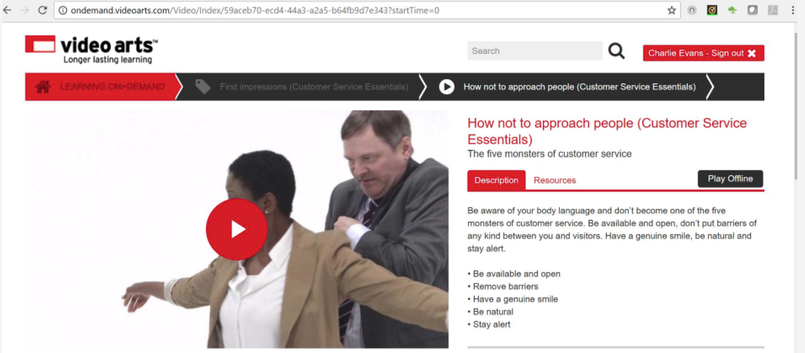

Body Language:

* Can be negative or positive
* Body language can affect the behaviour of others
* Should not be considered in isolation but should be considered along with the words being used
* Body language of both speaker and listener will affect outcome

When dealing with customers body language should always be positive, e.g. welcoming. When you are engaged in face-to-face verbal communication, your body language can play as significant a role in the message you communicate, as the words you speak. Your body language communicates respect and interest. It puts real meaning behind your words.

Your body language and tone of voice can convey exactly what you are thinking, despite the words you are saying.

The following all convey a message:

* The way we stand – posture
* Gestures we make
* Facial expressions:
  + A smile is welcoming
  + A frown is not, but can indicate thought
  + Raised eyebrows can indicate surprise or disbelief
  + Pursed lips – show disapproval

Be aware of your own body language to ensure you do not betray feelings of boredom or irritation. Ask colleagues for feedback on your body language – you may find you have habits you were not even aware of! If the opportunity arises, observe video footage of yourself.

**4 Posture**

* Standing straight makes us feel and appear confident
* Drooping our shoulders or looking at the ground conveys nervousness or disinterest
* Crossed arms indicate that you are defensive and convey the message of being unapproachable
* Putting your hands on your hips makes you look stern while putting your hands in your pockets can often make you seem nervous and can lead you to jingle the change in your pockets – something you may not notice but other people certainly do!
* Standing very close to a customer can be intrusive and forceful

**5 Eye Contact**

Making eye contact gives the impression that the person is important and you are talking directly to them.

* No eye contact – can be seen as ‘shifty’ and untrustworthy
* Do not to look at a person for more than a few seconds – they will feel uncomfortable
* With a group, make eye contact with each person

**6 Tips to improve your verbal communication skills**

about_teamwork_02.jpg

There are 10 verbal communication tips that you should strive to master. These are just as important in your personal life as they are in your professional life.  By improving your verbal communication skills, you will quickly connect and build rapport, earn respect, gain influence, and become more likable and accepted.

1. Be friendly. People who communicate with a friendly tone and warm smile almost always have the edge. The reason is simple: we are subconsciously drawn to people who are friendly because they make us feel good and bring more enjoyment to our lives.

2. Think before you speak. One of the favourite English Proverbs is “Better to remain silent and be thought a fool, than to open your mouth and remove all doubt.” Many people say whatever goes through their minds without putting any thought into what they are saying. As a result, they say things that end up reflecting poorly on themselves.

3. Be clear. Most of us don’t have the time nor do we want to spend our emotional energy trying to figure out what someone else is trying to say. People who are indirect in their verbal communication and who tend to hint at things without saying what’s really on their mind are seldom respected. When there is something you want to say, ask yourself, “What is the clearest way I can communicate this point?”

4. Don’t talk too much. For example, last week you met with a personal chef. At first you were impressed with him and considered hiring him for an upcoming event. However, the more he talked the less impressed you became. Very few people like to be around someone who talks too much and dominates the conversation.

5. Be your authentic self. People are turned off by those people who feel the need to put on a show to make their point. Instead, people are attracted to someone who speaks from the heart and is genuine, transparent, and real.

6. Practice humility. Humility is having a modest view of one’s own importance. It is one of the most attractive personality traits one can possess and is one of the most significant predictors of someone who is respected. People who speak with humility and genuine respect for others are almost always held in high regard.

7. Speak with confidence. You don’t have to sacrifice self-confidence to practice humility. Confidence is a self-assurance arising from an appreciation of one’s true abilities, whereas humility is having a modest opinion of one’s own importance. Speaking with confidence includes the words you choose, the tone of your voice, your eye contact, and body language.

8. Focus on your body language. When you are engaged in face-to-face verbal communication, your body language can play as significant of a role in the message you communicate as the words you speak. Your body language communicates respect and interest. It puts real meaning behind your words.

9. Be concise. Very few thingsare more irritating than when someone can’t get to the point of what he or she is trying to say. Plan ahead. Constantly ask yourself, “How can I say what needs to be said using the fewest number of words possible while still being courteous and respectful?”

10. Learn the art of listening. Being an attentive listener is more important in verbal communication than any words that can come out of your mouth. You must show a sincere interest in what is being said, ask good questions, listen for the message within the message, and avoid interrupting.

Select [here](http://www.littlethingsmatter.com/blog/2010/11/30/10-verbal-communication-skills-worth-mastering/#sthash.elM5jOTa.dpuf) to learn more**.**

**7 Communication barriers**

communicate_effectively_05.jpg

**At times, there will be obstacles to communicating effectively, these may include:**

* Poor listening skills; where an individual hears words, but doesn’t listen to the content and meaning
* Language problems; which may not be purely down to a different language but where an individual might have a speech problem or strong accent
* Lack of communication of essential information
* Lack of discussion between parties
* Misunderstandings or no understanding of what is being said or communicated

Technology breakdowns can now cause communication problems, such as lack of phone communication, internet access, etc.

It is important to adapt methods of communication to meet the individual needs of a range of customers for example those with:

* Language difficulties
* Health issues
* Different age groups
* Cultural differences
* Learning difficulties

It is always important to communicate in a clear, polite, and confident way. Where there are language difficulties it may require the service deliverer to talk slowly, clearly and without the use of jargon. The service deliverer should treat the customer with respect always and work with the individual to meet their needs.

**8 Interpersonal skills**

communicate_effectively_04.jpg

**Other interpersonal skills which can be used to achieve customer satisfaction are:**

* Oral communication skills
* Written communication skills
* Non-verbal communication skills (body language)
* Telephone skills
* Questioning skills
* Listening skills
* Decision-making skills
* Problem-solving skills
* Information-gathering skills
* Personal development skills
* Team working skills

**9 Establish rapport**

**What is rapport?**

A rapport means an understanding and feeling of mutual trust.

Ways to establish a rapport with your customer:

* establish their needs
* listen to them
* recognise any concerns or doubts
* exceed their needs
* ensure they are satisfied with the outcome
* keep any promises made
* communicate

Remember your customers are also your guests, so acknowledge them straight away, especially if you aren’t able to serve them immediately. Keep your approach fresh - you may have done this a thousand times but this is their first impression. Use the human touch, to give them an excellent first impression.

* Acknowledge customers straight away
* Keep it fresh
* Use the human touch. Your approach will shape their experience

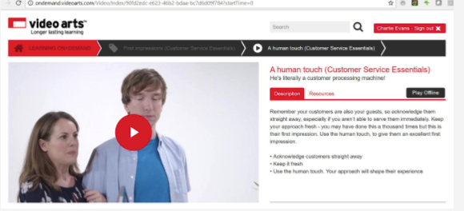

**Using your Voice Effectively**

Think about your pitch, pace and tone and use your natural voice when engaging customers. Be warm, and medium paced, without being smarmy or twittery. Try engaging customers by following their voice patterns a little, but don’t mimic them.

* Pitch, pace, tone
* Use your natural conversation voice
* Mirror pitch, pace and tone to engage

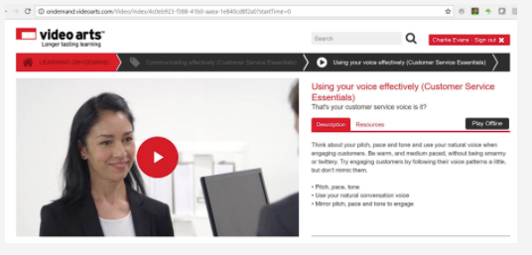

**Verbal and Non-Verbal Signals**

Verbal and non-verbal signals show how a customer may be feeling and they can be used to change the tone and content of your communication to ensure a positive outcome. 

**Verbal signals** include:

* positive - questions being asked, asking for clarification, use of key words
* negative - lack of questions, use of negative words
* positive and negative - tone of voice

**Non-verbal signals** include:

* positive - smiling, nodding
* negative - being easily distracted
* positive and negative - eye contact, posture

**Active Listening**

about_teamwork_04.jpg

Active listening is a skill that can be acquired and developed with practice.  However, active listening can be difficult to master and will, therefore, take time and patience to develop.

'Active listening' means, as its name suggests, actively listening. That is fully concentrating on what is being said rather than just passively ‘hearing’ the message of the speaker.

Active listening involves giving full attention to the speaker, it is important that the ‘active listener’ is also ‘seen’ to be listening - otherwise the speaker may conclude that what they are talking about is uninteresting to the listener.

Select the book below to learn more.

[Active Listening](https://skills.cgkpivot.com/mod/book/view.php?id=13488)

**1 Introduction**

Interest can be conveyed to the speaker by using both verbal and non-verbal messages such as maintaining eye contact, nodding your head and smiling, agreeing by saying ‘Yes’ or simply ‘Mmm hmm’ to encourage them to continue.  By providing this 'feedback' the person speaking will usually feel more at ease and therefore communicate more easily, openly and honestly.

Listening is the most fundamental component of interpersonal communication skills.  Listening is not something that just happens (that is hearing), listening is an active process in which a conscious decision is made to listen to and understand the messages of the speaker.  Listeners should remain neutral and non-judgmental, this means trying not to take sides or form opinions, especially early in the conversation.  Active listening is also about patience - pauses and short periods of silence should be accepted. Listeners should not be tempted to jump in with questions or comments every time there are a few seconds of silence.  Active listening involves giving the other person time to explore their thoughts and feelings, they should, therefore, be given adequate time for that.

Active listening not only means focusing fully on the speaker but also actively showing verbal and non-verbal signs of listening. Generally, speakers want listeners to demonstrate ‘active listening’ by responding appropriately to what they are saying. Appropriate responses to listening can be both verbal and non-verbal:

Watch the video to learn more about active listening:

<https://youtu.be/t2z9mdX1j4A>

**2 Signs of active listening**

effective_feedback_08.jpg

**Non-verbal signs of attentive or active listening**

This is a generic list of non-verbal signs of listening, in other words people who are listening are more likely to display at least some of these signs.  However these signs may not be appropriate in all situations and across all cultures.

**Smile**

Small smiles can be used to show that the listener is paying attention to what is being said or as a way of agreeing or being happy about the messages being received.  Combined with nods of the head, smiles can be powerful in affirming that messages are being listened to and understood.

**Eye contact**

It is normal and usually encouraging for the listener to look at the speaker. Eye contact can however be intimidating, especially for more shy speakers – gauge how much eye contact is appropriate for any given situation.  Combine eye contact with smiles and other non-verbal messages to encourage the speaker.

**Posture**

Posture can tell a lot about the sender and receiver in interpersonal interactions.  The attentive listener tends to lean slightly forward or sideways whilst sitting.  Other signs of active listening may include a slight slant of the head or resting the head on one hand.

**Mirroring**

Automatic reflection/mirroring of any facial expressions used by the speaker can be a sign of attentive listening.  These reflective expressions can help to show sympathy and empathy in more emotional situations.  Attempting to consciously mimic facial expressions (i.e. not automatic reflection of expressions) can be a sign of inattention.

**Distraction**

The active listener will not be distracted and therefore will refrain from fidgeting, looking at a clock or watch, doodling, playing with their hair or picking their fingernails.

**3 Five stages of active listening**

Listening is actually a complex of processes and skills and so it’s convenient to divide the listening process into stages or steps. Five stages can be identified: Receiving, understanding, remembering, evaluating, and responding.

Receiving -  listen not only to what is said (verbally and nonverbally) but also to what is omitted. You receive, for example, your boss’s summary of your accomplishments as well as the omission of your shortcomings or, perhaps, vice versa. Effective reception, then, consists of receiving what is as well as what is not said.

Understanding - process what you are hearing and extract the meaning from the message

Remembering -  it would help little if you received and understood the message but didn’t remember it. If you want to remember what someone says or the names of various people, this information needs to pass from your short-term memory (the memory you use, say, to remember a phone number just long enough to write it down) into long-term memory (or relatively permanent memory)

Evaluating - not all messages are equal - some are untrue, some are truths; some are significant, some are trivial; some are constructive, some are destructive

Responding - after you evaluate the message, you’re likely to respond in some way and your response should demonstrate that you have been through the stages of active listening above

**4 Verbal signs of attentive or active listening**

effective_feedback_12.jpg

**Positive reinforcement**

Although a strong signal of attentiveness, caution should be used when using positive verbal reinforcement.

Although some positive words of encouragement may be beneficial to the speaker the listener should use them sparingly so as not to distract from what is being said or place unnecessary emphasis on parts of the message.

Casual and frequent use of words and phrases, such as: ‘*very good*’, ‘*yes*’ or ‘*indeed*’ can become irritating to the speaker.   It is usually better to elaborate and explain why you are agreeing with a certain point.

**Remembering**

The human mind is notoriously bad at remembering details, especially for any length of time.

However, remembering a few key points, or even the name of the speaker, can help to reinforce that the messages sent have been received and understood – i.e. listening has been successful.  Remembering details, ideas and concepts from previous conversations proves that attention was kept and is likely to encourage the speaker to continue.  During longer exchanges it may be appropriate to make very brief notes to act as a memory jog when questioning or clarifying later.

**Questioning**

The listener can demonstrate that they have been paying attention by asking relevant questions and/or making statements that build or help to clarify what the speaker has said.  By asking relevant questions the listener also helps to reinforce that they have an interest in what the speaker has been saying.

**Reflection**

Reflecting is closely repeating or paraphrasing what the speaker has said in order to show comprehension.  Reflection is a powerful skill that can reinforce the message of the speaker and demonstrate understanding.

**Clarification**

Clarifying involves asking questions of the speaker to ensure that the correct message has been received.  Clarification usually involves the use of open questions which enables the speaker to expand on certain points as necessary.

**Summarisation**

Repeating a summary of what has been said back to the speaker is a technique used by the listener to repeat what has been said in their own words.  Summarising involves taking the main points of the received message and reiterating them in a logical and clear way, giving the speaker chance to correct if necessary.

Watch the video to explore how you can improve your own listening skills:

<https://youtu.be/D6-MIeRr1e8>

**5 Listening to the customer**

When dealing with a complaint, listen and empathise, don’t sympathise. Allow the customer to talk - don’t get defensive, and summarise your understanding before offering solutions.

* Listen and empathise
* Don’t get defensive

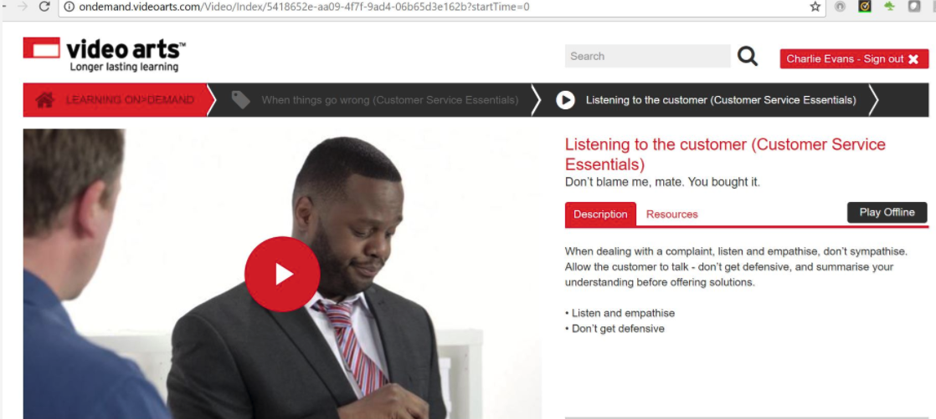

**Questioning Techniques**

effective_feedback_05.jpg

To provide good customer service you will need to have effective questioning skills to ensure that you fully understand the needs of your customer and to check their understanding. Select the book below to learn more.

[Effective Questioning](https://skills.cgkpivot.com/mod/book/view.php?id=13489)

**1 Checking Knowledge**

effective_feedback_01.jpg

Effective questioning should be used to check knowledge. This includes your knowledge and understanding of the needs of the customer and their understanding of the information you have provided. These techniques can be used:

* **Paraphrasing:**  this means that the listener restates the message in his/her own words, e.g. ‘If I understand correctly, you mean …’
* **Clarifying:**  this means the listener reviews their understanding by asking for clarity, e.g.  ‘What do you mean by …?’
* **Probing:**  in order that the listener may obtain more information by asking open and closed questions such as ‘Could you be more specific about …?’
* **Verifying:** this means checking for understanding, e.g. ‘Do you mean …? Is this correct?’
* **Summarising:**  briefly stating the key points of the discussion at its close
* **Leading:** a question that prompts or encourages the answer wanted

You should also ask brief questions and paraphrase the customer's statements to test for understanding. To help guide and control your customer’s interest, use rhetorical questions to confirm understanding, assumptive questions to create decisions, and leading questions to direct them towards a sale or solution.

* Use rhetorical, assumptive and leading questions

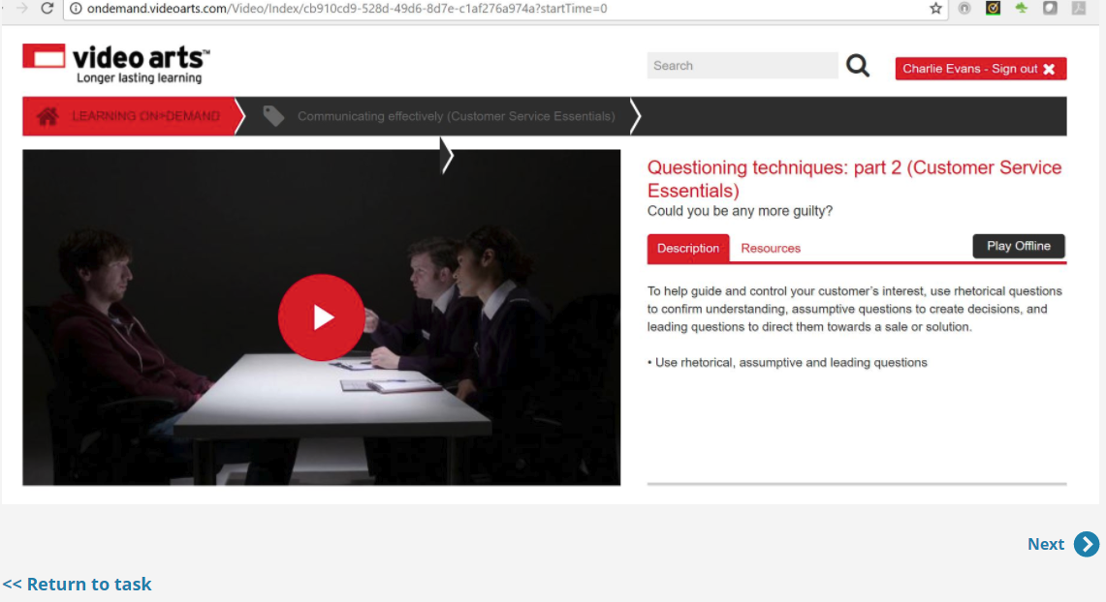

**2 What is an effective question?**

effective_feedback_08.jpg

At its most basic level a question is a sentence or phrase used to obtain information.

**Communication is key**

Asking the right question is fundamental to clear communication. We ask questions to check what people already know, identify gaps in knowledge and check understanding.

**The importance of good communication**

Make sure your questions are clear and in the format and language that the reciever will understand. Listen and check for feedback that indicates whether your question has been understood or not. This tells you if you need to adjust your questioning approach.

**3 Delivery Methods**

effective_feedback_12.jpg

There are many occasions when we ask questions, so much so that it’s an everyday occurrence. The methods we use to ask questions include a written memo or email, a face-to-face meeting or over the phone.

Feedback responses vary depending on the method used. In a face-to-face scenario, people can tell you there and then if something doesn’t make sense.

However, asking questions over the phone requires the need to pause or invite feedback.

**Stimulate thinking**

Questions often generate further questions that help to clarify and broaden understanding.

**Generating responses**

As well as getting information back, the answers you are given reveal misconceptions and misunderstanding as well as any understanding and knowledge beyond what’s expected.

**Making links**

This is less about asking for the facts and more about using what people already know to analyse, evaluate and create ideas.

**4 Open and Closed Questions**

effective_feedback_03.jpg

To get to know your customers and their needs, use closed questions to get facts, open questions to learn more, and recall questions to build a history.

* Use open, closed and recall questions

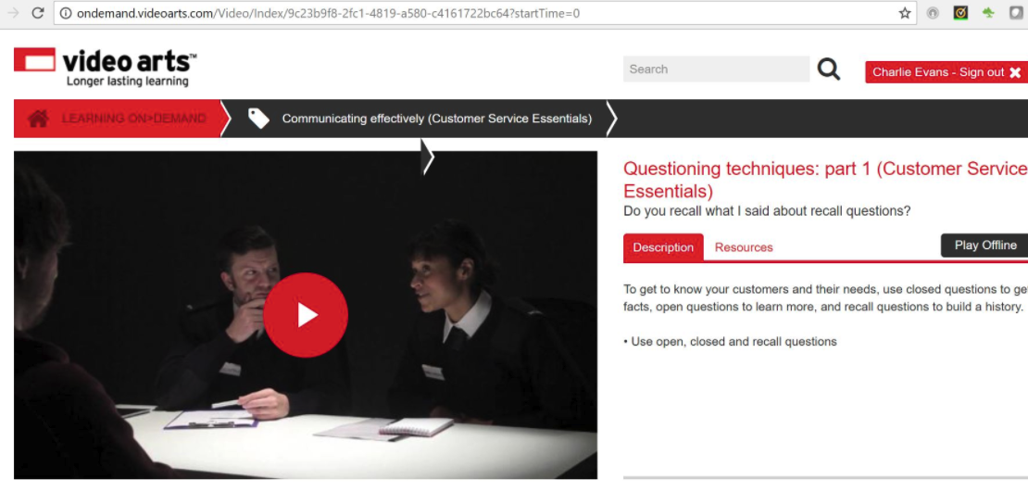

**OPEN** questions tend to start with “What …?”, “Why …?”, “When …?” or “How …?”. They invite people to express and expand their answers as fully as possible, even into multiple answers. So, they’re great for opening up discussion, problem solving and critical thinking.

**CLOSED** questions tend to get only one answer, like, “Have you sealed the valve?” or “What is the customer’s date of birth?” So, they’re best when you want to focus on something specific. For example, you might use closed questions to test knowledge like, “Should you direct customers immediately to the website?”

Closed questions are useful for simple responses that require a lower level of thought. Open questions result in longer, possibly more thoughtful responses and promote a higher level of thinking.

Select [here](http://examples.yourdictionary.com/examples-of-open-ended-and-closed-ended-questions.html) to learn more about open and closed questions.

If you have a chatty customer, use closed questions to keep them on subject, and don’t give up – even if they do drive you up the wall.

* Keep them on subject
* Don’t give up

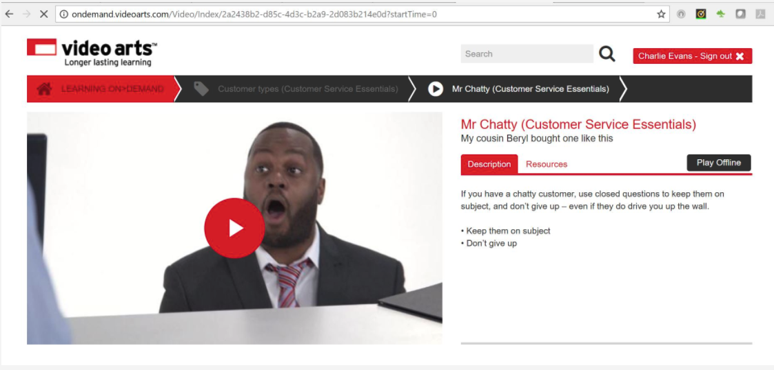

**Communication**

Asking the right question is the key to clear communication. Continue to listen and look for feedback and use this to find the right approach for you.

**5 Using questioning in customer service**

planning_structuring_03.jpg

When trying to resolve a customer service problem or query, keep quiet and let your customer have his or her say. Be prepared to listen. Do not interrupt.

* listen actively
* ask one question at a time
* wait for the customer to answer
* question to check your understanding using open and closed questions as appropriate

Show the customer you are taking the matter seriously and that you understand and care by acknowledging the customer’s feelings, e.g.: ‘I can see you are disappointed…’

* take ownership of the problem
* involve your customer in finding a solution and say what you will do next
* work within the limits of your own authority
* seek your customer’s agreement to any proposed actions
* carry out your actions

**Telephone communications**

If you are asking questions over the phone remember:

* telephone communication conveys words and tone, but without the aid of facial expression
* ensure customers are kept informed
* speak clearly and slowly
* prepare for the call you are going to make or take
* be polite and friendly and smile
* messages left on an answer phone need to be clear

**Preparatory activities**

* **Question 1**

Briefly explain what is meant by:

* 1. customer wants
  2. customer needs
  3. customer expectations

**Question 2**

What are the key differences between:

1. customer wants
2. customer needs
3. customer expectations?

**Question 3**

To identify your customer's needs, wants and expectations you will need to communicate with them clearly and use different questioning styles. Describe **at least three** situations in which you might use **open questions** with customers.

**Question 4**

Describe **at least three** situations in which you might use **closed questions** with customers.

**Question 5**

Research the **five stages** of **active listening**, and describe what each one involves.

**Question 6**

Which stage of listening should you try to adopt when talking to customers, and why is it important to do so?

**Question 7**

Explain why the following reinforcement techniques are useful for confirming customer needs and understanding:

a) summarising language

b) reiterating key points

c) clarifying questions

**Question 8**

Explain why it's important to balance the needs and expectations of a customer with those of the organisation.

**Question 9**

Research the importance of body language, and summarise why you need to adopt the right sort of body language when delivering customer service.

**Question 10**

Describe how the Equality Act affects how you should communicate with customers.

**Question 11**

Get a copy of your organisation's brand guidelines, if one exists, and make a note of things you need to keep in mind. Keep a copy of the guidelines safe in case you need to refer to them at a later date.

**Question 12**

Describe your organisation's communication procedures, tone of voice or house style for both written and verbal contact with customers. Can you see how these guidelines reflect your organisation's brand?

**Question 13**

Explain why following procedures in all communications is important to your organisation and its brand.

**Question 14**

Explain why working together and sharing good practice is important in customer service.

**Next steps**

Now you have completed this section select **SUBMIT TASK FOR REVIEW** and your Assessor will give you feedback. If you have any questions, please contact your Assessor via the messages function.

Task 13 Interacting effectively with customers

**Introduction**

To complete this task you will look at the importance of your interpersonal and influencing skills in communicating with customers to meet their needs and expectations. Delivering excellent customer service is vital to the continued success of your organisation, and you will be involved in this aspect of the organisation's work whatever your particular role and responsibilities.

When completing this task, you will:

* identify the differences between customer needs, wants and expectations
* explain the importance of balancing the needs of customers with the needs of the organisation
* explore open and closed questions as well as reinforcement techniques and explain, using examples, how and when you'd use them
* explain why active listening and body language are so important in interacting with customers, and get feedback from a colleague on how well you interact with customers

**Task 13**

In this task you will be looking at how you can build relationships with customers, regardless of whether you have a face-to-face or non-facing role. You will look at how the words you use, your tine and your body language all help to build trust and rapport. Building a relationship with the customer is key to understanding and meeting their individual needs and expectations.

As part of this task you will be working towards demonstrating the following skills, knowledge or behaviours:

|  |
| --- |
| **Knowledge:** |
| By completing this task you should be working towards understanding the different needs and priorities of your customers and the best way to manage their expectations, knowing how to adapt your style to be highly effective. |
| **Skills:** |
| By completing this task you should demonstrate:   * a willingness and ability to engage with customers in a positive manner using relevant interpersonal skills * the ability to work with customers to build a rapport, recognising and where possible meeting their needs and expectations * a willingness to work with others and share ideas where possible   If you have a **face-to-face** role you should also demonstrate:   * the ability to make initial customer contact and use appropriate verbal and non-verbal communication skills * the ability to adapt tone, behaviour and body language when necessary, recognising and confirming understanding of customer needs and expectations * the ability to recognise when to summarise, and the techniques to use   If you have a **non-facing**role you should also demonstrate:   * the ability to make initial customer contact and make use of appropriate communicate skills * the ability to adapt tone and behaviour when necessary, recognising and confirming understanding of customer needs and expectations * the ability to recognise and use reinforcement techniques during customer interactions |
| **Behaviours:** |
| By completing this task you should be working towards showing you can:   * demonstrate an ability to confidently approach customers, remaining positive and professional even when circumstances are challenging * establish customer needs and expectations, working towards meeting them where possible, and explaining where necessary when they cannot be met * demonstrate recognition of your own role, responsibilities, level of authority and organisational procedures when dealing with customers |

**Knowledge application**

**Question 1**

Describe three **wants** commonly expressed by your customers.

**Question 2**

Describe three **needs** commonly expressed by your customers.

**Question 3**

Describe three **expectations** your customers commonly have of your customer service offer.

**Question 4**

Describe **at least two** situations, using specific examples (without mentioning any names), in which you have used active listening when talking to customers to establish their needs, wants or expectations.

**Question 5**

Answer a) or b) depending on your role.

* 1. If you interact with customers **face to face,** ask a colleague to observe you serving a customer. Get them to feed back to you on how you communicated and built rapport, asking them to focus on your body language, tone and behaviour. Summarise the key points that they raised and how you plan to address them below.
  2. If your interaction with customers is **non-facing**, ask a colleague to listen in on a telephone call, or to proofread an email or letter you have written. Get them to feed back to you on how you communicated and built rapport, asking them to focus on your tone and choice of words. Summarise the key points that they raised and how you plan to address them below.

**Question 6**

Provide a specific example for each of the following situations at work in which you have fulfilled the criteria listed. If there are criteria that you cannot think of specific examples for, keep them in mind when working and make a note of when you next fulfil them.

1. Used reinforcement or summarising techniques to understand a customer’s needs, wants or expectations
2. Adapted your style or method of communication to meet the specific needs of different customers
3. Adapted to different customer personalities when dealing with a concern or complaint, while remaining calm and in control

**Case study 1**

Read the following case study and then answer the questions that follow.

You work for a company that employs an enthusiastic sales force to sell its products, and the initial sales reports are impressive. However, you soon get feedback that some customers are not satisfied with the products, claiming that the salespeople have made exaggerated claims about the product and created unrealistic customer expectations.

**Question 1**

How would you have established the customers’ needs and expectations?

**Question 2**

Describe the actions you would take to build a rapport with the dissatisfied customers to ensure that their needs and expectations will be met.

**Question 3**

How would you have explained the situation to the customers if their needs and expectations could not be met?

**Question 4**

How could you have used your own organisation’s procedures to try to rescue the situation and avoid losing the customers?

**Question 5**

Recognising your level of authority is important in customer service. In your current position and at your level of experience, would you be able to offer the solution you have outlined above, or would you need to get sign-off or refer the situation upwards?

**Case study 2**

Read the following case study and then answer the questions that follow.

Mrs Darling has ordered a washing machine, which could only be delivered on Wednesday between 10am and 2pm. She agrees to wait at home, although she has to get back to work in time to attend an important meeting. At 2pm there is no delivery so she calls the supplier, and is told that ‘the system is down and they can’t reach the driver’. She is promised a return call within 5-10 minutes to provide an update.

Half an hour later, Mrs Darling still has not received an update call. She calls again and this time is told that the driver is behind schedule, and won’t be available to deliver until after 4.45pm. Mrs Darling has to cancel her scheduled work meeting, inconveniencing a number of colleagues.

At 5.30pm the van arrives outside Mrs Darling’s house. The driver and his colleague carry the washing machine into the house but manage to scratch the side of the machine. Mrs Darling says, ‘Careful, you just scratched it!’ but the driver simply replies, ‘Don’t worry, its just a little scratch.’

On the way out they manage to smash one of Mrs Darling’s potted plants in the hallway, and don’t even acknowledge it.

**Question 1**

How would you have established the customers’ needs and expectations?

**Question 2**

Describe the actions you would take to build a rapport with Mrs Darling to ensure that her needs and expectations will be met.

**Question 3**

How would you have explained the situation to Mrs Darling if her needs and expectations could not be met?

**Question 4**

How could you have used your own organisation’s procedures to try and rescue the situation and avoid losing the customer?

**Question 5**

In your current position and at your level of experience, would you be able to offer the solution you have outlined above, or would you need to get sign-off or refer the situation upwards?

**Case study 3**

The following case study has been left blank for you to write about one of your own experiences with a problematic customer.

**Question 1**

Describe the situation you faced, or what the customer concern was.

**Question 2**

What facts, needs and expectations did you establish, and how did you go about finding them out?

**Question 3**

How do you think the customer felt?

**Question 4**

How did you respond in a way that built trust and rapport with the customer?

**Question 5**

What actions and procedures did you take to rescue the situation and avoid losing the customer? Think about whether you were able to meet the customer’s needs and expectations. If you were, explain what you did. If not, how did you explain to them that they could not be met?

**Question 6**

How might you have handled the situation differently?

**Question 7**

Think about your experiences of working with your colleagues, and how you work together to deliver customer service. Give an example of when you have worked as a team, either by making a recommendation for improving your customer service offer, or by going the extra mile to meet a customer’s needs.

**Question 8**

Sometimes you may not be able to go the extra mile to meet a customer’s needs because you will need to balance the customer’s needs and expectations with those of your organisation. Give an example of when you have been unable to meet a customer’s needs because of your responsibilities to your organisation.

**Next steps**

Now you have completed this section select **SUBMIT TASK FOR REVIEW** and your Assessor will review and give you feedback. If you have any questions, please contact your Assessor via the messages function.

g towards **distinction** level, the Customer Service Practitioner standards require you to be able to explain the:

* language - to different customers and their interactions, showing clear knowledge of the application of the Equality Act in all customer handling

Establishing customers needs and expectations

**Introduction**

An organisation needs customers in order to survive and all organisations recognise that it is easier to keep customers by giving good service, than to recruit new ones. Providing customers with the service they expect encourages loyalty and reduces complaints.

Select the book below to learn more about how to develop customer relationships.

[Building customer relationships](https://skills.cgkpivot.com/mod/book/view.php?id=13496)

**1 Good relationships with all customers**

Your customers are both internal and external to the organisation and good relationships with both have enormous benefits.

Good internal customer relationships:

* make it easier to get the job done
* promote efficiency
* create a better working atmosphere

Good external customer relationships:

Good_external_customer_relationships.jpg

**2 Customer loyalty and retention**

The importance of customer loyalty and retention:

* repeat business is easier than trying to attract new customers
* attracting new customers costs money
* organisations who retain their customers are able to grow
* loyal and satisfied customers often pass on the message to their friends and family

**Customer Retention**

Customer_retention_2.jpg

**3 Building relationships with external customers**

The keys to building a relationship with external customers include:

* Good product knowledge
* Remembering their names
* Identifying and remembering their particular needs
* Acknowledging  and recognising them as regular customers
* Create a good first impression
  + Greet customers
  + Always act professionally
  + Be aware of your body language
  + Establish customer needs with probing and open questions

**4 Attitude**

Customers always need to be treated with respect. A positive attitude should always be adopted even when circumstances are difficult. Everyone's attitudes are affected by their age, experiences, values, background and upbringing.

**Values** – are general principles held by individuals such as the need for:

* Freedom
* Privacy
* Honesty
* Equality
* Competitiveness
* Harmony
* Order/tidiness

**Beliefs** – relate to an individuals faith in the following:

* Spiritual
* Moral
* Social
* Intellectual
* Political
* Economic
* Environmental

An individual’s behaviour is affected by all these values and beliefs, and can influence how they deal with customers, colleagues and visitors and their beliefs in the organisations and its product and services . Our emotions also affect our behaviour towards customers:

* Anger - makes us ugly – emitting hostile energy, creating a cause for more ugliness in others
* Happiness/contentment - makes us smile and respond to customers positively
* Sadness - can affect our body language and voice and make customers respond in a similar way
* Pressure/stress - lead to impatience, intolerance and negative behaviours

**5 Gestures**

We make gestures with our arms, hands and our head. It is important, however, not to overuse hands, arms and head: nodding constantly or waving an arm about can be gestures we make without realising we are using them and can detract from the message we are trying to communicate.

* Drumming fingers on a table – can indicate impatience
* Pointing – can be seen as aggressive and threatening
* Mirroring (without obviously mimicking) - can create a feeling of empathy

Talking with our arms is something we all tend to do and in many cultures this is normal. It is important to realise that to different cultures, the messages you communicate through your body language can be different. In some cultures people guard their personal space and do not like it when you invade that personal space. Overall your body language speaks volumes and you should be aware of the message it is conveying.

**6 How to behave in a way that meets customers’ expectations**

Customer expectation varies according to the organisation they are dealing with. For example, if their expectation is basic, they will be happy with accuracy and service that is sufficient. They will not in this case expect a rapport to be established.

As they expect more the behaviours they will expect to see will be more advanced, with an attempt to establish rapport rising to a partnership and behaviour that treats the customer as king.

**7 How behaviour can affect customer expectations**

communicate_effectively_01_b.jpg

It is important to understand how behaviour, communication and interpersonal skills affect customer expectations and satisfaction.

When dealing with a range of customers, you will experience behaviours that require you to adapt your own behaviour. For instance, when confronted with:

* Aggressive behaviour
* Confused behaviour
* People who are upset
* Frustrated
* Worried
* People with special needs
* Cultural needs

Producing positive behaviours in turn will encourage a positive attitude and it is important that negative feelings are not displayed. Negative behaviour on your part will affect customer satisfaction and mean the customer's expectations will not be met.

Each customer transaction impacts upon longer term customer service relationships. Misunderstanding behaviour and making assumptions potentially leads to customer dissatisfaction and mixed communication.

Cultural factors can impact significantly on a customer’s expectation of the service you provide.

**8 Gaining Trust**

It is important to put customers at their ease and gain their trust.

The techniques that can be used to put customers at ease are:

* actively listen to them and show interest
* be patient
* check understanding
* understand their situation when they are complaining
* remain calm and in control when customers are not
* show respect
* allow questioning

The techniques to use to gain trust are:

* show interest
* make use of body language e.g. maintain eye contact
* be consistent
* keep promises e.g. call when you say you will
* admit when you don’t know the answer

**9 Keeping promises**

Customers are busy people and it is important for any promises made to be kept.

Not following up actions and keeping promises can not only result in a loss of the customer but in the customer’s dissatisfaction being passed by word of mouth to others.  It is important if a promise is made and can’t be kept to be honest and let the customer know. Customers may be angry but will then be likely to have respect for the honesty and may not be lost to the organisation or feel the need to complain.

For example, if a customer is told to expect a call they will give up time to wait on the call, and then will be dissatisfied and angry if the call does not come, possibly resulting in the loss of that customer for good.  Think about a time when you have felt let down by an organisation and how this made you feel.

**10 When you are unable to meet expectations**

Sometimes customer expectations cannot be met and it may be appropriate to make alternative service offers. These may include:

* refunds
* replacements
* discounts

Your organisation's policies and procedures will state who has the authority to make alternative service offers and under what circumstances. Always act within your own limits of authority.

**Managing the customer relationship**

An organisation needs customers in order to survive. It is easier to keep customers bygiving good service, than to recruit new ones. Providing customers with the service they expect encourages loyalty and reduces complaints.

Customer retention refers to the ability of a company to retain its customers over a long period. All organisations try to achieve high customer retention.

Select the book below to learn more about the benefits and methods used to achieve high levels of customer retention.

[Managing customer relationships](https://skills.cgkpivot.com/mod/book/view.php?id=13497)

**1 Understanding customer retention**

Customer retention can be defined as:

*The process of keeping existing customers and encouraging them to return to an organisation.*

Customer retention is about customer loyalty. Loyal customers form the base of a growing organisation and help to give a competitive advantage in the market place. As customer choice increases it becomes even more vital to encourage customers to return. Customer loyalty and retention can be encouraged from the first point of contact; a customer will choose to return if they feel they are receiving a good service and value for money.

Customer_retention.jpg

**2 The benefits of customer retention**

analysing_data_02.jpg

It is widely thought that it costs less to keep an existing customer than it is to attract a new one.  A recent survey found that 70% of businesses agreed with this. Costs such as new customer discounts and expensive advertising campaigns can be reduced if there is a customer base already in place. Customers who are satisfied enough to return to an organisation over and over again are much more likely to recommend it to someone else.

Factors that influence customer retention:

* price
* products/services offered
* level of customer service
* level of customer satisfaction
* competition

All the above can help a customer decide whether to use a service again.

**3 Techniques to attract and retain customers**

Organisations used varied methods and often use large budgets in order to attract customers to the organisation, for example:

customer_retention_01_c.jpg

Organisations also use additional techniques to retain existing customers, they can:

**1. Develop customer service standards**

Organisations should continually develop processes and service offers to ensure existing customers continue to receive a high standard of service. Customers are less likely to leave the organisation if they are happy with the service received. This can include offering new products and services and increasing the levels of service.

**2. Respond to customer feedback**

If a customer’s feedback is responded to they are more likely to feel valued by an organisation, if a customer’s views are ignored, they are likely to leave the organisation.

**3. Continue staff training and development**

Staff development is vital in order to consistently deliver high standards of service. A motivated, trained workforce is a contributing factor in the retention of customers. Customers that receive an accurate, relevant and informative service are more likely to be satisfied.

**4. Offer loyalty discount**

Loyalty schemes are one of the most obvious methods to encourage customers to continue to use a product or service. There are different types of loyalty schemes, including:

* Points card – each time you visit you receive points which translate into money off (e.g. Tesco Clubcard, Boots Advantage Card)
* Repeat usage rewards – the more you use a service the more offers you receive (e.g. Nando’s, Costa Coffee)
* Partner rewards – loyalty is rewarded through other organisations, rewards an be transferred to them (e.g. Tesco Clubcard Exchange)
* VIP rewards – exclusive offers for customers of certain groups within an organisation (e.g. BA executive Club)

**4 Customer recovery**

This is a term used to describe the processes used by an organisation to attract previous customers back to the organisation after they have stopped using the products or services.

customer_retention_01_d.jpg

Customer recovery can be done in several ways depending on the size, nature and culture of an organisation:

* customers can be contacted directly
* new procedures can be implemented
* incentives can be offered

Each organisation will look at this process differently.

To the customer, you are the organisation, so don’t rubbish the company. You are key to building the customer’s faith in the organisation so be proud of where you work and what you do. Watch this video to learn more about:

* Supporting your organisation
* Being proud of what you do
* Being proud of your products and solutions

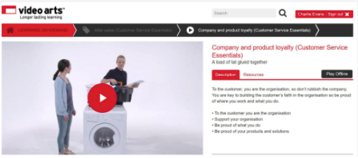

**Going the extra mile**

exceeding_customer_expectations_05

How to deliver the extra positive experience is unique to every business. It is that extra personal touch, or going the extra mile, that sets your organisation apart from the rest.

**Consider this...**

You have lost your mobile phone and not taken out insurance cover. You call your service provider to explain that you now wish to cancel the contract as you do not have the phone.

The customer service advisor informs you there is nothing that can be done and you will still have to pay the agreed monthly cost for the remaining eighteen months. How would you feel about that organisation?

But how would the customer feel if the advisor said this:

"You can reduce your existing tariff to say £10.00 a month, take out a new contract for less minutes and internet, and get a new phone. In total it will cost you the same as the previous contract."

The customer service agent has used her wealth of knowledge to meet your needs and exceeded your expectations, and brought extra business to her organisation.

**Preparatory activities**

**Question 1**

In your own words, and using specific examples, explain what a customer-focused experience might be.

**Question 2**

A key part of providing a customer-focused experience is dealing effectively with customers who need help or have a complaint. Describe a simple process you could follow in most situations to establish the facts when faced with a customer needing help.

**Question 3**

Download and complete this worksheet on facial expressions and body language. Once you have downloaded the worksheet, select ‘save as’ and rename the document to ensure that your work is saved.

Once you have completed the worksheet please upload it below.

**Question 4**

Describe **three ways** in which an organisation can build trust with their customers.

**Next steps**

Now you have completed this section select **SUBMIT TASK FOR REVIEW** and your Assessor will review and give you feedback. If you have any questions, please contact your Assessor via the messages function.

Task 14 Providing a customer-focused experience

**Introduction**

To complete this task you will look at the way you use available information to establish the needs and expectations of your customers. You will also look at the importance of gaining customers’ trust so that you are able to deliver a customer-focused experience.

When completing this task, you will need to:

* explain what a customer-focused experience is
* explain how you can establish the facts in a situation
* look at a number of facial expressions and gestures and identify what they might tell you about a customer’s mood
* describe how an organisation can build trust with customers
* suggest how your organisation could do more to deliver a customer-focused experience and build trust with customers
* complete case studies to explain how you would deal with a customer concern or complaint

**Task 14**

You can deal with customers face to face, by telephone or in writing. The way you establish facts and build trust with customers to create a customer-focused experience will differ depending on the situation. In this task, you will consider the way your organisation creates a customer-focused experience.

As part of this task you will be working towards demonstrating the following skills, knowledge or behaviours:

|  |
| --- |
| **Knowledge:** |
| By completing this task you should be able to:   * explain how an understanding of the facts can be used to create a customer-focused experience * explain how to build trust with customers, and the importance of doing so |
| **Skills:** |
| By completing this task you should demonstrate that you can use a range of questioning skills, including listening and responding in a way that builds rapport, determines customer needs and expectations, and achieves positive engagement. You should also demonstrate that you understand the customer's point of view. |
| **Behaviours:** |
| By completing this task you should be working towards showing that you can uphold the organisation's core values and service culture through your actions. You should also be working towards using communication behaviour that establish clearly what each customer requires, and manages their expectations. |

### Distinction

As part of working towards **distinction** level, the Customer Service Practitioner standards require you to be able to:

* explain how to respond to customer needs and requirements positively

**Knowledge application**

**Question 1**

Using examples, describe how trust is built with customers within your organisation.

**Question 2**

Recommend **one way** in which your organisation could do more to increase customer trust.

**Question 3**

Describe how your organisation delivers a customer-focused experience.

**Question 4**

Now think about an organisation of which you are a customer. Describe how it provides a customer-focused experience?

**Question 5**

Is there anything you think your organisation could learn from this other organisation in terms of providing a customer-focused experience?

**Question 6**

Customer concerns may also be received by email or post. Draft a response to the customer letter below and then upload your response.

Mr H Wilson

10 Downley Street

Brentford

Brentford Town Council

Town Hall

Brentford

18 November 2016

Dear Sir/Madam,

I am writing to express concern over the refuse collection service provided to this part of town. When the weekly collection of refuse was replaced by a fortnightly collection of non-recyclable refuse and a weekly collection of recyclables, we were assured that this would not lead to an increase in litter in the street or the number of rodents in the area.

In reality, the neighbourhood now resembles a war zone, with dustbins and recycling bins left all over the place, rubbish blowing through the streets and mothers afraid to leave their babies out for fear of rat-bites. Any request to the men carrying out the rubbish collection asking that they put the bins back neatly is met with a torrent of abuse.

This situation is intolerable, and I look forward to hearing the steps you will be taking to rectify the situation.

Your faithfully

H Wilson

**Scenarios**

You might be dealing with customers face to face, via written communication (e.g. letter or email) or via the telephone. When handling customer concerns by phone, you have only tone of voice and carefully chosen words to help you, because obviously the customer cannot see what body language you are using.

If you deal primarily with customers by the **phone**, think about asking your tutor, mentor or another learner to telephone you and role-play the following scenarios. Ask them to act as the customer, and think about recording your conversation. Afterwards, reflect on how the call went and see if the other person has any useful feedback.

**Scenario A**

The customer is angry over a failed appointment or delivery. They have taken time off work and waited in all day because your organisation said that the delivery or service call would be happening today. It is now 4.30pm, no one has arrived and no contact has been made. The customer is insisting on receiving the delivery or service today or they will demand compensation for their lost wages.

**Question 1**

What facts do you need to establish? How will these facts help you to give a customer-focused response?

**Question 2**

How do you think the customer feels?

**Question 3**

How could you respond in a way that builds trust with the customer?

**Question 4**

How might the organisation have handled the situation differently?

**Scenario B**

A customer calls to complain that they were told that all calls were free and that they had unlimited internet access when they signed up for a new mobile phone contract with your company. However, their first monthly bill is showing charges for calls to phones on other networks and for downloading music. These charges are correct, and the customer has clearly misunderstood the information they were originally given. They are not particularly computer literate, and are thoroughly confused over what they should be charged for.

**Question 1**

What facts do you need to establish? How will these facts help you to give a customer-focused response?

**Question 2**

How do you think the customer feels?

**Question 3**

How could you respond in a way that builds trust with the customer?

**Question 4**

How might the organisation have handled the situation differently to ensure the customer understood the information they were given?

**Scenario C**

The customer’s first language is not English. They are worried that they have not received a bill for their electricity usage since moving into their house eight months ago. They are concerned that their electricity might be cut off for non-payment, or that the bill will be very high when they finally do receive it.

**Question 1**

What facts do you need to establish? How will these facts help you to give a customer-focused response?

**Question 2**

How do you think the customer feels? Did they understand your response?

**Question 3**

How could you respond in a way that builds trust with the customer?

**Question 4**

How might the organisation have handled the situation differently?

**Scenario D**

The following scenario has been left blank for you to write about one of your own experiences.

**Question 1**

Describe the situation you faced, or what the customer concern was.

**Question 2**

What facts did you need to establish? How did these facts help you to give a customer-focused response?

**Question 3**

How do you think the customer felt?

**Question 4**

How did you respond in a way that built trust with the customer?

**Question 5**

How might you have handled the situation differently?

**Next steps**

Now you have completed this section select **SUBMIT TASK FOR REVIEW** and your Assessor will review and give you feedback. If you have any questions, please contact your Assessor via the messages function.

Products and services

**Introduction**

An important part of being able to provide information to customers is keeping your own knowledge up to date. This will involve keeping up to date with the products and services that your organisation offers including their features, benefits and terms and conditions.

Once you know these, you will be able to match the customer's wants, needs and expectations to the most suitable offer.

**Knowing your products and/or services**

To provide quality customer service it is essential that you are up to date with the products and services that are offered by your business. So that you can provide accurate information to customers, you need to take the time to familiarise yourself with many aspects of the products and services on offer. Keeping up-to-date with product and services knowledge is vital. Various sources of information about products and/or services will be available within an organisation e.g. catalogues, brochures, price lists, colleagues, internet, intranet, training sessions, organisational product and/or service information/literature, word of mouth from customers.

**Products** are commercially distributed goods that are the result of a fabrication, manufacturing or production process. These goods are then sold to customers before being consumed or used. **Services** however, are intangibles such as accounting, banking, cleaning, consultancy, education, insurance, expertise, medical treatment or transport. No transfer of ownership takes place when services are sold, they cannot be stored or transported, and they come into existence at the moment they are bought and consumed.

Knowing your stuff gets the customer onside. You should have a detailed knowledge of what you’ve got – your product range and its features. You should also know your policies, as well as having a wider knowledge of the business and the market landscape.

* Know what you’ve got
* Know your policies
* Know the business

Watch this video to learn more.

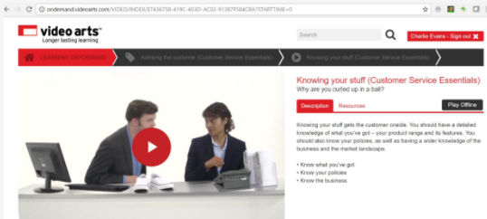

**Features and benefits**

Organisations will promote the features of a product or service, but the customer will buy the benefits. Features are what the product or service does, its dimensions and specification. The benefits are what the customer thinks they should experience or get. It can sometimes be difficult to tell the difference between the two, as many features might sound like benefits. For example, a smartphone may have a fast internet connection - this is actually a feature not a benefit, but this may be a benefit when the customer is looking for directions quickly when they are lost.

Another example is a low-calorie drink or snack. The low calorific value is a feature of the product, whilst the benefit to the consumer is that it is a healthier option. Therefore, the benefits of a specific product are how the product's features meet the needs of the individual customer. Benefits are the outcomes or results that customers will experience and are the reasons they will purchase your product or service. Customers purchase something to solve a problem, and understanding the individual needs of your customers will enable to to provide them with the appropriate product or service.

Features like ‘it’s got auto-tension’ are factual statements but they won’t entice customers to buy. A benefit (like ‘it’s incredibly comfortable’) answers the question ‘What's in it for me?’ People buy benefits – so explain them to them.

* Features are factual statements
* Benefits are value statements

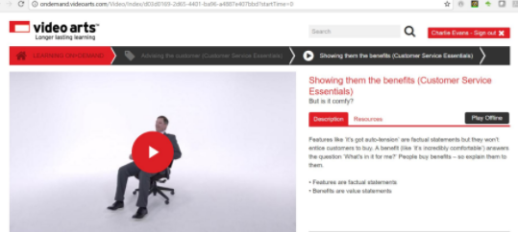

Think about the products and/or services offered by the organisation you work for, and what their features and benefits are.

**Unique selling points or service offers**

A unique selling point (USP) or unique selling offer (USO) is also called a unique selling proposition. USPs and USOs are used to differentiate what one organisation provides by way of products and/or services from another.

The unique selling proposition/unique sales proposition (USP) is the unique benefit of the product, which a firm promotes to its target customer. It should be remembered that ‘customers buy benefits, not features’ and these benefits are aggressively promoted by organisations consistently over time. The benefit is usually that the product, service or organisation has a certain superiority: best quality, best performance, lowest price, best economy, reliable delivery, greatest durability, best safety, most advanced technology.

Many people feel that organisations should promote only one benefit of a product or service and stick to it. An organisation that consistently promotes its product or service as the cheapest, the most advanced, the best quality, or as No. 1 and consistently achieves it will probably become best known for it. It should also be promoting that its competition cannot or does not offer this. Supermarkets for example may promote themselves as being the best value.

Others feel that organisations should list the major selling points of each product or service, highlighting these that are unique to the product or service and give an advantage over those similar products/services that are offered by the competition. This may be necessary when two or more companies in the same sector are promoting themselves as the best on the same benefit e.g. price. In recent years, companies are increasingly using more benefits to sell a product.

Organisations need to be very careful how they promote and position their product/ service, or self, as it is too easy to

a) fail to position the product etc (under-positioning)

b) give consumers too narrow a picture of the product (over-positioning)

c) give consumers a confused picture of the product (confused positioning)

d) stretch the consumers’ perception of the product too far (implausible positioning)

There are though organisations that focus on a unique emotional selling proposition (ESP). Here they may be similar or have a similar product or service to the competition but the customer has an emotional association, which is promoted. Rolls Royce, Ferrari are examples of this where they mean something very special to the customer – they are something the customer dreams of.

**Bringing products to life**

Watch this video about sharing positive stories from your customers to bring your products or services to life.

* Stories help bring your products/services to life
* Think about the positive stories your customers have shared with you

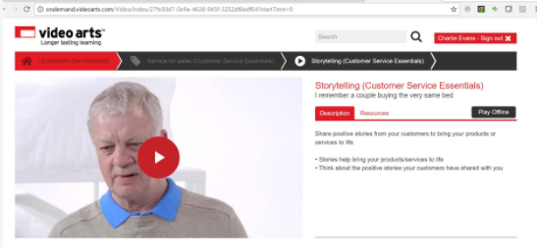

**Preparatory activities**

**Question 1**

In your own words, explain the differences between features and benefits, using examples from the products and/or services offered by your organisation.

**Question 2**

In your own words, explain the differences between products and services. If your organisation sells both products and services you should provide specific examples to help you demonstrate the differences.

**Case study 1**

Read the case study below and then answer the questions that follow.

You are working in the reference section of the public library. A customer who is new to using computers repeatedly approaches you to help her to set up an email account. She has no idea how to do it because she has never used a computer. As you are not busy, you provide her with help for a few minutes. A queue begins to form at your desk and you have to leave to attend to other customers. The woman then loudly complains about the lack of service at the library.

**Question 1**

How would you identify this customer’s expectations?

**Question 2**

How could you manage this customer’s expectations?

**Question 3**

How would you check that this customer’s expectations have been met as far as is possible in the situation?

**Case study 2**

Read the case study below and then answer the questions that follow.

You are working in an electronics store, helping customers to choose from a wide range of computers. You have an in-depth product knowledge, and enjoy advising customers about the features and benefits of different models, the costs of adding various software packages, and the ongoing charges involved.

You are trying to assist a customer who assures you that he does not want any assistance or advice, even though you know you could reduce his confusion.

**Question 1**

How would you identify this customer’s expectations?

**Question 2**

How could you manage this customer’s expectations?

**Question 3**

How would you check that this customer’s expectations have been met as far as is possible in the situation?

**Case study 3**

Read the case study below and then answer the questions that follow.

You are working on a project with an internal customer. You start getting the impression from their phone calls and emails that they feel you are not keeping them sufficiently informed about the project’s progress, timescales and costs.

**Question 1**

How would you identify this internal customer’s expectations?

**Question 2**

How could you manage this internal customer’s expectations?

**Question 3**

How would you check that this internal customer’s expectations have been met?

**Next steps**

Now you have completed this section select **SUBMIT TASK FOR REVIEW** and your Assessor will review and give you feedback. If you have any questions, please contact your Assessor via the messages function.

Task 15 Knowing your products and services

**Introduction**

When meeting customer needs, some of the most important things to know are the features and benefits of the products and/or services you can offer.

Once you know these, you will be able to match the customer's wants, needs and expectations to the most suitable offer.

When completing this task, you will need to:

* complete case studies to increase your understanding of how to meet customer expectations
* explain the importance of keeping your product or service knowledge up to date, and identify the sources of information you can use to do this
* identify the features and benefits of a number of products and services offered by your organisation
* identify the unique selling points or unique service offers of your organisation's products or services, and those offered by a competitor
* consider three key offers provided by your organisation, and describe the type of customer each offer is suited to and why

**Task 15**

In this task, you will consider the importance of updating your knowledge of your organisation's products and/or services.

As part of this task you will be working towards demonstrating that you have the following skills, knowledge or behaviours:

|  |
| --- |
| **Knowledge:** |
| By completing this task you should be able to:   * Explain the differences between features and benefits of products and/or services in your organisation * Describe how to maintain your knowledge of your organisation’s products and/or services |
| **Skills:** |
| By completing this task you should be working towards demonstrating that you can:   * Offer appropriate product and/or service options to meet the identified needs of customers and the needs of the organisation * Communicate to customers in a clear and coherent manner how the products and/or services offered meet their needs |
| **Behaviours:** |
| By completing this task you should be working towards showing that you can:   * Demonstrate knowledge of the organisational products and/or services * Knowledge and application of the organisation’s policies and procedures |

### Distinction

As part of working towards **distinction** level, the Customer Service Practitioner standards require you to be able to:

* explain why it is important to update your knowledge on the organisation's products and/or services

**Knowledge application**

**Question 1**

Explain why it is important that you keep your knowledge of the products and services offered by your organisation up to date.

**Question 2**

List the sources of information available in your organisation that will help you keep your product/service knowledge up to date. For each one, explain how and why it is useful.

**Question 3**

Give details of up to two different product and service training sessions you have attended. These could be formal sessions, or just informal training from a colleague.

For each session state:

* Subject of the training session
* What did you learn from attending the session?
* Why was it important that you attended the session?
* How will you use this training when advising customers on the product/service?
* Upload any certificates awarded as part of completing/attending the training session (if applicable)

**Question 4**

Download and complete this worksheet which will require you to research and describe the possible features and benefits of some products and services. Once you have downloaded the worksheet, select ‘save as’ and rename the document to ensure that your work is saved.

Once you have completed the worksheet please upload it below.

**Question 5**

Download and complete this worksheet which will require you to identify the unique selling points or unique service offers for the main products and services your organisation offers. Once you have downloaded the worksheet, select ‘save as’ and rename the document to ensure that your work is saved.

Once you have completed the worksheet please upload it below.

**Question 6**

Download and complete this worksheet which will require you to identify the main offers provided by your organisation. Once you have downloaded the worksheet, select ‘save as’ and rename the document to ensure that your work is saved.

Once you have completed the worksheet please upload it below.

**Question 7**

Research the main products or services of a leading competitor to your organisation. For each product, identify its unique selling points or unique service offers.

**Question 8**

Consider whether any of the products or services offered by the competitor could be adapted and added to your organisation’s range to improve sales and/or profits. Make a recommendation for a possible improvement or addition, explaining the benefits to your organisation’s offer.

**Next steps**

Now you have completed this section select **SUBMIT TASK FOR REVIEW** and your Assessor will review and give you feedback. If you have any questions, please contact your Assessor via the messages function.

Digital and social media

**Introduction**

using_social_media_01_a.jpg

Various digital media sites may be used by organisations within their customer service functions. Social media has become an important part of any organisation's digital marketing strategy and customer services are increasingly provided through the use of online chat and email.

Whilst these technologies can improve the customer experience you also need to be aware of the potential pitfalls and ensure that you are fully aware of your organisation's policies and procedures.

Select the book below to learn more about using digital and social media.

**What is digital and social media?**

**1 Traditional media**

Traditional media sources are TV, radio, newspapers and books and there are a number of key features in terms of how content is created and transmitted:

* **Single source** – with many receivers, e.g. a newspaper is printed by its publisher and sold to its many readers; a TV channel broadcasts its programmes to many viewers
* **Professional content**- the sources of media are paid professionals
* **Controlled** - the content is structured and controlled in the messages the broadcaster intends to transmit
* **Top-down, passive, one-way communication**- messages are transmitted from the single source down to its many readers, viewers and listeners and there is little or no opportunity for interaction

what_is_social_media_01.jpg

**2 Social media**

In comparison social media has many sources and many receivers. It is an active form of media and everyone can be both a source and a receiver. Again, there are a number of key features of social media:

* **User-generated content** - anyone using social media can post content, making it two-way communication.
* **Bottom-up** - social media allows those who were traditionally the receivers of information to generate information. There are several instances of high social media activity forcing traditional media broadcasters to take an interest in previously unreported crimes and trials. In situations of emergency or chaos, bottom-up reporting via social media has succeeded where traditional media sources have failed to provide enough information quickly enough (e.g. during the floods in the Balkans in September 2014).
* **Unstructured** - messages are based on individuals’ opinions rather than any controlled bias. Traditional broadcasters may slant their messages according to their purpose.

what_is_social_media_02.jpg

**3 Types of social media**

what_is_social_media_03.jpg

Social media is the broad term for internet-based tools used on PCs, laptops, tablets, and smart phones to help people make contact, keep in touch and interact.

|  |  |  |
| --- | --- | --- |
| **Type of social media** | **Description** | **Examples** |
| Blogs/microblogs | forms of online journal; microblogs often restrict word usage on subscribers’ opinions and comments | [WordPress](https://wordpress.com/create/), [Blogger](https://www.blogger.com/about/?r=1-null_user), [The Huffington Post](http://www.huffingtonpost.co.uk/the-blog/), [Twitter](https://twitter.com/?lang=en) |
| Business networks | making business contacts and professional networking | [LinkedIn](https://www.linkedin.com/), [Xing](https://www.xing.com/en) |
| Forums/chat rooms | topic lead threads providing questions and answers | [The Student Room](https://www.thestudentroom.co.uk/), [Slick Deals](https://slickdeals.net/) |
| Products/services review | consumers post their reviews and comments about products and services, allowing others to make informed purchasing decisions | [TripAdvisor](https://www.tripadvisor.co.uk/), [Reviews.co.uk](https://www.reviews.co.uk/) |
| Interest catalogues/bookmarking | save content posted by others according to their interests | [Pinterest](https://www.pinterest.co.uk/), [Stumbleupon](https://www.stumbleupon.com/) |
| Social networks | interactive networking with friends | [Facebook](https://en-gb.facebook.com/), [Google+](https://plus.google.com/collections/), [Match.com](http://www.match.com/) |
| Video/photo sharing | view, share and upload videos and photos | [YouTube](https://www.youtube.com/), [Flickr](https://www.flickr.com/) |
| Gaming/virtual worlds | allow Massively Multiplayer Online Games (MMOGs) where a large number of players create their own characters and interact in a virtual world | [Kaneva](https://www.kaneva.com/) |

**4 Social media use**

what_is_social_media_09.jpg

* Around 70%* of adults have at least one social media profile
* Around 90%* of those aged 16–24 have at least one profile
* Facebook and Twitter continue to be the most popular sites
* The increasing popularity of social media suggests there are many positive aspects of joining an online community
* Many of those positive aspects may be identified by looking at what people use social media for

*Source: Ofcom Adults’ media use and attitudes Report 2015. This sees an overall increase from 60% in 2014.

**5 Positive uses of social and business networking**

what_is_social_media_05.jpg

* **Making friends and forming relationships** – it is quick and easy to make contact with others which may extend beyond virtual friendships
* **Finding a job** – professional networking sites allow you to provide a resumé of your skills and experience and notify you of potential employment opportunities. Others who know you professionally can endorse your skills
* **Staying in contact with friends and family** – our lives have become time-poor and few people have time to keep in touch with friends by telephone; social network sites provide a quick way of maintaining contact wherever those friends are in the world
* **Sharing photos** – allowing friends to view and download photos – these might be of products they have recently purchased
* **Recouping lost contacts** – with around 70% of the adult population having a social network profile, it is easy to find old friends you have lost contact with and quickly catch up on what they have been up to
* **Exchanging news and information** – by sharing posts, there is rapid dissemination of news and information which can be used to promote new products and offers
* **Asking for help** – it is easy to ask your group of friends for advice or help, for example, if you are looking to find a new flatmate or source a recommendation for a product or service
* **Fund-raising** – posted and shared clips of videos showing friends performing amusing actions have been highly successful in raising money for charities
* **Advertising** – it is relatively cost effective for organisations to purchase advertising space on social media sites and popular adverts are shared widely which promotes recommendations and reaches a wider audience and potential new customer bases

**6 Negative aspects of social media**

negative_aspects_01.jpg

As with any popular medium, negative aspects can arise from its use.

These can be categorised under the following headings:

* **Behavioural problems** – e.g. cyberbullying and lost work time
* **Privacy issues** – e.g. social media posts can be used in criminal cases or divorce hearings
* **Defamation** – damage to personal or organisational reputations through careless posting of information or comments
* **Criminal use** – e.g. hacking and phishing for personal details, robbery due to posting that you will be on holiday, and copyright infringement due to sharing unauthorised content
* **Spread of misinformation** – e.g. in 2015, in a bid to be the first with the news, a BBC employee mistakenly reported the death of queen on Twitter, causing a stir and resulting in disciplinary proceedings against her.
* **Inappropriate exposure** – of children to inappropriate content, grooming and sexting

**7 Minimising risks**

negative_aspects_08.jpg

* Social media is here to stay…and so are all your posts
* The posts that seem hilarious and cool now are most likely not going to reflect your personality in ten years’ time
* The instantaneous nature of many social media interactions means they are likely to be less considered than other types of permanent written communication

**When posting:**

* **Consider the appropriateness of using social media for communicating information** – sensitive communications should be by other methods. Consider the reactions of those reading the post
* **Use social media positively** – Do not be afraid to block/unfollow people whose posts stir up negative emotions in you, whether these be feelings of discontent with your life, painful reminders of a past relationship or simply irritation. Make sure that if you are using social media within your organisation your posts are positive and reflect well on your company
* **Think before you post!** Your profile is an advertisement for you and/or your organisation. Do not allow inappropriate photos or off-the-cuff comments to count against you in the future

**Social media in the workplace**

using_social_04.jpg

When using digital and social media in the workplace either for personal use or to communicate with customers you need to be aware of your organisation’s policies and procedures. Select the book below to learn more.

**Using social media in the workplace**

**1 Types of organisations using social media**

This video looks at how businesses can use social media:

<https://www.youtube.com/embed/rKtijMCqmvM>

Social media is used for different purposes by different types of organisations. Many organisations use social media as a marketing tool:

* to increase website traffic
* to build conversions with existing and new customers
* to raise brand awareness
* to create a brand identity and positive brand association
* to improve communication and interaction with key audiences

But social media is not just about marketing. The majority of consumers now go to social media for customer service and they expect fast response times and 24/7 support.

**2 The appropriate use of social media in the workplace**

using_social_09.jpg

Work is a big part of your life so it is only natural that day to day experiences good and bad can filter into social media conversations. If your employer has valid concerns about the way their employees conduct their personal lives, such as breaches of commercial confidentiality or bringing the organisation into disrepute. Such activities could count as gross misconduct, and even justify dismissal. This is the same whether the misconduct happens online or offline.

Select the link to look at the [social / digital media](http://blog.hirerabbit.com/5-terrific-examples-of-company-social-media-policies/) policies of some international brands. It is important that you understand your organisation’s social / digital media policy as it will enable you to provide excellent customer service without compromising your organisation or your own position.

**3 Employees and social media**

using_social_10.jpg

The impact of social media on the workplace is increasing and affects communication among managers, employees, and job applicants, how organisations promote and control their reputation, and how colleagues treat one another. It can also distort the boundaries between home and work.

Your employer should have a policy on personal use of IT equipment, and clearly explaining what you are allowed to do, and what you cannot do. If you have any questions speak to your supervisor or line manager.

Some employers will be happy for you to make personal use of the internet during clearly defined periods, such as breaks or after hours. Others who want to structure work in more flexible ways may be happy for you to take occasional breaks when you wish, so long as you make up the time overall. This depends on the management style of your employer.

It may also be relevant to consider whether your employer permits you to use a work email address to register for social media services. Unless you are using Facebook officially as part of your job, it would be more appropriate to use a private email address.

**4 Social media and you**

On social media you’re never fully off duty. Make sure you maintain high personal standards. Don’t be critical of the company, colleagues or customers. Watch this video to learn more:

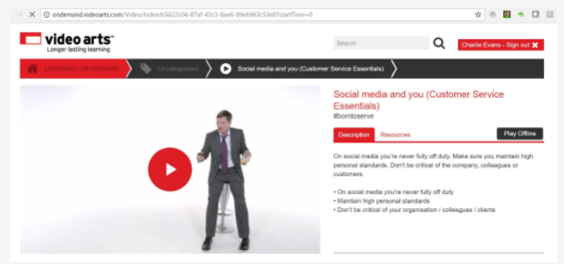

**5 Social media and the customer**

When using social media, empathise with customers publicly, but take one-to-one discussions away from the public eye. Remember you represent the company, and don’t over promise. Watch this video to learn more:

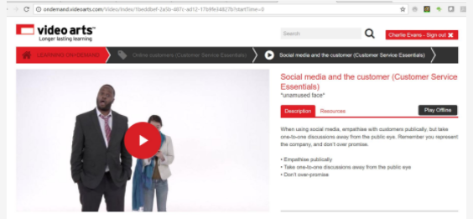

**6 Email and webchat**

When emailing and in webchat, you can be more informal that you might in a letter, but don’t take it too far. Check your emails, and respond promptly to those requesting action. Above all, be polite and don’t email when angry! Watch this video to learn more:

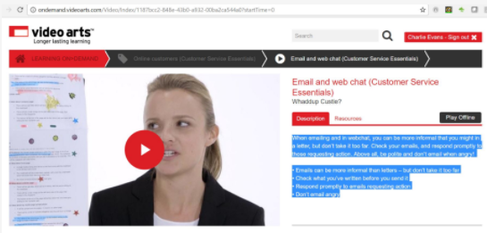

**Preparatory activities**

**Question 1**

Research and list the different types of **social** and **digital media** that are available for use.

**Question 2**

Think about your **personal usage** of **social** and **digital media.**  What consequences might there be for you and your organisation if you are not careful about your use?

**Question 3**

Which **digital** and **social media** are used in your organisation?

**Next steps**

Now you have completed this section select **SUBMIT TASK FOR REVIEW** and your Assessor will review and give you feedback. If you have any questions, please contact your Assessor via the messages function.

Task 16 Using digital media

**Introduction**

managing_use_socialmedia_01_a.jpg

To complete this task you will research digital and social media policies to see how they affect delivery of customer service. If your organisation is fairly small and has no social or digital media policy, you will be asked to research those of other organisations and come up with some suggestions as the basis for a new digital and social media policy.

Digital and social media policies set expectations that any public posts will not expose the organisation to legal problems or embarrassment. Policies often include instructions about when an employee should identify themselves as a representative of a company on a social networking website, as well as rules for what types of information can be shared publicly.

When completing this task, you will need to:

* look at the types of digital and social media available
* reflect on how to use them appropriately
* research the digital and social media policies of different customer service organisations, and explain why these policies are necessary
* make recommendations for improving your organisation's use of digital and social media

**Task 16**

In this task, you will consider digital media policies and why they are important.

As part of this task you will be demonstrating that you have the following skills, knowledge or behaviours:

|  |
| --- |
| **Knowledge:** |
| By completing this task you will be able to:   * describe the guidelines in a digital media policy that affect the use of social and digital media in the work environment. |
| **Skills:** |
| By completing this task you will demonstrate personal organisation skills in your research by motivating yourself and managing your workload. You will also be considering how to use an appropriate tone of voice in digital communications that reflects the organisation’s brand. |
| **Behaviours:** |
| By completing this task you will work towards showing you can uphold the organisation’s core values and service culture through your actions, as well as taking responsibility for keeping your service knowledge up to date. |

**Knowledge application**

**Question 1**

Explain why it is necessary to have digital and social media policies in customer service organisations.

**Question 2**

Research the digital and social media policies that exist in different organisations. Briefly summarise a typical digital and social media policy from one of the customer service organisations that you have researched.

**Question 3**

Research the digital and social media policies that exist in your organisation (if your organisation has any). Upload a copy of the relevant policies if you are able to. Briefly summarise the policies here.

**Question 4**

Explain how following your organisation's policies will affect your role in delivering customer service. If your organisation does not have a digital media policy, look at the typical policy you researched and explain how following that would affect your role.

**Question 5**

Prepare a presentation to deliver to the relevant person/people in your organisation, explaining how introducing or improving the use of digital and social media could improve your organisation’s customer service. Keep in mind any existing digital and social media policies and how they would need to be considered or adapted.

Make notes on what you will cover in your presentation below and if possible attach a copy of your presentation.

**Next steps**

Now you have completed this section select **SUBMIT TASK FOR REVIEW** and your Assessor will review and give you feedback. If you have any questions, please contact your Assessor via the messages function.

Communicating effectively with colleagues

**Introduction**

effective_teamwork_01_a.jpg

Effective communication produces efficient working relationships, supports delivery of effective customer service and allows you and your colleagues to resolve issues in a collaborative manner.

As part of increasing the effectiveness of your customer service delivery, you will also consider how best to communicate with customers to help you develop suggestions for improvements.

**Teamwork**

effective_teamwork_01_c.jpg

A team is a small group of people who possess complementary skills and who are working together to accomplish common goals.

Select the book below to learn more.

**Working as a team**

**1 Teamwork**

about_teamwork_01.jpg

Teamwork enables you to accomplish tasks faster and more efficiently than tackling projects individually. Cooperating on various tasks reduces workloads for all employees by enabling them to share responsibilities or ideas. Teamwork also reduces the work pressure on every worker, which allows him/her to be thorough in the completion of the assigned roles. In sharing ideas or responsibilities, every employee should have a role that suits their specialisation. You should also consider employees' levels of interest in the project at hand, which positively influences the efficiency or speed of their output in accomplishing the task.

A team is at their most effective when:

* Everyone understands the common goals that they are trying to achieve and appreciates that the team's aims are more important than the individual's
* Everyone has a role in the team and each member understands their role and the skills of others
* Everyone is relaxed in the company of the team members and offers support when it is needed
* There is trust, respect and open communication
* Everyone shares responsibility for the work

All teams must work to achieve the organisation's objectives, so every member of staff needs to:

* Be aware of the organisation's objectives
* Understand how the work of the team helps to achieve them
* Understand how their own role helps to achieve them

Every team will have its own targets and objectives that feed into the overall organisation.

For a team to work effectively, they have to develop productive and positive working relationships that are based on:

* **clear lines of communication** – so that people know where to go to ask questions, or report and discuss issues
* **openness –** giving and receiving correct and appropriate information
* **mutual trust and respect** – where everyone listens to each other, and acknowledges feelings and opinions.

**2 Teams or groups?**

team_characteristics_01.jpg

It is important to understand how **teams differ from groups** in the workplace:

* a group is a collection of individuals who coordinate their individual efforts
* a team is a group of people who have a common team purpose and challenging goals. Team members are mutually committed to the goals and to each other

The difference between a group and a team can be illustrated by looking at the examples of a high street bank cashier and a surgeon. Both employees have a clear focus on what is required of them but there are several important differences about how they work.

The cashier that serves you when you are paying in money is one of a number of cashiers. The role of each cashier is to provide customers with a number of services. Each cashier, however, works independently. The cashiers in a bank could be described as a work **group**.

However a surgeon works as part of a team in the operating theatre. The surgeon, the anaesthetist, the nurse, and the junior doctor all have distinct roles. These roles are complementary and inter-dependant. The surgical procedure could not be undertaken effectively without each member of the **team** co-operating fully.

Organisations use both groups and team depending on the work to be undertaken.

**3 Effective teamwork**

about_teamwork_02.jpg

Teamwork is important in an organisation because it provides employees with an opportunity to bond with one another, which improves relations among them. Workers who constitute a team working on a project often feel valued upon the successful completion of such tasks. A situation in which all of them find a chance to contribute towards the tasks improves relations within the team and enhances their respect for each other.

**Benefits of team work – match up the statement with definition**

|  |  |
| --- | --- |
| Shared workload | Shared and delegated according to individuals’ strengths and abilities |
| Best use of individuals’ strengths and abilities | Members can learn from each other and thus diversify and increase their skills |
| Support, greater productivity, efficiency | Co-operative, supportive team will be much more efficient and therefore contribute to greater productivity |
| Motivating | Team spirit increases morale, gives a sense of commitment, makes working more enjoyable and motivates individuals |
| Sense of participation | People feel that they are part of a team and the decision-making process, they accept change better |

**4 Benefits for individual team members**

effective_teamwork_01_d.jpg

Individuals can benefit from, for example:

* **feeling proud to be associated with a successful and effective team** – e.g. a sense of belonging and job satisfaction
* **feeling supported when tackling tasks or learning new skills** – e.g. being able to develop their skills and stretch their talents with the help of others
* **feeling secure and confident** – e.g. from knowing that they are delivering high-quality goods and services
* **other team members’ knowledge, skills and experience** – e.g. making the whole team more successful
* **opportunities for creativity and career development** – e.g. from team members supporting each other and being innovative
* **increased motivation** – e.g. to stay on a good team and help it to succeed by doing their best
* **feeling valued** – e.g. knowing that their input is important and that their opinions matter

**5 Benefits for teams**

effective_teamwork_01_b.jpg

Teams can benefit from:

* **working towards shared objectives** – e.g. working together effectively towards agreed, shared goals
* **team members who are flexible and able to do several tasks** – e.g. multi-skilled team members who can be moved around between tasks or cover for each other’s holidays or periods of sickness
* **a balanced and supported environment** – e.g. from being a happy team where the members support each other and tackle objectives and problems together
* **bringing together expertise of team members for the benefit of the whole team** – e.g. having people with different strengths and attributes

**6 Benefits for the organisation**

about_teamwork_01.jpg

The benefits of effective team working can be considerable for an organisation, for example:

* **successful achievement of organisational objectives** – e.g. to meet or exceed sales or production targets
* **access to a wide range of talents and strengths within the workforce** – e.g. pooling different talents that work together well to achieve major goals
* **good internal communications** – e.g. where team members and different teams communicate well with each other to improve operational productivity
* **increased efficiency and less duplication of work** – e.g. where teams understand each other’s tasks and needs, then work together to streamline their operations
* **a more flexible workforce** – e.g. where team members can cover for each other and perform a variety of tasks to maintain consistency and continuity
* **better relationships with customers** – e.g. from offering consistently high-quality customer service
* **better relationships with others connected to the organisation** – e.g. from having a reputation for being a reliable, consistent and smooth-running operation

**7 Team dynamics**

about_teamwork_03.jpg

Team dynamics are the behavioural relationships between members of a group that are assigned connected tasks within a company. Dynamics are affected by roles and responsibilities and have a direct result on productivity.

It is important to build and maintain good working relationships, as this can impact on the work that is produced.  
  
Productive working relationships:

* Help achieve targets and meet deadlines
* Increase motivation
* Increase efficiency, by sharing workloads
* Encourage mutual support and advice
* Generate better ideas from the team

**Skills for building and maintain good working relationships:**

|  |  |
| --- | --- |
| Co-operation | Co-operate and understand other people’s feelings |
| Courtesy | Be courteous, e.g. always say good morning and have respect for others |
| Openness | Admit it when you are wrong or have done something wrong Don’t blame or criticise your colleagues when they do something wrong |
| Loyalty and friendship | Be loyal and friendly – don’t talk about people behind their back and don’t spread gossipn |
| Feedback | Give praise where it is due, this should be timely, direct, personal and specific to the person |
| Trust | Understand why some decisions have been made even when you don’t agree with them |
| Consideration | Learn to listen and to think before you speak. Listen and understand the views of the others even if you don’t necessarily agree with them – take others’ views into account in before making decisions or acting |

Poor working relationships are not effective for any organisation. The team will not feel productive or motivated if its members:

* Work in or create a culture of blame or criticism
* Are self-opinionated or dictatorial to others in the team
* Argue openly with others
* Don't work as hard as the others or leave others to do all the work; making them feel as if they are being taken for a 'mug'

It is key that the team communicate well and feel like the job is worth completing.

Treat people how you would like to be treated, with respect, fairness and courtesy and fulfil agreements and provide support when need will build on the relationships that have been formed.

**8 Team Role Theory – Belbin’s Theory**

time_management_01_b.jpg

Belbin suggests that, by understanding your role within a particular team, you can develop your strengths and manage your weaknesses as a team member, and so improve how you contribute to the team. This should create more balance in a team. Read through the team roles below and consider which one you feel you are.

Belbin’s nine types of team roles and how they contribute to performance:

* **Shaper** – they challenge, are dynamic and overcome obstacles. They can be prone to offend and can be easily provoked.
* **Implementer** – disciplined, reliable, conservative, turns ideas into practical actions. They can be inflexible and slow to respond to change.
* **Completer finisher** – delivers on time, conscientious, checks for errors and pays attention to detail. They can worry unduly and be reluctant to delegate.
* **Co-ordinator ̶** Mature, confident, clarifies goals delegates well. They can be seen as manipulative and offloads tasks they don’t like.
* **Team-worker** – Co-operative, mild, perceptive and diplomatic listens and keeps the peace. They can be indecisive in a crisis.
* **Resource investigator** – Extrovert, enthusiastic, good communicator, explores opportunities and shares information. They can be over optimistic and lose interest quickly.
* **Plant** – creative, imaginative, solves difficult problems. They can be prone to ignoring details and are too preoccupied to communicate well.
* **Monitor evaluator** – strategic, sees all opinions and is accurate. They tend to lack drive or the ability to inspire.
* **Specialis**t – single-minded, self-starter, dedicated and brings knowledge. They are prone to only working within narrow parameters and dwells on technicalities.

Belbin’s theory is a tool for leaders to help them recognise the diversity in their teams.

Select [here](https://www.123test.com/team-roles-test) to see Belbin’s team roles questionnaire which can be used with your team.

**9 Cross-team working**

cross_team_working_01_a.jpg

As an extension of teamwork, some organisations also have cross-team working. This is based on collaboration between different teams and is a useful way of working when there is a shared project or objective. The number of people involved in cross-team working will depend on the scale of the collaboration.

Some teams with **different functions work together all the time**. For example, in a car manufacturing company, functional teams that work together all the time could include separate teams who:

* build the bodywork of the cars
* install the engines
* install the electronics and trim
* do the paint finishing

Each team’s work is very dependent on input from other teams, so they need to liaise on a regular basis about subjects that include, for example:

* the speed of production – so that the cars flow steadily from one team to the next without any delays, backlogs or excessive waiting times
* quality – so that all the teams work to a recognised standard
* problem-solving – so that they have agreed procedures on what to do when things go wrong to minimise the knock-on effect on other teams

Sometimes, **different functional teams only come together for a specific project**. For example, a wedding planning company works with over a hundred different suppliers and brings together different teams for each event. The requirements are unique for each couple and they can choose from several suppliers for each function, including, for example:

* venue
* catering
* waiting and bar service
* floristry
* music and entertainment
* table and room decoration

The wedding planner then has to bring together the different functional teams to work together just for the one wedding. Some of the supplier teams may know each other, and work together from time to time, but each wedding will be different.

In cross-team working, it can help to smooth the process by having **some individuals move from one team to the other.** This can be on a temporary or permanent basis. It can help to ease problems by having an expert on hand to answer queries and help solve problems. For example, in the car manufacturing company, a paintwork specialist could work with the bodywork team to help them to prepare the metal to a suitable standard to accept the paint well. This wold be particularly useful when:

* a new procedure or product is introduced – e.g. they need to work out new methods together when designing the quality standards for a new model
* there have been quality issues – e.g. to make sure that adjustments and improvements are effective

Moving individuals from one team to another can also be of great benefit to their career development and working relationships. For example, in a large hotel or restaurant, kitchen team members and front of house team members rely on each other to deliver excellent products and service to the guests. To really appreciate what the other team does and needs, it can be useful and enlightening to work with them for a short while.

**10 Communication**

about_teamwork_04.jpg

Any team needs to communicate to be effective. The best way of doing this is to have regular team meetings. Meetings will allow and encourage the following:

* Consultation – to seek out the ideas and opinions of all the team members
* Monitoring – to monitor progress towards targets and deadlines
* Decision-making – to arrive at a decision as to action or a way forward that is acceptable to the whole team
* Problem-solving – to gather ideas for acceptable solutions to any problems that may arise
* Acknowledge team achievements and celebrate success
* Discuss strengths and identify areas for improvement

**Benefits of having team meetings:**

|  |  |
| --- | --- |
| Information | A good way of ensuring everyone has up to date information on any new developments |
| Exchange of ideas | An opportunity to learn from the ideas and experience of colleagues |
| Time saving | Information can be communicated to everyone at the same time |
| Understanding | Listening to the views of others can promote better understanding of both the issues at hand and the differences in opinions and work methods of colleagues |
| Commitment | Bringing the team together regularly promotes the feeling of working towards a common goal and underlines the dependence of achieving the target on the actions of the individual members |
| Consensus | The team will work more positively if members feel that they played an active part in any decisions made |
| Organisation targets | Information from team meetings can be communicated to higher management to provide feedback and progress towards overall achievement |

**Consider This ...**  
How you behave affects the relationship/performance of the team, so consider these points to build good working relationships and participate in effective teams.

|  |  |
| --- | --- |
| Responsibilities | * Understanding your job role and responsibilities * Know your position in the organisational structure * Understand the goals of the team and work with others to ensure achievement of the common goals |
| Attitude | * Co-operative and willing * Courteous and respectful * Avoid blame culture – admit it when you are wrong and don’t blame or criticise your colleagues when they are wrong * Loyal and friendly – discuss problems openly not behind backs |
| Communication | * Listen actively and think before you speak * Listen and understand the views of the others even if you don’t necessarily agree with them * Give praise where it is due; support when required * Be aware of your non-verbal communication signals |

**Team and customer loyalty**

You are part of a team, so be loyal to your colleagues - support them and what they do. Be loyal to your customers too, you are not there to judge them and it will help you get the best for them.

* Don’t rubbish your colleagues / clients
* Get the best for your customer

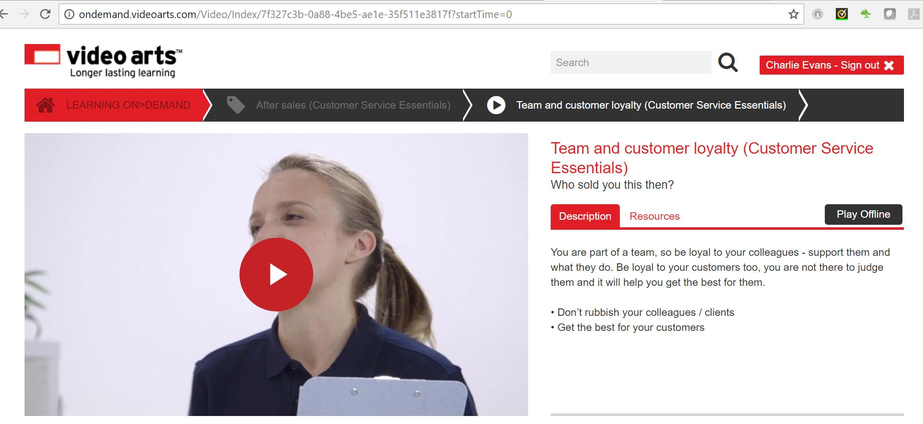

**Improving the customer service offer**

measuring_organisational_effectiveness_01.jpg

It is vital for all organisations to continuously improve their customer service and how effective they are in meeting customer needs to

* increase business
* retain customers and
* to maintain market share

Select the book below to learn more.

**Improving customer service**

**1 Introduction**

Any organisation has many reasons for needing to make improvements to the standard of customer service it offers. Change needs to be considered and no organisation will make change just for the sake of doing so. Any change will be consider the advantages and disadvantages and take into account customer feedback, sales, levels of complaints etc.

Changes in customer needs can include:

* **customers demand new ways of purchasing products or services**: e.g. with new technology customers want the ability to make purchases on a 24/7 basis
* **customers demand higher levels of service**: e.g. through social media customers are now more aware of what the standard of service is from competitors and have higher expectations of what the level of service is they should be offered by an organisation

Through television, social media and the Internet, customers are more aware than ever of the level of customer service that is acceptable and what their rights are. This means any organisation will need to ensure that their customer service meets the expectations of their customers, and if not, to make improvements. Technology has changed all our lives, and all organisations now need to be aware of its influence.

**2 Trends**

Customer service may need to change because of trends. Trends can include:

* new technology which can affect purchasing, ordering or appointment making - this can benefit customers who want to be able to do this at times that suit them, anywhere
* use of new approaches to greet customers or to finish a sale
* changes to reception areas e.g. making them more open, accessible and people-friendly
* changes in seating, e.g. in coffee shops where there are sofas etc

Customer service is not just about how you deal with people face to face but how you work to meet customer expectations.

**3 Environment and economy**

Additionally customer service may need to change because of environmental issues. For example, people are keen to save the environment and make use of less paper so items like tickets, vouchers can now be accessed and accepted on mobile phones or laptops.

Economic issues can also affect customer service. For example when there is a recession organisations need to be leaner but still offer a level of customer service that meets or exceeds that of the competition. In an economic boom people except a higher quality of service which they may be willing to pay for.

**4 Methods of change**

The standard of customer service being delivered by staff will always be checked. Customer service can be improved by:

* staff training
* observation of staff
* improved procedures
* use of new methods

Change can only be successful if it is introduced with care. Change requires the support of others who are involved. Support can be obtained by informing others through:

* team meetings
* memos
* emails
* training sessions
* management updates
* colleagues

Successful introduction of change or improvement requires those involved to be:

* informed about the change and why
* trained in its introduction
* involved in its implementation
* involved in its evaluation

Those involved need to be behind change as they will have to implement it. They need to be positive as customers will soon pick up if they are resentful or negative. If staff are not involved in change, it can be difficult to implement easily and its success can be compromised. Staff or other service providers need to have change or improvement discussed with them and they need to be involved as it may be there practices that need to be changed.

**5 Sources of information and constraints**

There are many sources of information that may help identify ways in which customer service can be improved:

* customer feedback
* sales
* complaints
* returns
* staff feedback

There are a number of constraints on staff and their ability to suggest improvements to customer service:

* level of authority - they may not been seen as senior enough to comment
* level of experience - they may not been seen as experienced enough to comment
* cost - the suggested improvements may be too expensive
* lack of resources - there may not be sufficient resources in place to carry out the improvements

In terms of actually implementing customer service improvements, organisational policies and procedures need to be followed. It is important that staff with the relevant level of authority implement any agreed customer service improvements. Always act within the limits of your own authority.

**6 Obtaining customer feedback**

gathering_customer_feedback_03.jpg

Customer feedback is an important tool in evaluating and improving customer service. To enable you to effectively evaluate customer service you need to understand the measurement tools relevant for gathering, analysing and interpreting customer feedback. These include:

* Online
* Written - emails and letters of complaint
* Verbal - face to face and by phone
* Text
* Social media - comments on Twitter and Facebook
* Surveys - online and paperbased
* Questionnaires - Comments and Suggestion Boxes

Feedback can be gathered formally or informally. Formal feedback gives useful information on an organisation’s performance:

* Formal feedback is structured, written feedback, actively sought by the organisation
* Formal feedback techniques include:
  + questionnaires
  + interviews/surveys
  + loyalty cards

Informal feedback is often the source of information on individuals’ performance, and is obtained where a customer offers feedback without being asked, e.g. through:

* online reviews/forums
* social media sites
* comment cards
* spontaneous comments
* complaints

Informal feedback should be reported and shared.

The purpose of encouraging customers to provide feedback is to:

* continuously improve
* be responsive to the changing needs of customers in order to maintain their loyalty
* identify if customer service standards are slipping
* prevent a situation becoming a problem that has to be solved
* identify potential problems, particularly with processes
* rectify repeated problems
* show the customer they are valued

**The importance of feedback**

Organisations have many methods of monitoring customer service, but the most important is customer feedback. If the customers are not happy, the organisation will find itself in trouble.

**7 Loyalty cards**

Loyalty cards are also used by organisations to collate information and feedback from customers. They:

* Create a database on the organisation's customers
* Record details of customer purchases
* Identify customer purchasing trends
* Allow the organisation to target promotional offers to specific customers
* Encourage loyalty

**8 Uses of feedback**

* actively seek customers’ opinion as to how service could be improved
* share feedback
* act on customer feedback

Uses_of_feedback.png

**9 Individual performance review**

effective_feedback_12.jpg

As well as customer feedback you will also have regular performance reviews or appraisals with your line manager. Customer feedback may form part of your appraisal. During an appraisal you can expect your line manager to look back on your achievements and agree training to improve your overall performance moving forward.

You can also expect targets to be set and a future appraisal date will be agreed.

**10 Sales/performance targets**

measuring_organisational_effectiveness_04.jpg

* Performance targets are a simple way to monitor the performance of an individual or team
* Targets are set based on an individuals and or teams past performance. Your targets may also be set to meet the companies targets set by management
* Your manager will always monitor team and individual targets and they may adjust them. If a target is changed you can expect to be given reasons for the change

**11 SMART Targets**

measuring_organisational_effectiveness_05.jpg

Principles of target setting are outlined in the SMART method:

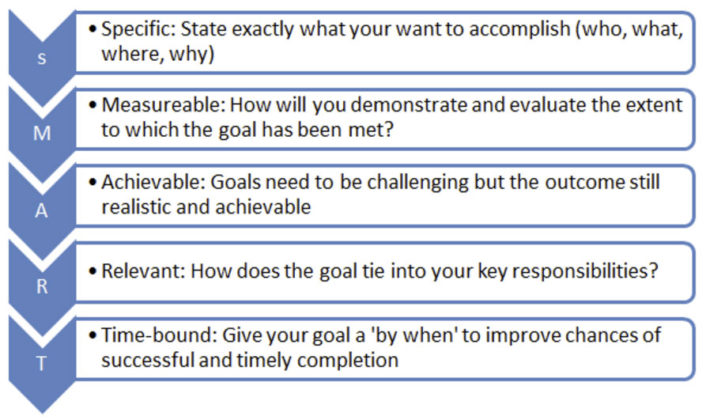

**12 Competitor benchmarking**

measuring_organisational_effectiveness_06.jpg

Companies will always keep a close eye on their competitors. They will try to gather as much information about each other as possible for example:

* A mystery shopper - may test the customer service
* Pricing - ensuring the prices of similar products and services are similar
* Sales/ special offers
* Monitor advertising campaigns
* Published records – all companies have to publish their accounts and profits.

**13 Methods of identifying service failures**

measuring_organisational_effectiveness_08.jpg

**Complaints** must be recorded and followed up properly following your company policy.

**Customer feedback** can be in any form – formal or informal. Customer comments or suggestions do not have be complaints.

**Market research** is a useful indication of customer wants, needs and expectations and can be matched to the current service offer.

**Sales figures** can highlight failures because the actual sales are less than the forecast or required sales.

**Product returns** can be used to identify if the same products are being returned consistently and for the same reasons.

**Staff monitoring** within performance reviews and sales/performance targets.

**Mystery shoppers** - undercover quality assurance officers can check service from a customer’s point of view, giving valuable insight into how the organisation delivers its offer.

**Customer focus groups** are a way of gaining feedback into what customers think about an organisation and how they could improve. New ideas can be generated and highlighted.

**14 Other considerations**

gathering_customer_feedback_06.jpg

**Policies and procedures**

When gathering any feedback, all organisations will have policies and procedures which must be adhered to. These policies and procedures are in place to explain:

* the roles and responsibilities
* the limits of authority
* how to handle of customer information

These policies will also explain the service offer that the organisation will provide.

**Legal requirements**

When gathering any customer feedback organisations must consider the legal requirements of gathering, storing, and using information from their customers. This legal requirement is written in to the Data Protection Act.

**Ethical requirements**

Customer feedback must be gathered according to the organisation's policies and procedures. Included in this is the organisation's ethics - the way the business is going to ‘do the right thing’.

**Preparatory activities**

**Question 1**

Recognising the different roles within your team and how you all fit together is vital in understanding team dynamics and communicating effectively. Research [Belbin Team Roles](https://skills.cgkpivot.com/mod/book/view.php?id=13160&chapterid=7475) and look at the members of your team to see who, if anyone, is fulfilling each role. Remember to consider your own role. Download and complete [this worksheet](https://content.cgkpivot.com/documents/CSP/Belbin_Team_Roles.pdf) and then upload your completed worksheet below. Once downloaded, select 'save as' and rename the worksheet so that your changes are saved.

**Question 2**

Teams and groups are actually two different things. Knowing whether you are working in a team or a group should affect how you communicate with your colleagues. Research and list **five** key differences between teams and groups.

**Question 3**

Do you think you work in a group or a team? Give reasons for your answer.

**Question 4**

How will this knowledge affect how or what you communicate with the rest of your colleagues?

**Question 5**

In your own words, explain why it is important to communicate effectively with your colleagues to ensure that you offer quality customer service.

**Question 6**

Obtaining customer feedback is a vital part of improving a customer service offer. Research a change that has taken place in your own organisation as a result of customer feedback. Your manager or mentor might be able to suggest some examples.

If there are no suitable examples in your own organisation, research how other companies have made changes as a result of either positive or negative customer feedback. For example, the introduction of 'New Coke' in 1985 by Coca-Cola, and its later scrapping. Explain how customer feedback influenced the decision to revert to the original name.

**Question 7**

Research and evaluate **two different methods** of collecting both **formal** and **informal** customer feedback that you could use within your organisation. Download and complete[this worksheet](https://content.cgkpivot.com/documents/CSP/Formal_and_informal_customer_feedback.pdf)and then upload your completed worksheet below. Once downloaded, select 'save as' and rename the worksheet so that your changes are saved.

**Next steps**

Now you have completed this section select the **SUBMIT TASK FOR REVIEW** button below and your Assessor will review and give you feedback. If you have any questions, please contact your Assessor via the messages function.

Task 17 Improving your customer service offer

**Introduction**

sales_marketing_01_a.jpg

To complete this task you will look at how communicating effectively with your colleagues supports delivery of effective customer service.

Effective communication also produces efficient working relationships and allows you and your colleagues to resolve issues in a collaborative manner.

As part of increasing the effectiveness of your customer service delivery, you will also consider how best to communicate with customers to help you develop suggestions for improvements.

When completing this task, you will need to:

* identify examples of when sharing knowledge has supported the development of good customer service practice
* explore the importance of customer feedback to improving customer service and evaluate how best to collect it
* carry out a customer feedback exercise and suggest improvements based on the results

**Task 17**

In this task you will be considering which legislation and regulations have an impact on your customer service.  As part of this task you will be working towards demonstrating that you have the following skills, knowledge or behaviours:

|  |
| --- |
| **Knowledge:** |
| By completing this task you should be working towards showing you understand the different needs and priorities of your customers, as well as recognising and knowing how to adapt to those needs. You should also be working towards showing you understand how to use systems, equipment and technology to meet customer needs. |
| **Skills:** |
| By completing this task you should be working towards demonstrating appropriate verbal and non-verbal communication skills. You will also be working towards demonstrating they you can use a range of questioning skills to get feedback, clarify understanding and respond to it appropriately. |
| **Behaviours:** |
| By completing this task you should be showing that you can:   * work with others in a positive and productive manner * communicate information in a timely and reliable manner to team members to support them in meeting customer needs efficiently * share personal learning and information with others to support good customer service practice |

### Distinction

As part of working towards **distinction** level, the Customer Service Practitioner standards require you to be able to explain the:

* recognise when to adapt your personal behaviour and communication approach to meet the needs of team members and customers
* present reasoned ideas for improving customer service practice to the appropriate colleague

**Knowledge application**

**Team work**

**Team work**

Download and complete [this worksheet](https://content.cgkpivot.com/documents/CSP/Team_work.pdf). Once downloaded, select 'save as' and rename the worksheet so that your changes are saved.

Once you have completed the worksheet please upload it below.

**Personal learning experiences**

Download and complete [this worksheet](https://content.cgkpivot.com/documents/CSP/Personal_learning_experiences.pdf). Once downloaded, select 'save as' and rename the worksheet so that your changes are saved.

Once you have completed the worksheet please upload it below.

**Question 1**

Good customer service can be informed by customer feedback and experiences as well as by your colleagues. Consider the feedback tools you looked at in the preparatory activities and decide which would be the best method for collecting feedback in your organisation. State your choice below, giving reasons for your answer. Make sure you have thought about the amount of time needed, the likely volume of responses and how you would implement any changes as a result of the feedback.

**Question 2**

Using the feedback method you have chosen, collect an appropriate amount of customer feedback. You may find it useful to pick a specific area to focus on rather than carrying out a more general survey. Be aware that you might need to obtain permission from your manager or the organisation to collect feedback from your customers. You may already have customer feedback you can use here that you collected as part of using organisational systems and resources.

Based on the results of the feedback, come up with some recommendations for improvements to ensure efficient customer service delivery in your organisation. Summarise your recommendations below.

Consider whether it is worth presenting these recommendations to your line manager.

**Next steps**

Now you have completed this section select the **SUBMIT TASK FOR REVIEW** button below and your Assessor will review and give you feedback. If you have any questions, please contact your Assessor via the messages function.

Customer conflict and complaints

Introduction

conflict_management_01_a.jpg

Dealing with challenging customers can be difficult, and here we will look at how to deal with customer conflict and complaints effectively. It is always important to resolve complaints positively whenever possible. If you handle the situation well, you might even be able to improve your organisation's relationship with them and create opportunities for doing further business.

Select the book below to learn more.

Customer Service Problems

**1 Customer Service and Complaints Procedures**

Customer service procedures include:

* what promises an organisation makes to its customers
* what you are required to do for customers
* how you are expected to behave
* how you should dress
* how you should greet customers
* handling of telephone calls

Customer complaints procedures usually cover:

* who can deal with complaints
* what complaints are referred to others
* the timescale for a reply
* compensation
* can the complainant take the complaint further

**2 Techniques**

Techniques to identify customer service problems and their causes include:

* active listening - concentrate and focus your full attention on the speaker to understand the information that is being relayed to you
* listen for the underlying emotions as well as the content
* gather the facts, e.g. dates, times and reference numbers
* identify what the customer expected but did not receive
* repeat back to check the information you have been given

Managing Challenging Conversations

People do not usually like challenging conversations and will often try to avoid them. We usually feel uncomfortable when we have to tackle someone about a difficult issue, especially if the conversation is face-to-face, and may feel awkward, embarrassed, nervous or afraid.

However, conflicts of interest, disagreements, complaints and disciplinary issues arise in the workplace from time to time, and we might be involved with difficult conversations when we work to resolve them.

Select the book below to learn more.

[Managing Challenging Customers](https://skills.cgkpivot.com/mod/book/view.php?id=13182)

**1 Challenging Conversations**

Challenging conversations with customers can take place face-to-face, on the telephone or when using other electronic methods of verbal communication.

Whatever the cause of the problem, the main aims when dealing with challenging customers are to:

* diffuse emotions
* identify the problem
* agree and implement solutions
* take appropriate follow-up action

When dealing with customer’s objections, don’t panic - play it cool. Don’t focus on the objection – instead, put it in perspective, or outweigh it with compensating factors.

* Don’t panic! Play it cool
* Make the objection specific
* Put it in perspective
* Give compensating factors

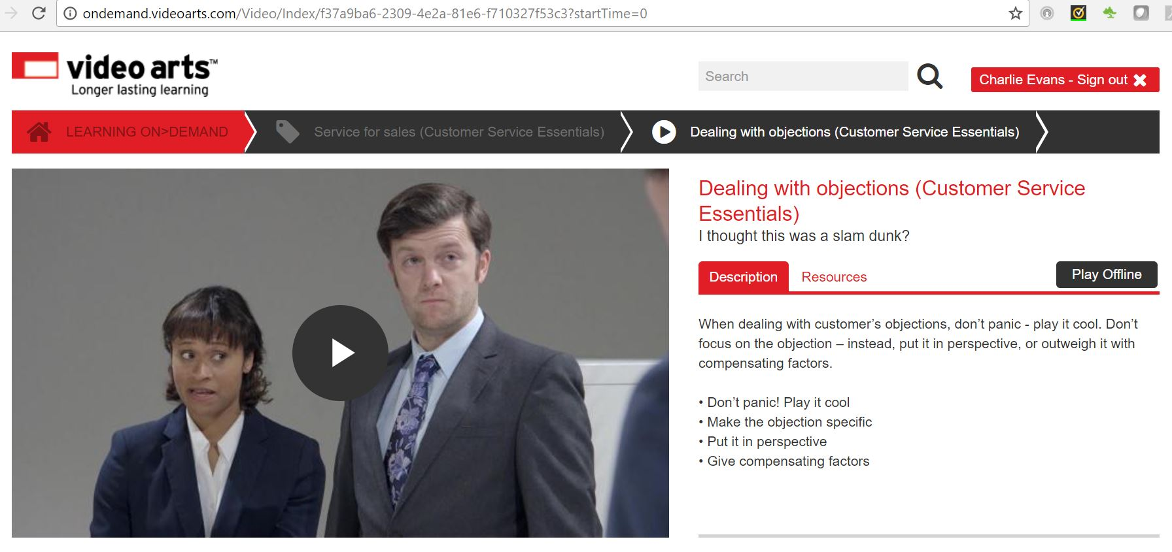

**2 Challenging Customers**

In a customer service environment challenging customers include those who are:

* angry
* aggressive
* impatient
* abusive
* confused or undecided
* have special requirements
* have a language barrier

Never rush a picky customer. Understand the reason behind their need for extra detail. Use your product knowledge to give them a clear picture and if you don’t know, offer to find out. Try and remain friendly.

* Don’t rush them
* Understand their need for detail
* Remain friendly

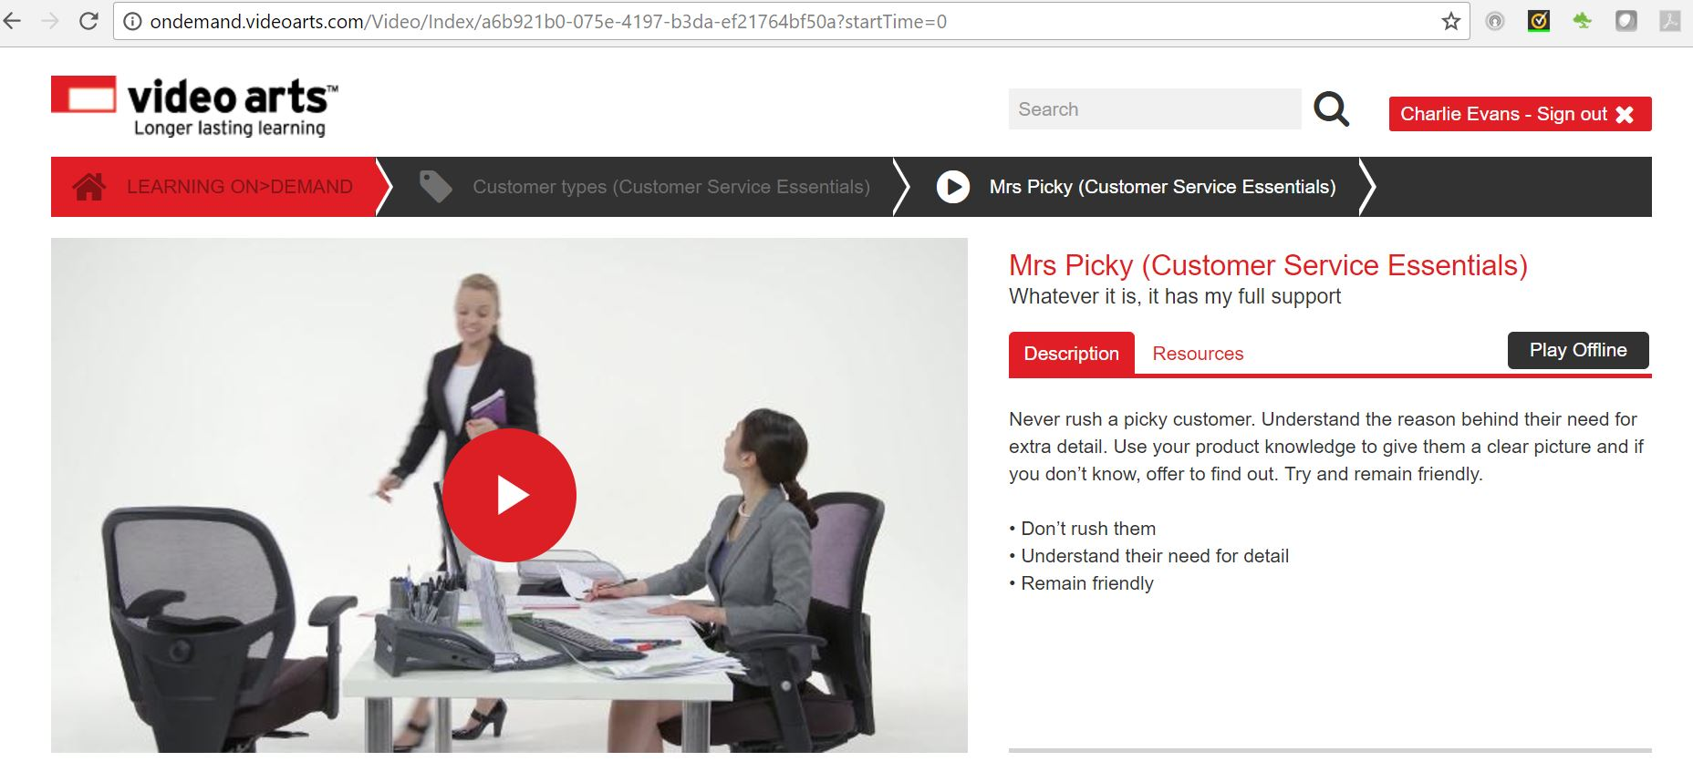

Challenging customers may display the following challenging behaviours:

* unreasonable attitude
* unwilling to listen
* aggression
* lack of understanding
* frustration

Challenging or dissatisfied customers can be identified by their:

* tone of voice
* attitude
* body language
* verbal communication

It is important that you follow your organisation’s procedures for dealing with challenging customers. These will include:

* service offer
* customer service policy
* policy on abusive behaviour

Your organisation may have standards of behaviour relating to the standards of behaviour of both the staff and customer, that you are expected to know and follow. Your organisation could have a:

* policy on abusive behaviour
* point at which the challenging customer should be referred to others
* set procedure for the way in which staff handle such customers and the support that can be offered in their handling

**3 Assertive and Aggressive Behaviour**

Assertive behaviour is where the customer is confident and self-assured but not aggressive.

Don’t get cheesed off with arrogant customers. Be respectful. Put yourself in their shoes and imagine how they want to be seen. Avoid confrontation and awkwardness by being tactful.

* Don’t get competitive
* Be respectful
* Be tactful

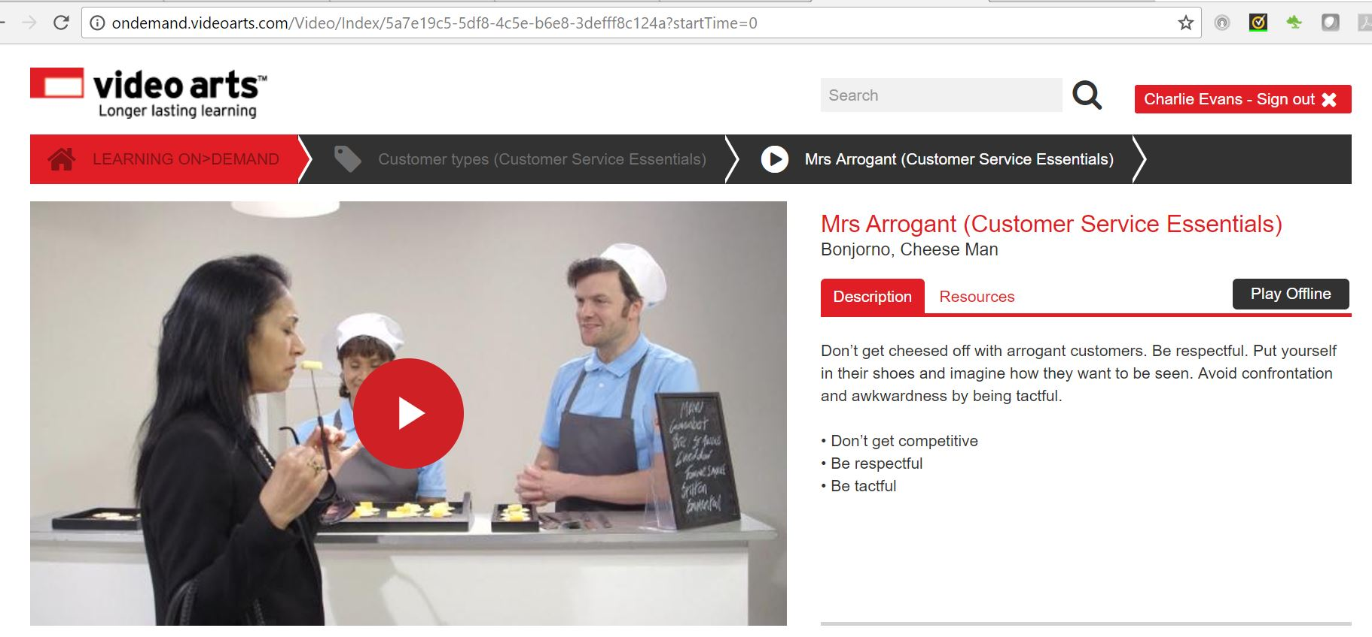

Aggressive behaviour is where the customer is very unpleasant and most likely threatening or even abusive or violent. It is likely your organisation will have a policy on how such people should be handled.

Never go into battle with a rude customer, that’s just what they want you to do. Don’t surrender either. Stand your ground, be polite and neutral.

* Don’t go into battle
* Don’t surrender
* Be polite and neutral

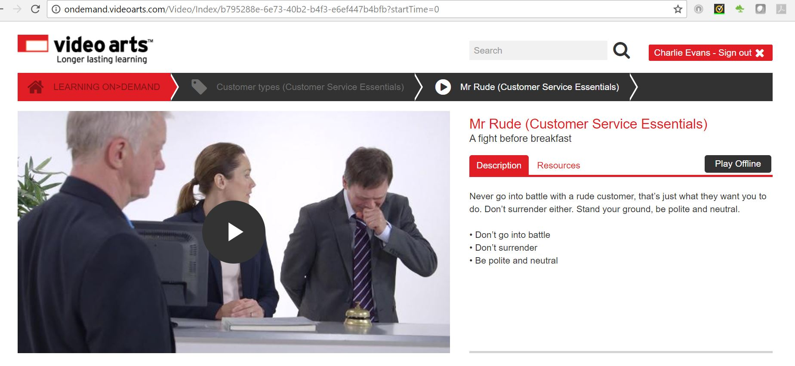

**4 Preparing for challenging conversations**

managing_challenging_conversations_book_01.jpg

When preparing for challenging conversations, it is important to remember to follow your organisation’s policies and procedures, as well as the requirements of different regulations and legislation, such as:

* **the Equality Act 2010** – to avoid discrimination based on any of the protected characteristics
* **the Data Protection Act 1998** – to maintain confidentiality
* **consumer-related legislation** – to protect the customers’ rights
* **the Health and Safety at Work Act 1974** – to minimise the risk of harm to staff members, customers and others

There are several things that we can do to prepare for challenging conversations that can help to reduce tension, minimise the risk of harm and increase the chances of a successful outcome. For example, we can prepare by:

* **having clear objectives**
* **considering the available facts and options in advance** – including what could happen during and after the conversation
* **planning the environment and approach** – as far as possible

In a customer service environment you do not always have the opportunity to prepare in advance for challenging conversations, therefore you need to ensure that you are fully aware of your organisation's policies and procedures and the regulatory and legislative requirements that you need to follow.

Your organisation's policies and procedures will state who should deal with customer complaints and challenging customers. Ensure that you are aware of the levels of authority within your organisation and at what level you are able to operate and make decisions.

**5 Having clear objectives**

effective_feedback_01.jpg

It is important to have **clear objectives** about what needs to be achieved during the conversation. You need to have a clear vision of the **desired outcome** – the main focus and goals.

For example, if a manager needs to have a challenging conversation with a customer who has made a complaint, the main objectives could be to:

* build a rapport with the customer
* identify the problem
* agree and implement solutions
* take follow-up action – including reviewing policies and procedures to improve the organisation’s output

In this example, the manager’s desired outcomes are to have a satisfied customer and reduced complaints in the future.

Clear objectives help us to focus on the issues that needs to be resolved, and give us a guide about how the meeting needs to progress. By concentrating on goals, facts and options, we can shift the focus away from the individuals involved, which should reduce anxiety and negative emotions and increase the chances of a successful outcome.

**6 Considering the available facts and options in advance**

managing_challenging_conversations_book_03.jpg

Studying the background to the problem helps us to ensure that we have as many facts as possible before we start the conversation. We can then think about possible solutions, so that we are ready to discuss different options. Things to consider before the meeting include, for example:

* the background to the issue that is causing the problem
* possible solutions to the problem
* potential problems that may occur in the meeting, or in the future
* follow-up actions that may be required
* what to do if actions are unsuccessful

Whilst thinking about the background to the problem, potential solutions and objectives, wider issues may be highlighted.

In the example of the manager dealing with the angry customer, the manager needs to think about what could happen if the customer becomes violent or upset during the challenging conversation.

They need to prepare for this by having a colleague or security officer nearby.

**7 Planning the environment and approach**

managing_challenging_conversations_book_04.jpg

To minimise distress, discomfort and other negative consequences of a challenging conversation, the person leading the meeting needs to plan the location and timing of the meeting, if possible. They need to make sure that the meeting is private and confidential so that the person can air their views and confidentiality is not breached.

They also need to plan their approach, and be prepared to adapt as the situation demands.

Depending on the circumstances and objectives of the discussion, their approach could be, for example:

* formal or informal
* warm and friendly or cool and distant
* apologetic or demanding
* direct and firm or gentle and vague
* to listen and ask a few questions
* to take command, speak and ask lots of questions

**8 Techniques for managing challenging conversations**

techniques_for_managing_01.jpg

Following on from the planning stage, there are several techniques we can use when managing challenging conversations. We can, for example:

* create the right environment
* use effective communication methods and styles
* use a range of question techniques and active listening skills
* use emotional intelligence

By setting the scene and communicating well, we maximise the chances of a successful outcome.

Techniques to deal with customers’ challenging behaviour include:

* remain calm
* listen
* talk clearly and confidently
* remain in control
* let them speak without interruption when they are angry
* ask questions and speak slowly and with concern in tone when they are confused
* alter communication to suit the customer
* ask for assistance from others where necessary
* if an angry customer try to move them away from other customers but do not allow yourself to be alone with them or out of sight of colleagues

**9 Creating the right environment**

techniques_for_managing_02.jpg

The environment needs to be suitable for the people who will have the challenging conversation, if at all possible. A suitable environment has several benefits. For example:

* the people having the conversation feel at ease, safer and less threatened
* if there are emotional outbursts, they are not in front of other people, such as colleagues or other customers
* they give a professional image of the organisation and its staff

Ideally, the area needs to be:

* **quiet**– away from other people, distractions and excessive noise
* **private** – so that confidentiality is not breached

In addition to the room itself, we need to think about other things that support the meeting and improve accessibility for all. These might include, for example:

* **general accessibility to the building** – e.g. ramps, lifts, wide doors and corridors to make access simpler for people with walking difficulties or who use wheelchairs or pushchairs
* **assistance for people with hearing or sight difficulties** – e.g. a quiet area away from background noise; using large print, symbols, graphics or Braille on supporting information
* **translation services** – e.g. where there are legal implications, such as in a police station following arrest

**10 Communication styles**

communication_methods_styles_02.jpg

A manager who is dealing with a complaining customer needs to diffuse the situation, make the conversation less challenging and maximise the chances of a successful outcome. They may concentrate on:

* having an open and non-confrontational posture
* being polite, courteous, patient, apologetic and confident – to inspire trust
* listening more than they speak – using active listening skills
* using a calm, polite, respectful but confident tone of voice
* using open, closed and rhetorical questions – maybe with probing questions if more detail is required

Communication methods and styles need calm, fair and professional so that, for example:

* the challenging conversation is less likely to lead on to further complaints or accusations of harassment and bullying
* the good reputation of the individuals and the organisation are maintained

**11 Using emotional intelligence**

communication_methods_styles_03.jpg

Whatever our approach, we need make allowances for the other person’s feelings when managing challenging conversations. The chances are that they will be nervous, afraid, uncomfortable, aggressive or defensive. By using our emotional intelligence, we can read their feeling and reactions more accurately and adapt our approach and employ appropriate skills.

People can be challenging to deal with for many reasons. They may have, for example:

* additional needs or requirements – e.g. impaired vision, hearing or mobility issues
* poor communication skills – e.g. learning difficulties that make communication difficult
* language or cultural barriers – e.g. making them upset because they find it hard to express themselves in English
* personal problems – e.g. issues with alcohol, drugs or a medical condition; childcare or family problems; difficult living conditions
* an incident, emergency or trauma – e.g. reacting badly if they (or a person close to them) have been involved in an accident, injury or serious illness
* dissatisfaction and disappointment – e.g. reacting emotionally when there is a problem with the product or service
* impatience – e.g. being short-tempered if they are not dealt with straightaway
* indecision – e.g. uncertainty about how to proceed, what they want or how to solve problems
* being overly assertive, confident or intimidating – e.g. coming across as a bully when talking
* being too talkative – e.g. making problems unnecessarily complicated, hard to identify and deal with

By being aware of background information, it is possible to use our emotional intelligence to ‘step into their shoes’, understand their viewpoint and take appropriate measures to achieve the objectives of the conversation. This skill of using empathy and understanding can be extremely useful. It helps us to amend our approach, diffuse problems and use the listening, speaking and questioning techniques that will most effective.

We also need to be aware that some people find it extremely hard to use and understand emotional intelligence, and we cannot assume that we all have the same ability to ‘put ourselves in someone else’s shoes’ when we are involved with challenging conversations.

**12 Re-opened or Escalated complaints**

Sometimes customers reappear or make contact asking for the same problem or complaint to be looked at again. This is called **re-opening** a complaint.

Alternatively a customer may not be happy with the proposed solution and they may **escalate** the complaint by either asking for management to be involved or by contacting management direct.

As covered previously you should be aware of the levels of authority in your organisation within the policies and procedures relating to managing challenging customers and also those covering re-opened or escalated complaints.

When dealing with complaints, ask open questions to understand the issue and closed questions to confirm a resolution. Don’t let your emotions control you, be polite and remain positive. Watch this video 'Asking the right questions':

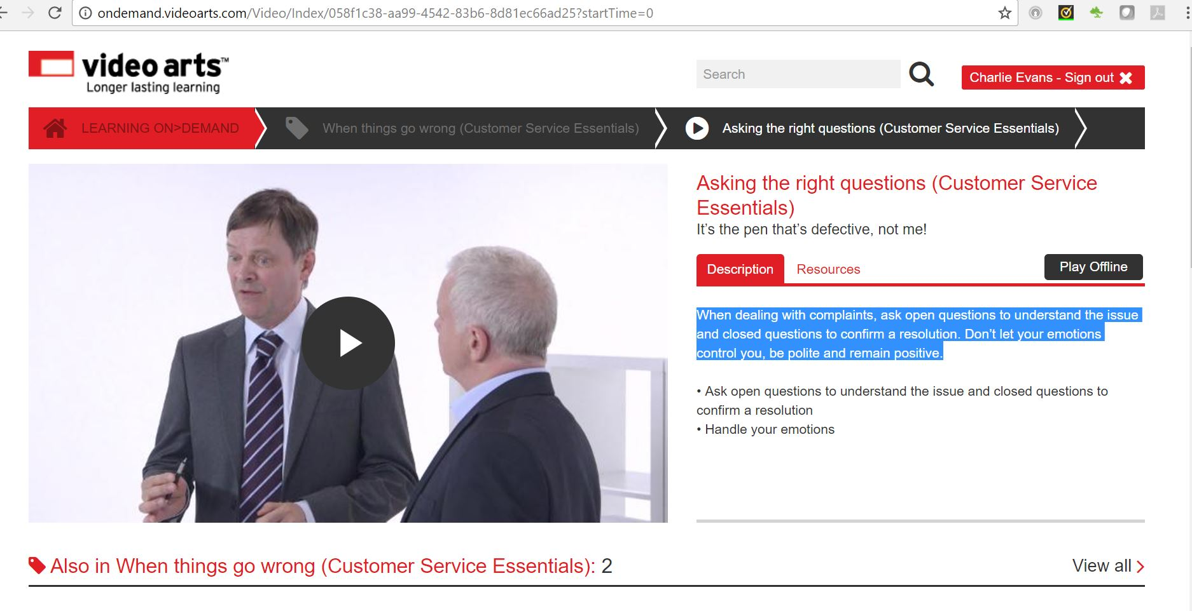

Complaints Management

In this section, you’ll learn about what exactly constitutes a complaint, why people complain, and the benefits of responding quickly and effectively. Complete the e-learning module below.

Essentials plus https://skills.cgkpivot.com/mod/scorm/player.php?a=229&currentorg=&scoid=0&sesskey=TxTfxf7rT0&display=popup

**Getting to a Solution**

Involve the customer in the solution. Ask them what their preferred solution would be, and offer them options.

* Involve the customer in the solution
* Ask them what their preferred solution would be
* Offer options

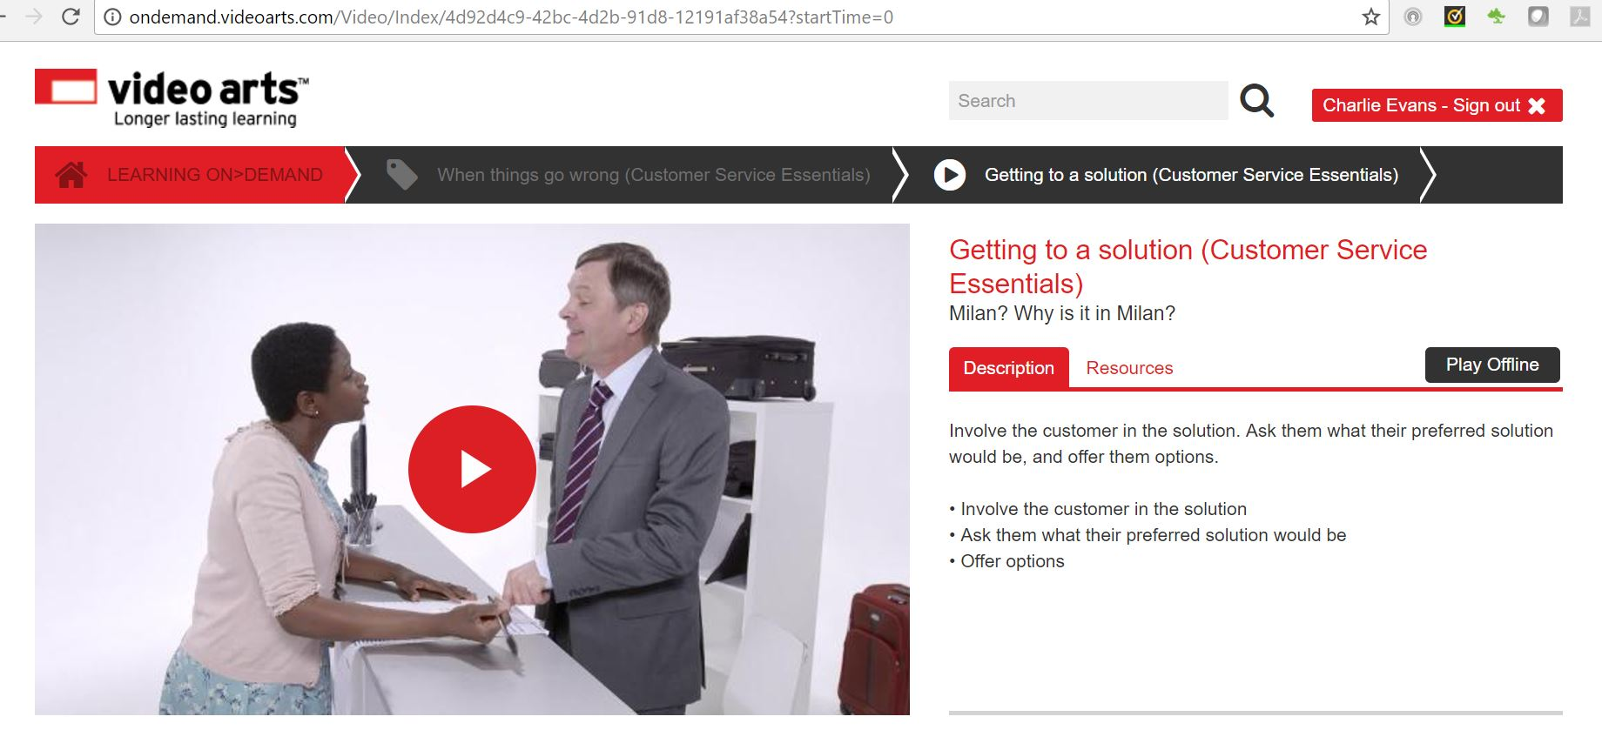

Conflict Management

conflict_management_01_b.jpg

When speaking to challenging customers you may find that the situation is quite heated. Conflict can arise when dealing with complaints. There are numerous ways of dealing with conflict and no one best way, albeit that the most appropriate solution is likely to be one in which a ‘win-win’ is achieved – i.e. where both parties are content with the outcome. Using conflict management techniques will reduce the tension in this situation. In this section, you will learn about effectively using conflict management techniques when dealing with challenging customers.

Watch the video below to learn more about conflict resolution.

<https://www.youtube.com/embed/QJiJ95mHftE>

Select the book below to learn more.

[Conflict Management Techniques](https://skills.cgkpivot.com/mod/book/view.php?id=13184)

**1 Assertive Behaviour**

communicate_effectively_04.jpg

Although some customers demonstrate assertive or aggressive behaviour, you must ensure that your behaviour is only assertive:

* Listen
* Really listen to what they are saying
* Focus your attention on them
* Use non-verbal clues
* Paraphrase
* Use ‘open’ questions
* Remain calm
* Show understanding and be prepared to seek a solution
* Consider a compromise
* Avoid triggers which can escalate conflict for example:
* Embarrassment
* Disrespect
* Insults
* Rudeness
* Being ridiculed
* Being ignored
* Being patronised
* Recognise when it is not working and when to involve others

**2 Signalling understanding and avoiding conflict**

conflict_management_techniques_02.jpg

When dealing with customers you may be able to defuse an escalation of aggressive behaviour through your actions supported by good communication. Try to remember P.A.L.M.S.

**P**osition – Consider your position in relation to the customer - don’t stand square on

**A**ttitude – Maintain a positive attitude

**L**ook and listen – Listen to what they say and watch what they do

**M**ake space – Keep an appropriate distance between yourself and the customer

* Intimate space 0m-0.5m
* Normal space 0.5m to 1.2m
* Stranger space 1.2 to 3m

**S**tance – Consider your position in relation to the customer and consider how you look.

**3 Approaches to dealing with conflict**

Approaches to dealing with conflict include:

|  |  |
| --- | --- |
| **Compromise** | Finding the middle ground – to move on quickly |
| **Challenge** | Fighting to get your way – as opposed to illuminating and addressing the issue(s) |
| **Collaboration** | Working together to agree solutions that meet as many current needs as possible. Can absorb a lot of time but is likely to give a lasting solution |
| **Avoidance** | Basically ignoring it – hoping the issue will go away or fade in significance. This has a place when it is just not worth the effort |
| **Accommodation** | When you give in to others. Can cause internal anger and is best avoided |

**4 ACT UP**

about_teamwork_04.jpg

Whatever approach you use to tackle the dispute, it is likely that you will find conflict uncomfortable. There are several ways you can tackle disputes and conflicts to resolve the problem. One method could be to ‘ACT UP’. Before exploring this conflict resolution model, it is important to understand that tackling conflict is not easy and is likely to involve the 3Ds: discussion, disagreement and discomfort. If we cannot lift ourselves above the conflict by forgetting about the person and concentrating instead on the problem, we will spend a lot of time in conflict.

ACT UP stands for:

**A**cknowledge

**C**onsider

**T**alk

**U**nderstand

**P**ropose

We first must acknowledge that a dispute exists and that we are in conflict. We then should consider whether we have all the facts and a clear understanding of why we are in conflict with the customer. If we fail to talk with them, we will not be able to clarify or ask questions to ensure that we understand the problem or issue: keeping a channel of communication open is essential in tackling conflict.

We also must understand the perspective and perceptions of others. Just because we view the world in a certain way does not mean the customer will see it the same way. And, finally, we must propose a way forward that is agreeable to both parties: this is not about compromise rather it is about seeking a ‘win-win’ solution to the problem.

**5 How Should You Respond to a Problem or Complaint?**

conflict_management_techniques_06.jpg

If problems are dealt with effectively customers will feel satisfied and this will improve the future customer relationship and their loyalty. This will result in the organisation meeting their targets, improving their sales figures, and reducing complaints, which will enhance their business performance.

If it is a problem that you can deal with then it should be followed-up by telephone to ensure that you have dealt with it promptly.

If it is a complaint the customer should put it in writing, the response should also be in writing, followed-up later by a telephone call to the customer to ensure that they are happy with the response.

Negotiation Skills

Negotiation is a useful skill in customer service, and a skill that everyone can develop.  Negotiation skills can help to achieve resolution of problems with customers, but can also apply every day when interacting with colleagues and management.

Select the book below to find out more.

[Negotiation skills](https://skills.cgkpivot.com/mod/book/view.php?id=13185)

**1 The importance of negotiation in customer service**

effective_feedback_04.jpg

Negotiation is required when two parties need to reach an agreement that is acceptable to both. It is not necessarily about ‘winning’, and is likely to involve some compromise. Good negotiating is about both sides feeling they achieved what they wanted.

Think about your job role and identify situations in which you may have to negotiate.

**Styles of negotiation**

This table outlines the five recognised styles of negotiation:

|  |  |
| --- | --- |
| **Negotiating Style** | **Features** |
| **Competitor** | Assertive, uncooperative, out to ‘win’, can damage relationship with other party |
| **Collaborator** | Assertive, cooperative, willing to find common ground, good at retaining good relationship with other party |
| **Compromiser** | Assertive, cooperative, meets other party half-way |
| **Pleaser** | Unassertive, overly cooperative, gives in to demands too easily |
| **Avoider** | Unwilling to contribute or make a decision, uncooperative, unassertive |

**2 Preparing to negotiate**

effective_feedback_05.jpg

Your negotiating style is likely to reflect your personality.  To gain an advantage while negotiating, there are several tactics and approaches used by good negotiators; including adopting different negotiating styles.  Understanding these tactics may help you develop your own negotiating skills, but also provide you with an insight so you can recognise when others are using them.

In business, negotiation is used in a range of situations; from arranging a timescale for a delivery, agreeing a pay rise, to deciding on an incentive to increase sales.  Negotiations can happen face-to-face, on the telephone and in writing.

The process of negotiation should begin with preparation. Both parties should have a clear idea of what they hope to achieve. Good preparation will involve consideration of the following:

* What is your preferred outcome?
* What are you prepared to and have the authority to concede?
* What is the minimum you are prepared to accept?
* What facts and figures do you have to strengthen your negotiating position?

Your starting position should factor in these considerations, but not reveal your minimum level.  When negotiations begin, both parties will declare their starting positions, and then gradually reduce the gap between the two, until an agreement is made. If the other party knows your minimum level, they will just offer this and know you will accept. If the other party’s best offer is below your minimum, you need to be prepared to walk away.

**3 Approaches to negotiation**

effective_feedback_06.jpg

**Soft negotiation**

Collaborative negotiators use this approach.  They will treat the other party as a friend, making allowances and offering concessions easily to find a common ground.  Soft negotiators tend to be honest and upfront about the deal they would like to achieve.

**Hard negotiation**

Competitor negotiators use this approach.  Hard negotiations are based on mistrust; they include lots of tricks and misleading tactics.  The other party is treated as a rival and the aim of in to ‘win’.

**Principled**

This is an approach based on compromise.  The principled negotiator will understand that each party will have a preferred outcome, but there will be numerous different outcomes

that could work for both.  They will enter negotiations with a best alternative (an acceptable

plan b), and be willing to compromise to meet the other party half-way.

**Distributive**

This approach is similar to hard negotiations, in that the aim is to beat the opposition and ‘win’. However, the focus of this approach is the goal, rather than the method of negotiation.  Each party in this negotiation wants to agree a deal in which they receive the biggest ‘slice of pie’.  In fact, this approach is often called fixed pie negotiation.

**Integrative**

Integrative negotiation involves working together to understand each other’s requirements and desires. Both parties in this approach recognise the need to reach a mutually acceptable agreement.

**4 Tactics**

effective_feedback_07.jpg

The table below outlines some common tactics adopted by negotiators.  A counter tactic, or response, has also been included.

|  |  |
| --- | --- |
| **Tactic** | **Counter Tactic** |
| Two offers are made: one that is marginally more acceptable than the other, which will appear more attractive than the alternative | Refuse both offers and walk away |
| An attractive offer is made, but then extras are added | Ensure the specification is detailed and does not allow for extras |
| One of the negotiating parties is represented by two negotiators; one with a starting position of high demands and the other, with more reasonable demands.  The latter is likely to be accepted, when compared to the impossible demands | Use a similar strategy |
| An appealing offer is made with a short deadline for acceptance | Ensure an acceptable timeframe for decision making is agreed at the start of negotiations.  Alternatively, become an avoider |

**5 Outcomes to negotiation**

effective_feedback_08.jpg

Once negotiation discussions end, there are three possible outcomes:

**Win-win** – Both parties agree an outcome that meets their minimum goals

**Win-lose** – One party achieves a positive outcome

**Lose-lose** – Neither party achieves a satisfactory outcome

Preparatory activities

**Question 1**

Download [this worksheet](https://content.cgkpivot.com/documents/CSP/Dealing_with_conflict.pdf) which includes all the preparatory activities. Once downloaded, select 'save as' and rename the worksheet so that your changes are saved.

Complete all the questions in the worksheet and then please it upload below.

Next steps

Now you have completed this section select **SUBMIT TASK FOR REVIEW** and your Assessor will review and give you feedback. If you have any questions, please contact your Assessor via the messages function.

Task 18 Dealing with conflict

Introduction

negotiation_skills_l23_01_a.jpg

To complete this task you will look at how to deal with customer conflict and complaints effectively, as well as why it's so important to resolve them positively whenever possible. Dealing with challenging customers can be difficult, but if you handle the situation well, you might even be able to improve your organisation's relationship with them and create opportunities for doing further business.

When completing this task, you will need to:

* complete case studies detailing what you would do in particularly challenging customer situations
* give examples of how you have dealt with tough situations in your own role and evaluate how you did

Task 18

In this task, you will be looking at how you can increase the likelihood of resolving a conflict in a positive way through the language that you use, by following set organisational procedures and by being proactive about seeking a solution that suits everyone.

As part of this task you will be demonstrating the following skills, knowledge or behaviours:

|  |
| --- |
| **Knowledge:** |
| By completing this task you should be working towards showing that you understand the different needs and priorities of your customers and know the best way to manage their expectations, recognising how to adapt your style to be effective. |
| **Skills:** |
| By completing this task you should demonstrate that you can:   * + handle customer objections in a positive and professional manner   + remain calm and patient at all times when dealing with challenging customer situations   + demonstrate sensitivity to, and interest in, customers' concerns   + communicate in a clear and coherent manner the next steps and/or options to meet the needs and expectations of customers   + resolve customer conflicts and/or challenges in line with the relevant organisational policies and/or procedures   + keep customers informed of progress while resolving issues   + maintain accurate records of customer issues and progress to resolution |
| **Behaviours:** |
| By completing this task you should be showing that you can:   * + take ownership from beginning to end, building and maintaining a relationship with the customer   + recognise the importance of good customer service to the customer and in turn the organisation, making contact as promised, referring to others as necessary with all required detail, and following up to ensure a conclusion is reached |

### Distinction

As part of working towards **distinction** level, the Customer Service Practitioner standards require you to be able to explain the:

* provide appropriate explanations to customers in situations where a mutually beneficial outcome cannot be reached
* take ownership of customer issues, taking the appropriate actions to ensure customer needs and expectations are met

Knowledge application

**Question 1**

Give **at least three** specific examples of entries that you have personally made in your organisation's customer issues and resolutions records. Remember not to use any names.

**Question 2**

Give a more detailed example of an occasion when you have **taken ownership**of a customer issue and **needed to refer**to a colleague or line manager. Within your answer please include:

a) What was the problem?

b) Was there any sort of resolution you could provide without having to refer it to someone else?

c) What resolution was provided by your colleague or manager, following the referral?

d) Why was this solution the most appropriate?

**Question 3**

Give an example of an occasion when you have **taken ownership**of a customer issue and resolved it **without the need to refer**it to a colleague or line manager. Within your answer please include:

a) What was the problem?

b) What resolution did you provide?

c) What other resolutions did you consider?

d) Why was the solution you provided the most appropriate?

**Question 4**

List the kinds of resolutions you can and cannot offer as part of your role

Resolutions I can offer .........

Resolutions I cannot offer .........

Case study 1

Read the case study below and then answer the questions that follow.

You are working in a small post office where you are the only member of staff on counter duty, and there are a number of customers waiting to be dealt with. Conflict arises between two customers who both insist they are next in the queue. The customers are both becoming angry, and their words and actions are becoming threatening.

**Question 1**

What communication strategies would you use to ensure that the situation does not get out of hand?

**Question 2**

How would you deal with the situation in a way that would ensure that the needs and expectations of all the customers are met? What next steps or options would you suggest?

**Question 3**

Are there any procedures or policies for dealing with a similar situation in your organisation? If yes, describe them here.

Case study 2

Read the case study below and then answer the questions that follow.

One of your most important customers has just walked into your office unannounced and burst into an angry rant because your organisation has failed to make a delivery on time. Because of this, the customer was unable to demonstrate a key product, which meant that he lost an important sale.

**Question 1**

What communication strategies would you use to ensure that the situation does not get out of hand?

**Question 2**

How would you deal with the situation in a way that would ensure that the needs and expectations of the customer are met?

**Question 3**

Are there any procedures or policies for dealing with a similar situation in your organisation? If yes, describe them here.

**Question 4**

You do your best to reason with the customer, but nothing you say helps the situation. The customer only gets angrier, shouting accusations and flying further into a rage. Within a few minutes he walks out, vowing never to do business with your organisation again.

What next steps or options would you suggest to retain the customer's business? When and how often would you make contact with the customer regarding the resolution of the issue?

Case study 3

Read the case study below and then answer the questions that follow.

A customer has returned a desk lamp by post, which they purchased online three weeks previously from your organisation. Your customer returns policy says that returns will be acknowledged within five working days.

Your colleague dealing with this return has sent the following email to the customer:

'We acknowledge receipt of one desk lamp model ASP45, purchased 21st April. Thank you for doing business with us.'

The customer telephones, saying they are not satisfied with this response. Your colleague states that he has dealt with the return in line with the stated company policy. You are tasked with resolving the conflict between the customer and your colleague.

**Question 1**

Do you think your colleague has dealt with the return in line with the company's stated policy? Give reasons for your answer.

**Question 2**

How would you word an email to a customer in a similar situation?

**Question 3**

How would you deal with the situation in a way that would ensure that the needs and expectations of the customer are met? What communication strategies would you use? What next steps or options would you suggest?

**Question 4**

Are there any procedures or policies for dealing with a similar situation in your organisation? If yes, describe them here.

**Question 5**

When and how often would you make contact with the customer regarding the resolution of the issue? At what stage(s) of handling the return would you update them?

Dealing with conflict - your experience

Download and complete [this worksheet](https://content.cgkpivot.com/documents/CSP/Dealing_with_conflict_your_experiences.pdf) which allows you to describe situations that you have dealt with in your own organisation. Once downloaded, select 'save as' and rename the worksheet so that your changes are saved.

Next steps

Now you have completed this section select **SUBMIT TASK FOR REVIEW** and your Assessor will review and give you feedback. If you have any questions, please contact your Assessor via the messages function.